ERASMUS+

Technical guidelines
for completing
application e-Forms

For actions managed by
National Agencies

For actions managed by
National Agencies

For actions managed by National Agencies

Version 2 of 09/03/2015

Table of Contents

Introduction 4
Preparation 4
Electronic forms catalogue 4
Technical requirements and settings needed to use an electronic form 5
Adobe Reader 5
Incompatible Readers 5
Operating Systems 6
Security and Java Script Settings 6
How to fill an electronic application form 9
Checking that you have downloaded the correct form 9
Choosing the correct National Agency 10
Using your PIC in an electronic form 12
Mandatory fields 13
Lists of values 14
Dynamic sections 14
Manually adding entire sections and entries 15
Participating Organisations 15
Adding new entries in lists of values 18
Filling in the budget section 19
Activities' Details 19
Completing the Budget 21
Checklist 26
Validating a form 27
Compulsory fields 27
Duplicated PICs in participating organisations 28
Double entries in lists 28
Invalid flow duration given activity type 29
Annexing documents 30
Annexing a Declaration of Honour 31
Submitting a form 32
Submitting more than once 34
Late submission of the application 34
Specific guidelines concerning the different Erasmus+ action types 36
Application forms for Accreditation 36
KA108 - Accreditation of Higher Education Mobility Consortia 36
Application forms for Mobility of learners and staff under KA1: Learning Mobility of Individuals 37
KA101 - School education staff mobility 37
KA102 - VET learner and staff mobility 39
KA103 - Higher education student and staff mobility within Programme Countries 42
KA104 - Adult education staff mobility 44
KA105 - Youth mobility 46
KA107 - Higher education student and staff mobility between Programme and Partner Countries 48
Application forms for Strategic Partnerships under KA2: Cooperation for innovation and exchange of good practices 49
Context Section 49
Priorities Section 49
Participating organisation(s) Section 50
Description of the Project Section 51
Implementation Section 51
Intellectual Outputs Section 51
Multiplier Events Section 52
Learning/Teaching/Training Activities Section 53
Budget Section 54
Application form for Stakeholder dialogue and policy promotion under KA3: Support for Policy Reform (relevant only for the field of Youth) 56
Application form in general 56
Context Section 56
Main Activities Section 56
Activities' Details Section 56
Follow-up Section 56
Annexing documents – Timetables of activities 56
Registering your organisation in the European Commission's Participant Portal 57
Logging into the Participant Portal 57
Register yourself in ECAS (European Commission Authentication Service) 58
Enter your organisation's details 60
Finishing your registration 62
Wrapping up 63
Uploading supporting documents in the Participant Portal 65

Introduction
This document describes the use of electronic application forms (eForms) for the Erasmus+ programme actions managed by the National Agencies in the Programme Countries. For simplicity reasons, we will call them "decentralised actions" in this guide.

Preparation
Before we dive into the process of completing an electronic application form (the "e-Form"), it is important to know which forms are available for which actions of the Erasmus+ Programme.

Electronic forms catalogue
The following tables describe the relevant application forms:
 | Action Type
Accreditation | KA108 - Accreditation of Higher Education Mobility Consortia
Accreditation | KA109 - Vocational Education and Training Mobility Charter
Accreditation | KA110 - Accreditation of youth volunteering organisations

 | Action Type
KA1 – Learning Mobility of Individuals | KA101 - School education staff mobility
KA1 – Learning Mobility of Individuals | KA102 - VET learner and staff mobility
KA1 – Learning Mobility of Individuals | KA103 - Higher education student and staff mobility within programme countries
KA1 – Learning Mobility of Individuals | KA104 - Adult education staff mobility
KA1 – Learning Mobility of Individuals | KA105 - Youth mobility
KA1 – Learning Mobility of Individuals | KA107 - Higher education student and staff mobility between Programme and Partner Countries
KA2 – Cooperation for innovation and the exchange of good practices | KA201 - Strategic Partnerships for school education
 | KA202 - Strategic Partnerships for vocational education and training
 | KA203 - Strategic Partnerships for higher education
 | KA204 - Strategic Partnerships for adult education
 | KA205 - Strategic Partnerships for youth
 | KA219 – Strategic Partnerships for Schools Only
KA3 – Support for policy reform | KA347 - Dialogue between young people and policy makers

Technical requirements and settings needed to use an electronic form

Adobe Reader
The Erasmus+ decentralised actions application forms were built using Adobe Forms technology. You need Adobe Reader to use the forms.
In order to be able to properly use an Erasmus+ application form you will need to use the following versions of Adobe Reader:
Minimum Adobe Reader version | Adobe Reader 9.1 or higher
Recommended Adobe Reader version | Adobe Reader XI version 11.0.06
Adobe Reader can be downloaded for free from the internet at the following location:
http://get.adobe.com/reader/otherversions/
If you are using a different version than the above mentioned ones you will not be able to use the form and will be confronted with the following screen:
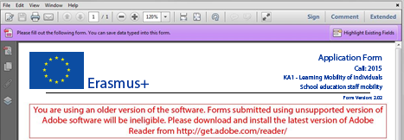

Incompatible Readers
Adobe Reader is the only accepted reader. If you happen to use another reader such as "Foxit" or Adobe Acrobat X PRO you will not be able to use the electronic form and may even corrupt it as the following message shows:
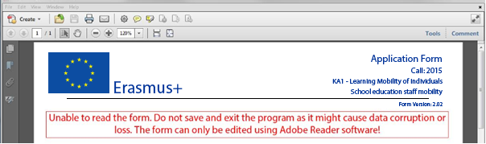

Operating Systems
The above mentioned Adobe Reader versions are supported on Microsoft Windows and Apple OS X. Mobile platforms such as iOS, Android, Microsoft Windows RT, Windows Phone and BlackBerry are not supported by the application forms.
Application forms can be opened on Linux platform only with Adobe Reader version 9.1.

Security and Java Script Settings
When an electronic form is downloaded from the internet for the first time, Adobe Reader will detect that the form has originated from a potentially unsafe location and ask you to confirm the safeness of the file:
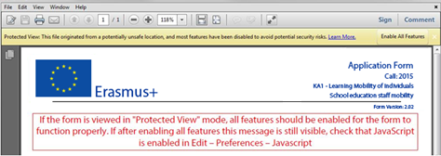
In this case you should press button "Options", choose "Trust this document always" and save the electronic form:
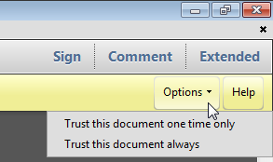

If the problem persists, check your Java Script settings in Adobe Reader:
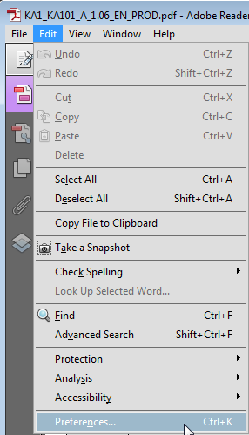
You should have the following configuration:
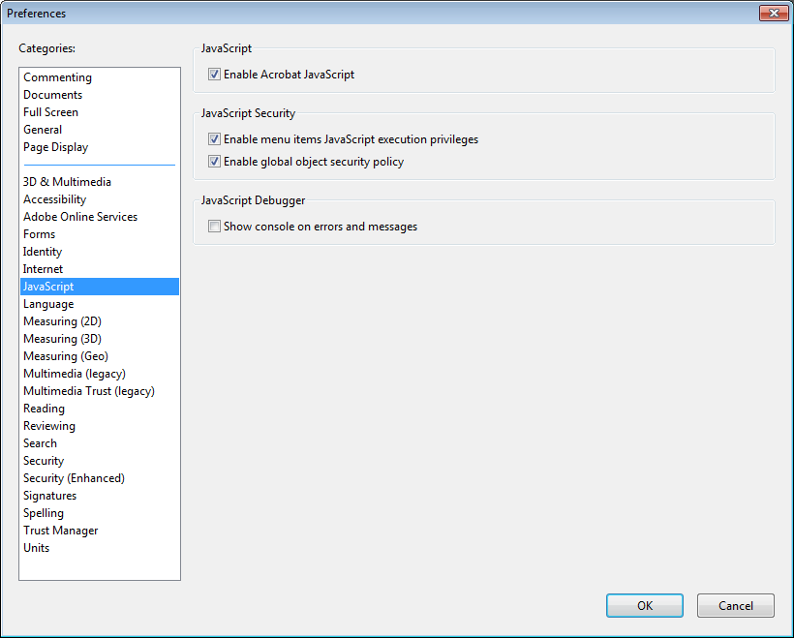
On top of what is written above, Adobe Reader uses an enhanced security feature that detects when the electronic form is attempting to connect to the internet. Such situation will happen every time you need to input and validate a PIC (Participant Identification Code, provided to the organisation upon registration in the Participant Portal (see section on "Registering your organisation in the European Commission's Participant Portal" at the end of this document) for a participating organisation, or when you have changed a piece of data that impacts the budget section, such as a distance band in the "Travel" budget section. In both scenarios the electronic form will contact central European Commission servers to fetch the latest data and information. The message displayed by Adobe Reader is as follows:
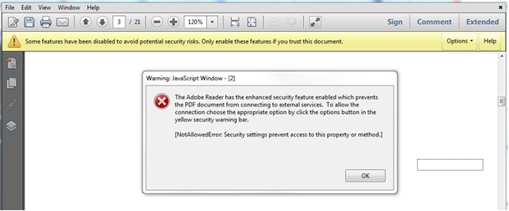
When confronted with this message you should press button "Options", select "I trust this document always" and, when asked, save the form with the same name. This process is sometimes a bit slow, so just let it finish before proceeding.

How to fill an electronic application form
This section will guide you through the main aspects to consider when filling an electronic application form for applying for a grant under an Erasmus+ action managed by the National Agencies.

Checking that you have downloaded the correct form
Before you start working on your application and filling in your project's data, it is important that you check that you have the right form for the right "Action Type", "Call" and "Round". Page 1 of every electronic application form contains this information:
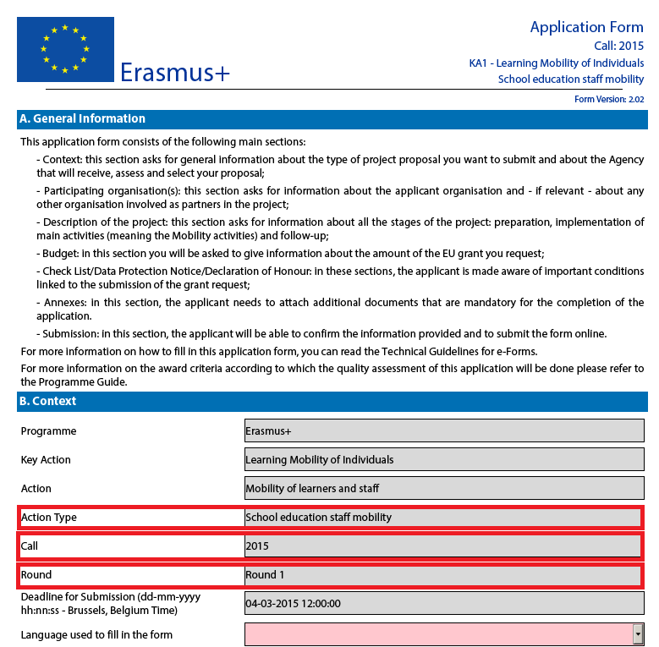
Field "Action Type" will show you the action type and the field of education, training and youth which the application form concerns. Do make sure you are using the right one as your application will not display all fields that apply to your project if you submit it through a different form and may be considered as ineligible as a consequence.
Field "Call" is another important piece of information, as it indicates the year of the Erasmus+ Call for proposals concerned.
In some cases, more than one application round may be organised within the same call. Therefore, it is also important to check the selected application "Round" to which you want to apply, since selecting an inactive round, i.e. one that is already closed, will not allow you to submit your application.
Note that you cannot change the content of these three fields. If you find out that you have selected the wrong application form, you need to close it and download the correct form from your National Agency's website (see "electronic forms catalogue").

Choosing the correct National Agency
Another important aspect to take into account is the National Agency to which you want to submit your application. The selection of the National Agency is normally done on page 2 of an application form. There you can find a drop-down list with the allowed Erasmus+ National Agencies covering each field of education, training and youth. In the list of values below, each National Agency is identified by a unique code accompanied by the name of the country in the national language:
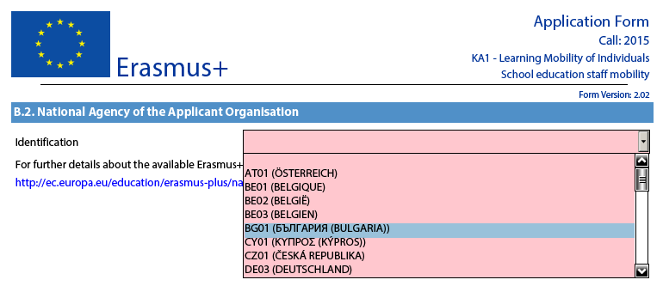
If a country has more than one National Agency, use the following hyperlink to consult the full list of National Agencies, and find out the code of the National Agency responsible for your field of education, training and youth to which you should submit your application:
http://ec.europa.eu/programmes/erasmus-plus/national-agencies_en.htm
The information to look for is illustrated in the screen shots below and includes the National Agency code and the fields in which it is active.
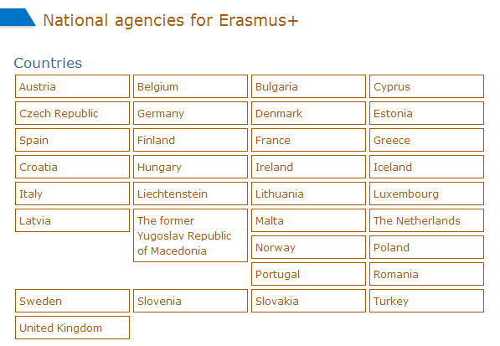
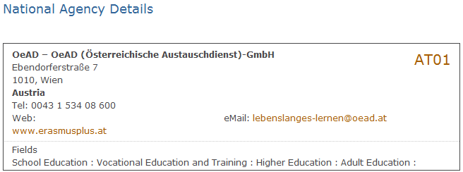
The last aspect concerning the field(s) for which a National Agency has been designated is of particular importance as this needs to match the electronic application form you have chosen. In order to help you, the electronic application forms will only show you the relevant National Agency reference according to the field of education, training and youth that you want to submit your project to.
As an example, if you are interested in applying for a "KA101 - School education staff mobility" grant, the application form will allow you only to select the following NA: AT01 (ÖSTERREICH). Whereas if you are interested in applying for a "KA105 - Youth mobility", the application form will display the following NA: AT02 (ÖSTERREICH).
UK02 National Agency Caveat
Due to technical reasons, UK applicants will have to select UK02 as their National Agency for action types in sectors Vocational Education and Training and Adult Education for KA1 and KA2 electronic application forms.

Using your PIC in an electronic form
All participating organisations should be registered in URF and should use their PIC (Participant Identification Code) when filling-in an eForm (please see section on "Registering your organisation in the European Commission's Participant Portal" at the end of this document). This applies also to applications from consortia even though in the eForm the field "PIC" for a given Consortium Member is not mandatory and the eForm could be submitted without this information (you can find more information on the mandatory fields later on in this document).
When you and your partner organisations have a PIC, you can start using these identifiers in your electronic application forms.
The PIC field name is the place where you need to enter your organisation's identification:
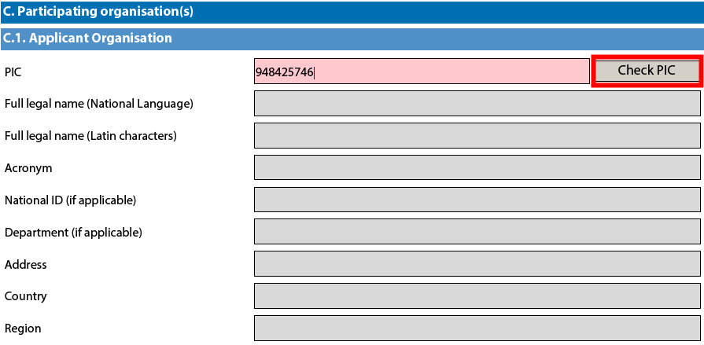
After you have entered it, press button "Check PIC" so that the electronic form fetches the organisation's data from the Participant Portal. In other words, you do not need to enter again in the application form the organisation data that are already registered in the Participant Portal.
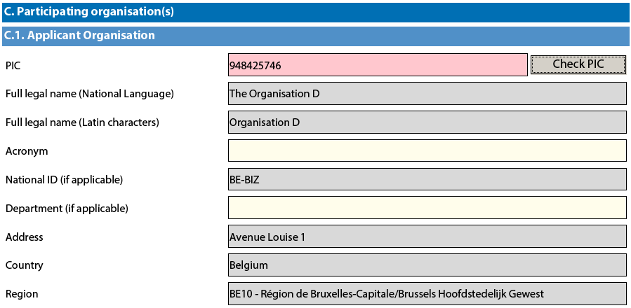
Once you have entered the PIC and the eForm has fetched the relevant information in section C.1., you will also see that part of the information in section C.1.1 has also changed:
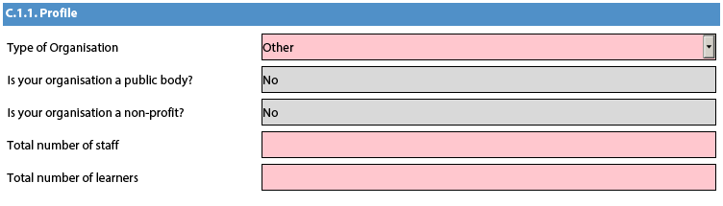
In the 2015 eForms the applicants can indicate the type of the organisation as this information is no longer filled in the Participants Portal. Please note that, as the field Type of Organisation is a compulsory one, the applicant cannot leave it empty and should pick one option from the drop-down menu. If you cannot find the right organisation type in the list of the drop-down menu, the organisation type can stay "Other" in the electronic form.

Mandatory fields
Mandatory (compulsory) fields are clearly identified in electronic forms through a pink colour as depicted below:
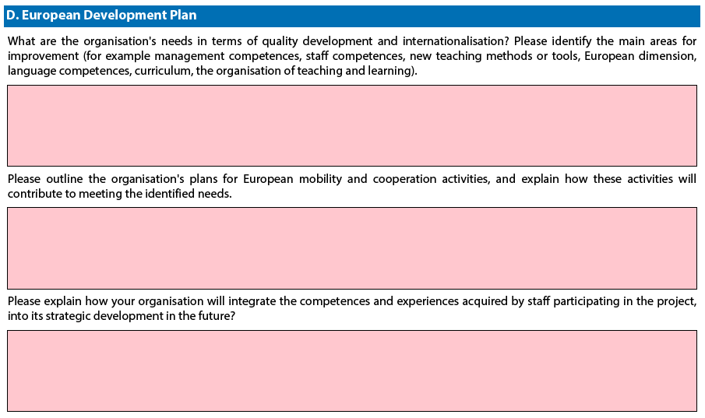
They need to be filled in, otherwise you will not be able to validate and submit your electronic form.

Lists of values
Lists of values represent closed questions that you will need to answer by choosing one or more entries from the ones available in the list. The example below represents the selection of the language used to fill in the electronic form i.e. the language used by the applicant to enter the project information:
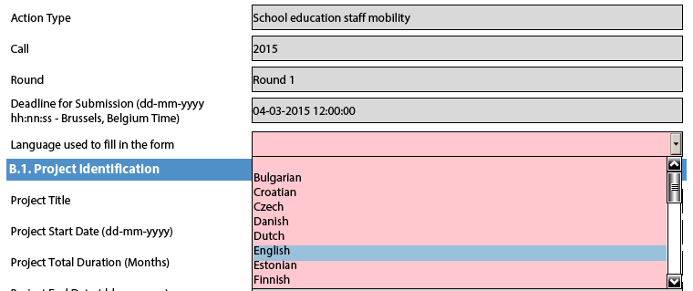

Dynamic sections
Some selections made in an electronic form will trigger the appearance or disappearance of fields or sections following them. A typical example of this is the "Consortium" section where an applicant can enter if it is applying on behalf of a consortium:
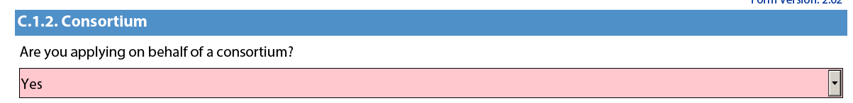

If the applicant enters "Yes" then a new "Consortium Member" section will be shown where the members of the consortium can be identified:
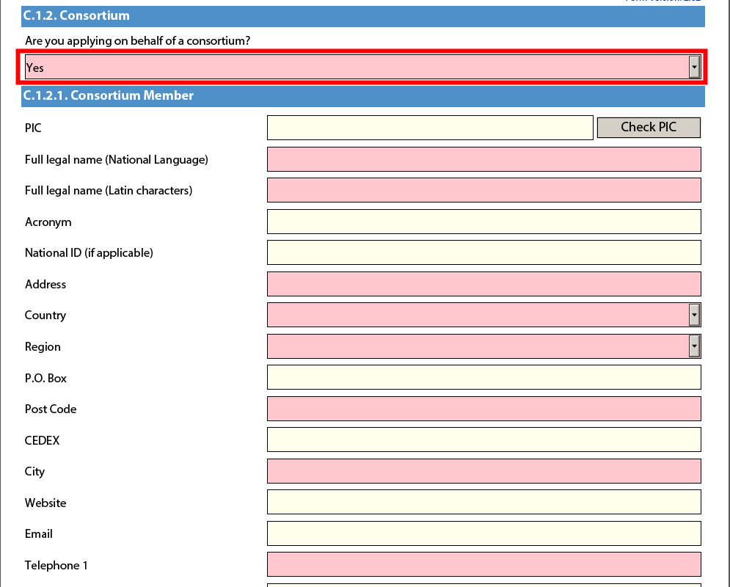

Manually adding entire sections and entries
In certain places, you can add entire sections to the form, if they are relevant and necessary for you. An example is adding project Partners.

Participating Organisations
In this section the data about your organisation is already available in the sub-section "Applicant Organisation":
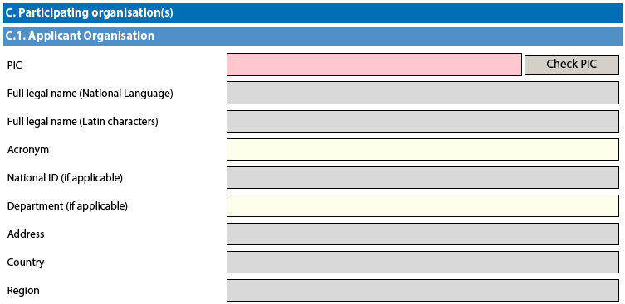

If you need to add partner organisations to your application, you can do so by pressing the button "Add Partner" located at the end of the "Applicant Organisation" sub-section:

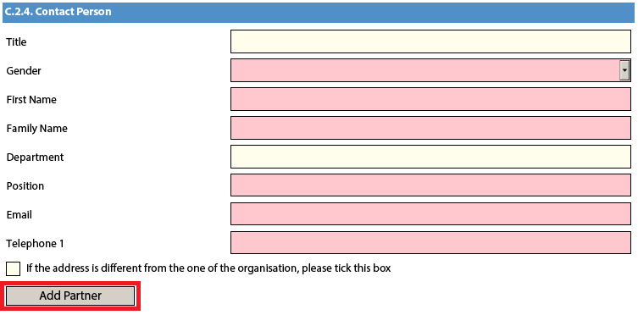
A new sub-section will then appear, called "Partner Organisation", where you can enter all needed details:

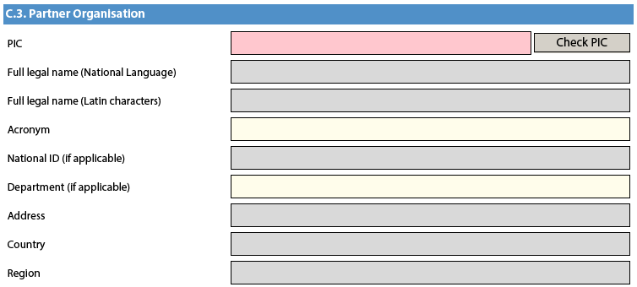

Partner organisations can be removed by pressing the button "Remove Partner" located at the end of the last partner organisation:

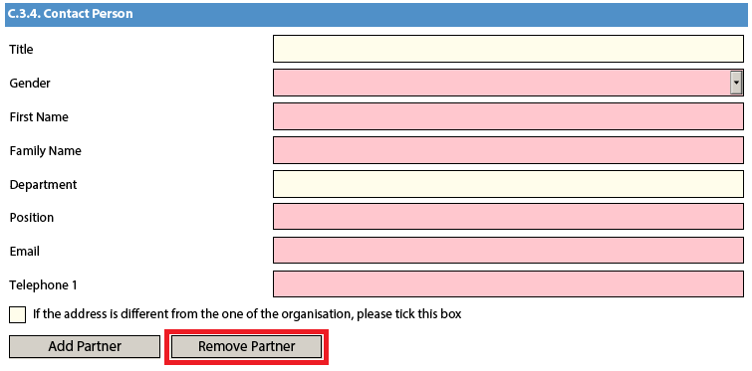

Please note that you can only add partners at the end of the already introduced partner sections, e.g. you cannot add partners between partners 2 and 3, if you have already included 3 partners.

Adding new entries in lists of values
You can add new entries by clicking a button. For example, the question about the list of topics that are most relevant to a given application:

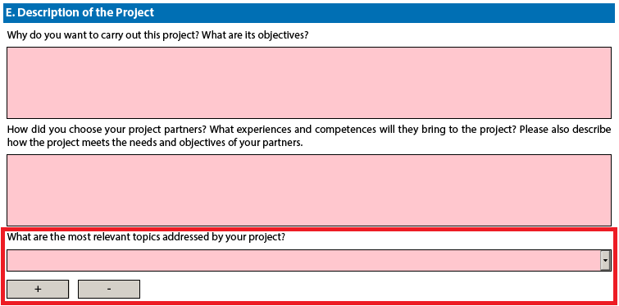

You should press the "+" button to add new entries or the "-" to delete existing ones. Please note that the question is compulsory, so once you add a new entry you will need to fill it in with one of the available options:

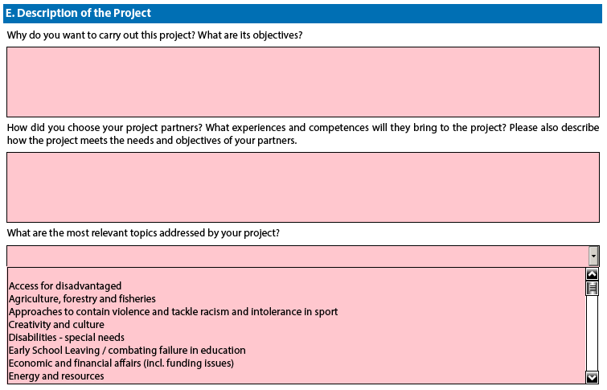
You can enter the same topic only once.

Filling in the budget section
The budget is one of the most important sections of your electronic application form. It is partly completed based on what you have entered before in the content related questions of the form.
More concretely, if you are preparing an application under "KA1 - Learning Mobility of Individuals", the "Activities' Details" section will be paramount. Note that this section is not applicable to the application form for Higher education student and staff mobility between Programme Countries under "KA1 - Learning Mobility of Individuals".
If you apply for a Strategic Partnership grant under "KA2 - Cooperation for innovation and the exchange of good practices", note that the sections "Participating Organisations", "Intellectual Outputs", "Multiplier Events" and "Learning/Teaching/Training Activities" will drive most of the information contained in the budget sections.
We will use an example of KA1 to illustrate the behaviour of the electronic application forms in detail.

Activities' Details
There are two types of mobility activities in the Erasmus+ Programme:
- Short duration mobility from 1 day to 2 months (60 days) depending on the activity type as specified in the eligibility rules in the Programme Guide.
- Long duration mobility from 2 months (61 days) to 12 months depending on the activity type as specified in the eligibility rules in the Programme Guide
Let's assume that you are preparing an application for "KA102 - VET learner and staff mobility" and you have the following scenario:

Mobility Activity Type | Origin | Destination | Duration | Total No. of Participants | Participants With special needs (out of total number of Participants) | Acc. Persons (out of total number of Participants)
VET learners in companies abroad | Austria | Belgium | 30 days | 4 | 2 | 1
VET learners in companies abroad | Austria | Portugal | 60 days | 6 | 3 | 1
Staff training abroad | Austria | France | 60 days | 5 | 0 | 0

The first step is to create the needed activities for both types mentioned above: "VET learners in companies abroad" and "Staff training abroad". You start with the first two flows that will cater for the "VET learners in companies abroad" type:

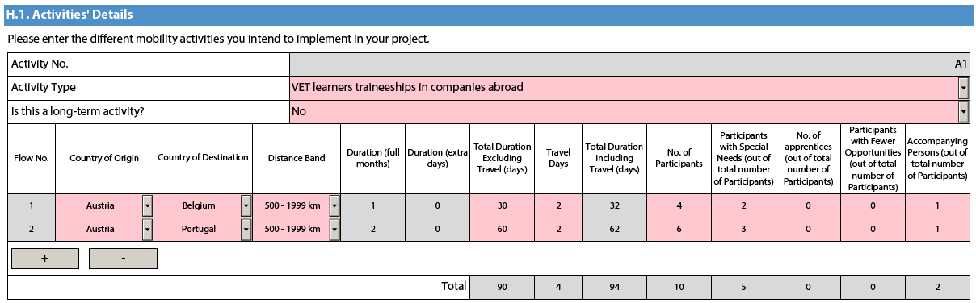

The first activity will cater for the 4 participants going to Belgium for 30 days and the remaining 6 participants going to Portugal for 60 days. Please note that column "No. of Participants" refers to the total number of persons within the flow which also includes participants with special needs, accompanying persons, etc. The different destinations and flow durations are handled by breaking down the total number of participants in the activity into two different flows. In the given example, all flows include two additional days accommodating the travel time to and from both destinations.

Accompanying persons are only allowed for learner mobility activities. In our example this corresponds to activity type "VET learners in companies abroad". Please also bear in mind that accompanying persons are not allowed for staff mobility activities.
Finally, you have to create a new activity to cater for the flow for all other relevant staff participants that are going from Austria to France for 60 days:

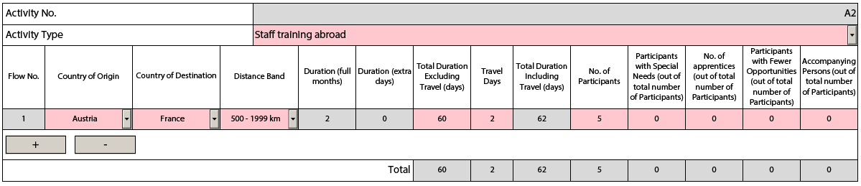

Completing the Budget
Now that you have entered the needed activities and other relevant information, it's time to look into the budget section where the funds needed to support your project are to be specified.
One of the most important principles of Erasmus+ is the wide use of unit cost based grant items. In the case of unit costs, you do not have to calculate the real cost of expenses, but indicate the number of units (number of days or number of participants) for a given grant item; based on that number, the form then calculates automatically the grant amount that can be requested, multiplying the number of units with the unit cost concerned. You can find all information in the Programme Guide to verify the type of costs eligible under each grant item, the unit cost levels and rules of allocation.
When filling in an application form for KA2, it also very important to bear in mind that each project activity must be assigned to a specific organisation in order for the grant to be calculated correctly. This means that if you enter activities but don’t state which participating organisations will implement them, they will not appear in the budget section.

Travel
The first section you need to check is "Travel". The electronic form should have fetched the proper travel grant per participant depending on the correct distance band entered for each of the previously created flows.
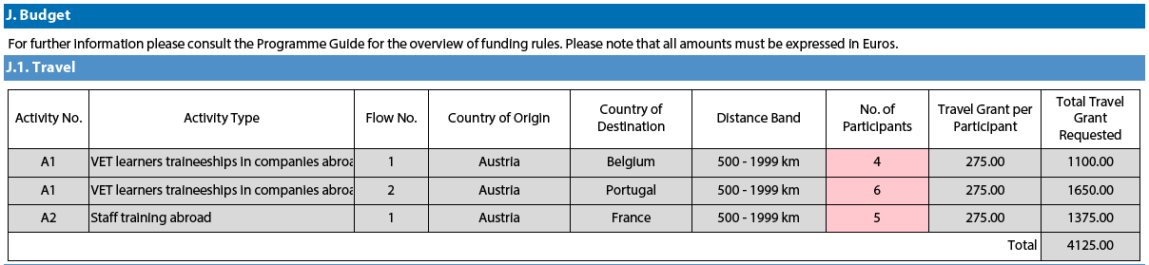
Some participants may not need to receive a grant for travel purposes. In that case you can decrease the No. of Participants and fund less than the total number of participants indicated previously:
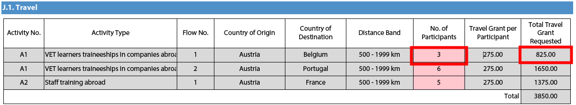
In order to select the correct distance band, you need to get the distance calculated by the web tool that you can access via this hyperlink:
http://ec.europa.eu/programmes/erasmus-plus/tools/distance_en.htm

With this tool you can enter the Origin and Destination cities in two given countries and get the calculation of the distance in one direction. On the basis of this information you have to select the corresponding distance band. If the participant needs to go to a farther city to get to his/her final destination (to reach the airport for example) it is possible to take this city as departure point.
The distance band chosen will determine the grant amount available for that distance, as specified in the Erasmus+ Programme Guide. You only need to enter the distance band: the correct grant amount corresponding to the distance band is completed automatically.

Nota bene: When calculating the actual distance you should fill in only the distance from the place of origin to the place of destination and not both ways. The unit cost is calculated on the basis of one way distance; however, the related grant is a contribution to the expenses for travelling in both directions.

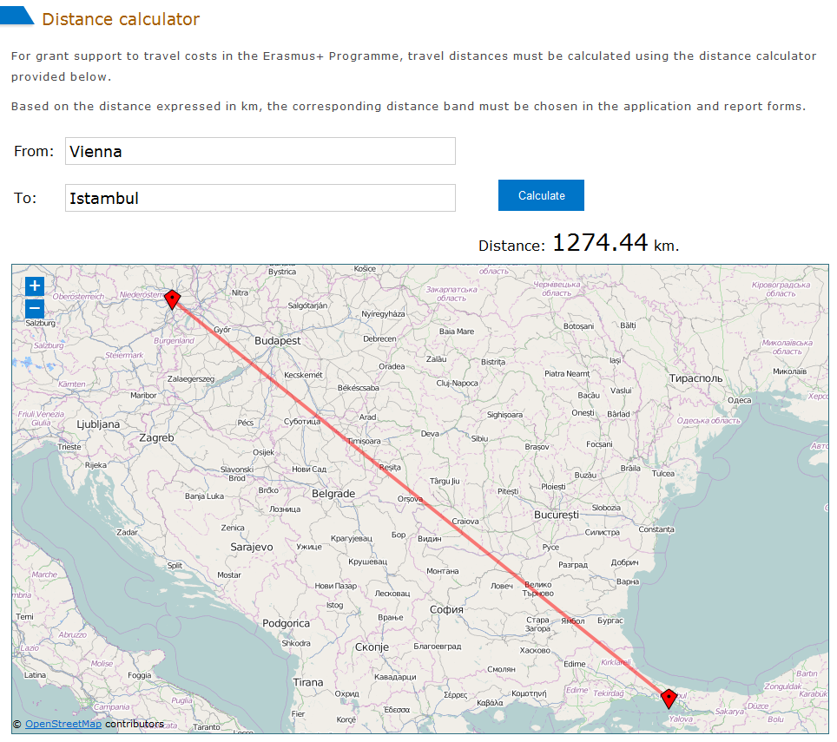

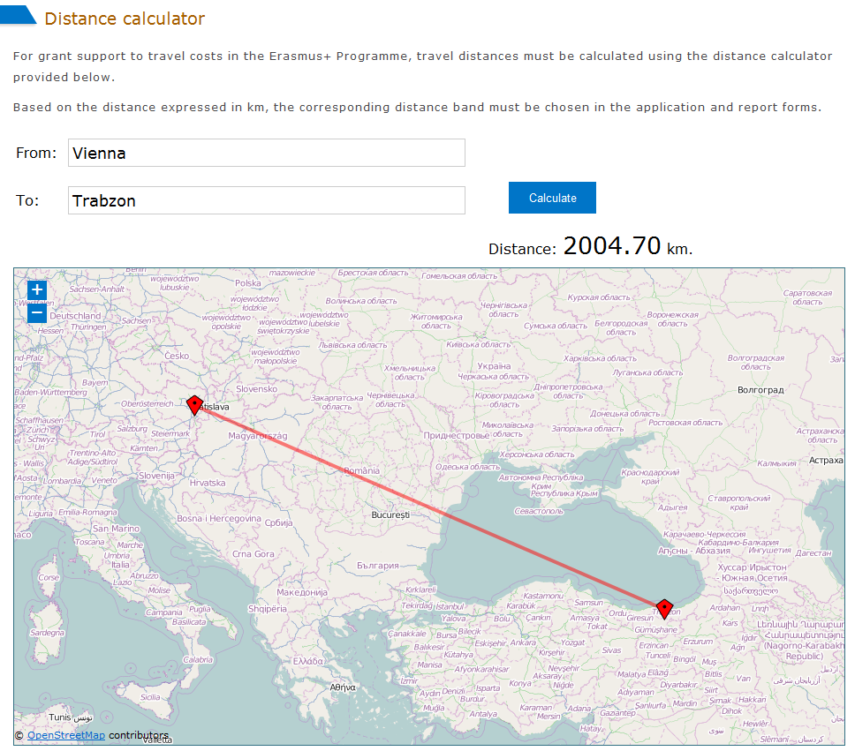

The distance band calculator calculates actual distance. As a consequence, you may get a situation whereby travelling from one country to another may result in the use of different distance bands depending on the actual place of origin and arrival for each mobility. In such cases, you can, if you wish, create several flows with the same Countries of Origin and Destination in order to get the breakdown that you will need to indicate different distance bands in the budget section.

If for example, you have two groups of participants both going from Wien, Austria to two different cities in Turkey that are quite distant from each other like Istanbul and Trabzon, you use this approach to request the right travel grant for both groups of participants:

Origin | Destination | Distance (from Distance Calculator Web Tool) | Corresponding Distance Band | Travel Grant per Participant
Vienna, Austria | Istanbul, Turkey | 1274 km | Band [500 – 1999] km | 275€
Vienna, Austria | Trabzon, Turkey | 2004 km | Band [2000 – 2999] km | 360€

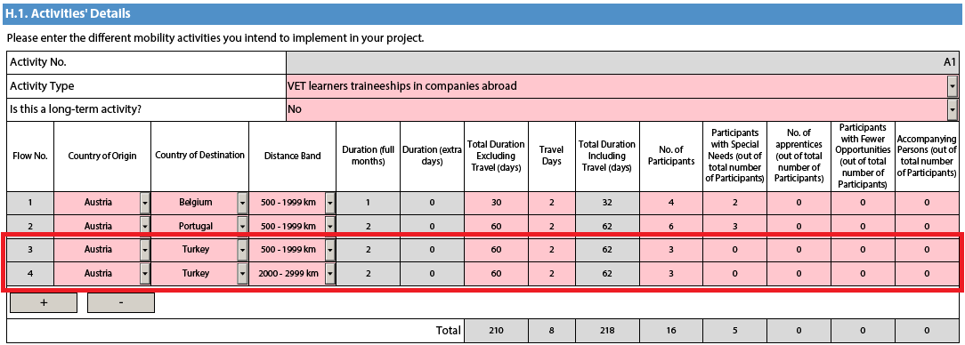
This approach will allow you, in the budget section, to specify a different distance band for the two different groups of participants, even if they share the same Origin and Destination countries:
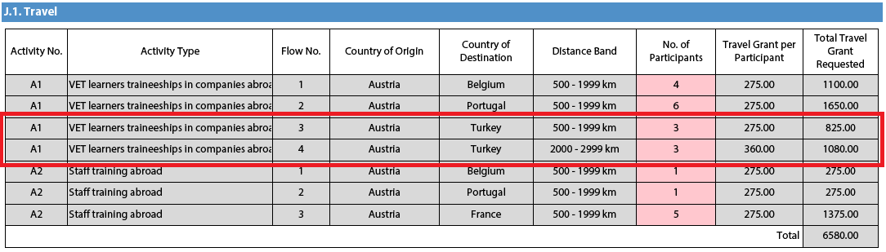
In the Country of Origin you should specify the country from which the participants will travel, i.e. the country in which the sending organisation is based.

When applying for a structured course for School education staff mobility or Adult education staff mobility, it is possible that the exact distance cannot be specified at application stage. The sending institution might have a realistic idea about the place of destination but in case it doesn't, the average distance for the chosen country should be inserted. At final report stage, the actual final destination will have to be used to select the correct distance band.

Individual Support
Some cells in the budget tables do not require you to enter any values. This is because the information you have entered before in the Activities' Details section allows the electronic form to calculate automatically the grant amounts that you can request. Please note that here you can request funding for a lower number of participants by changing the units which in this case are the number of participants (excluding accompanying persons) and the number of accompanying persons. The budget section Individual Support is one such example as you can see below:
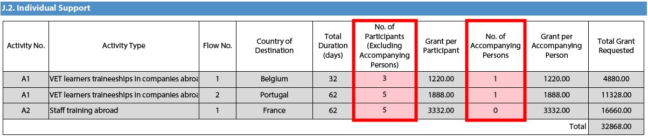

Normal Participants vs Accompanying Persons
Sometimes the accompanying persons stay for a shorter period than the normal participants. If this is the case, you can encode this scenario by creating a new flow in the same activity in the "activities' details" section with the same origin and destination country:
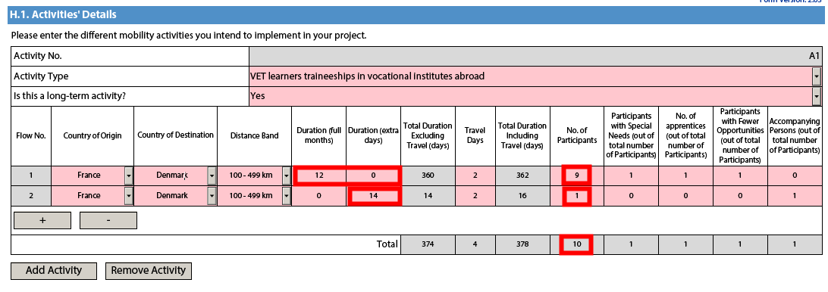
In the budget section, each flow will get a different individual support amount with a Normal Participant getting the amount specified for it and an Accompanying Person the amount configured for a Staff participant:
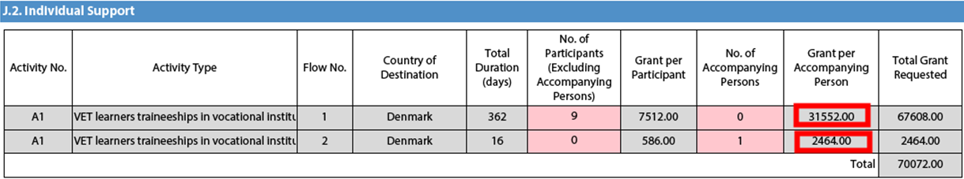

Special Needs Support
This budget section is different from the ones mentioned above because here the electronic form will not perform any automatic calculations. You will therefore have to indicate the additional amount you wish to receive as a grant for those mobility activities that include participants with special needs. Please note that "participants with special needs" refers exclusively to persons with disabilities as specified in the Erasmus+ Programme Guide. The number of participants indicated per activity cannot exceed the total number of participants with special needs mentioned in Activities' Details section.

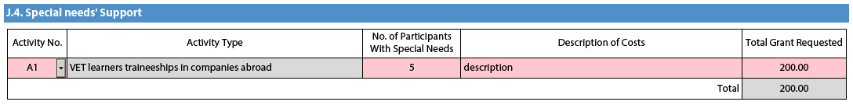

Nota bene: As regards special needs support for Strategic Partnerships, it concerns any additional costs related to involvement of participants with special needs, i.e. it is not limited to additional costs of persons with special needs taking part only in teaching/training/learning activities.

Budget Summary
The budget summary will give you a complete overview of your project's budget, broken down per activity and per budget section:

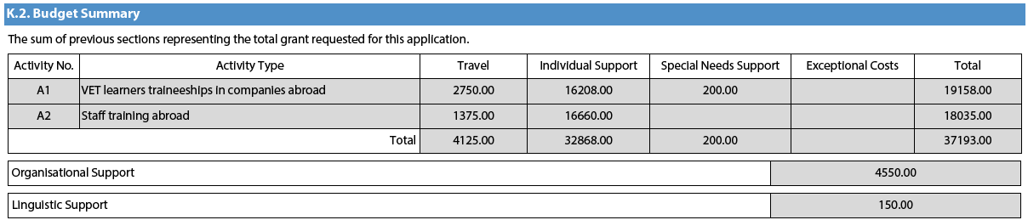
The values shown in the Budget Summary are calculated automatically on the basis of the values calculated and/or entered in the detailed budget sections. Any corrections (for example because you forgot to introduce a certain grant request) have to be made in the detailed budget sections, not in the Budget Summary. Please note that in the above given example Organisational Support and Linguistic support are also shown for completeness reasons.

Project Total Grant
Finally, the electronic form will show you the total calculated grant requested in your application form:

Checklist
After you have completed the application form but before you validate it and submit it to the National Agency, it is highly recommended that you check the points listed in the Checklist to make sure that your application fulfils all basic requirements.

Please note that in KA1 mobility project applications, the attachment of mandates for each partner organisation is required only for applications in the youth field and for partner organisations in national consortia in school education, higher education, vocational education and training and adult education.

In case you are applying for a grant exceeding 60.000 EUR and your organisation is not a public body or an international organisation, you must have uploaded the required documents to give proof of your financial capacity in the Participants' Portal where you registered your organisation. These documents must be available to your National Agency at the latest before signing the grant agreement in case your project is selected.
Concerning the attachment of supporting documents, you should only attach the documents that are required for the type of organisation in question. For further reference, please check the national requirements that your National Agency may have set and the applicable rules for your type of organisation.

Validating a form
In order to ensure correctness of the data entered into the form, the electronic application form will apply the relevant Erasmus+ rules as much as possible. The following non-exhaustive list shows the major types of validations carried out:

Compulsory fields
If you do not enter an answer in a compulsory field, you will not be able to submit your application, and the electronic form will ask you to enter the missing information.

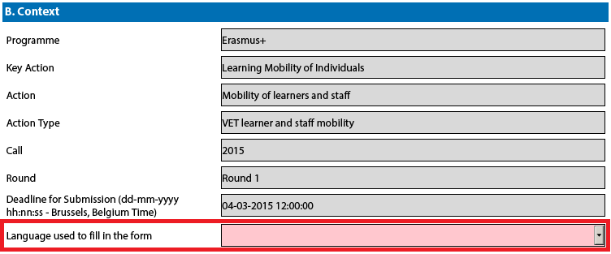

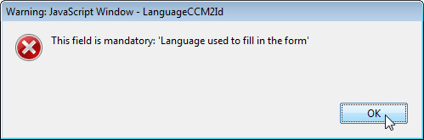

Duplicated PICs in participating organisations
Once a PIC is used for one of the participating organisations, the same PIC cannot be used for another organisation.

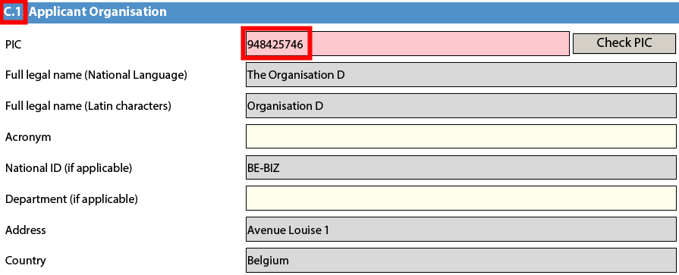
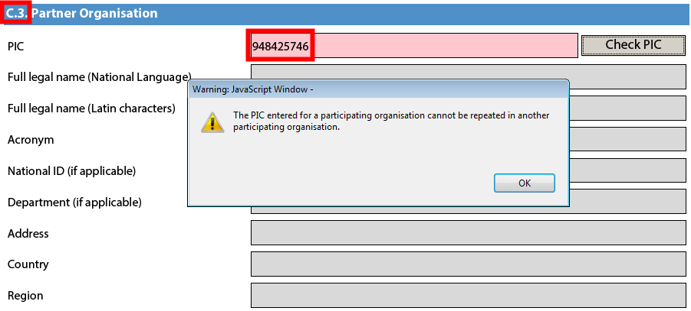

Double entries in lists
If you are confronted with a closed question asking you to select one or more items from a list, you cannot choose the same entry twice.

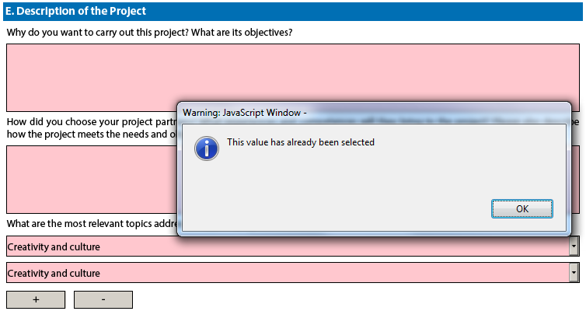

Invalid flow duration given activity type
Each flow within an activity type is constrained by several rules that guarantee the respect of the eligible duration per type of activity.

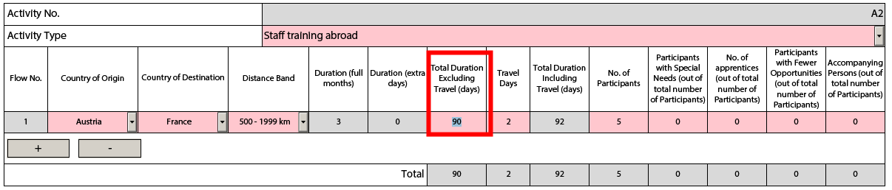
If you enter a duration that is under the minimum or above the maximum allowed, the form will not be valid.

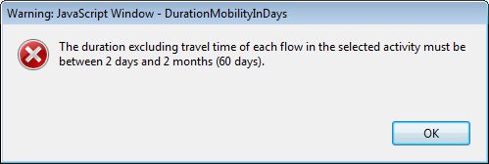

You will also not see any grant amounts in the budget section for such an activity.

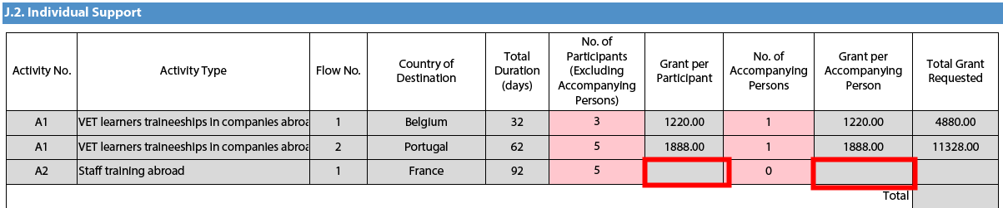
If any such issue is present in a form, the validation process will detect it and redirect you to the question where the issue was identified. You should correct your input and validate the form again.

This process needs to be repeated until all validation rules are met and the form is in a validated status, at which moment you will see the following message:

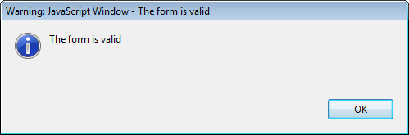

Annexing documents
You need to attach some files to your application.
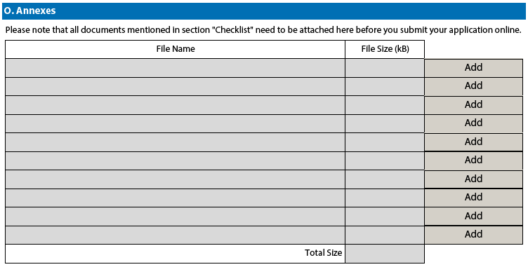
There are, however, constraints that need to be observed, such as the allowed number of attachments, the file types used and the total size of all attached files.
The allowed number of attachments is constrained by the number of rows in the above table to a maximum of 10 files.
Concerning the attachment of mandates to the applicant organisation, the documents should be scanned together with the Declaration of Honour in a single file. The file types allowed are the following:

- PDF
- DOC (a pre-2007 word document)
- DOCX (a post-2007 word document)
- XLS (a pre-2007 excel file)
- XLSX (a post-2007 excel file)
- JPG (an image file in jpeg format)
- TXT (a text document)
- ODT (open office word processor document)
- ODS (open office spreadsheet document)
You can use a maximum of 5120 kB for all your attachments, meaning that you can have files of different sizes as long as their total combined size does not exceed this limit.
If you need to attach a lot of documents to your electronic application form, you should scan, group and attach them so that they fit the 10 available slots for annexes. An example of this case would be the participating organisations' mandates. In this example you can perfectly well group all scanned mandates into a single PDF file and attach it to the form.

Annexing a Declaration of Honour
One of the files you are required to annex to your application form is a duly signed Declaration of Honour, partially depicted here:
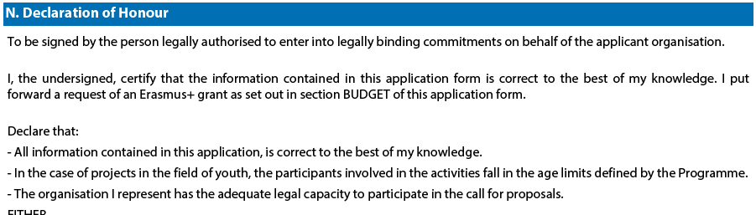
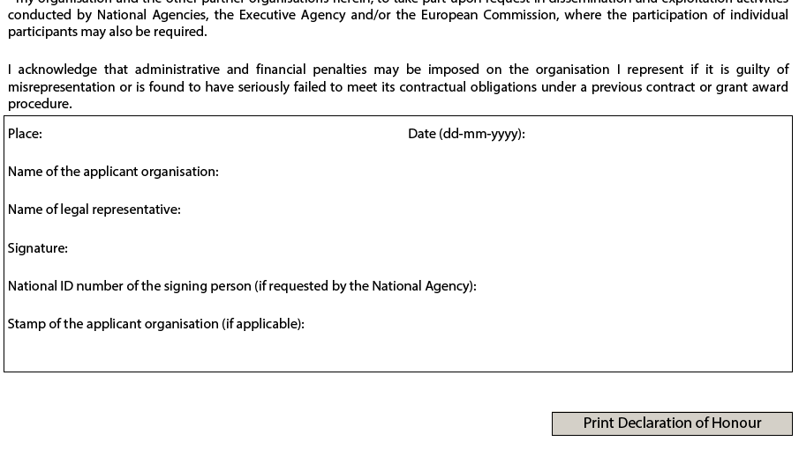To do so you first need to print it. This can be done by using the "Print Declaration of Honour" button as illustrated above. You must then have it signed by the person who is legally authorised to represent your organisation.

For mobility project applications, the attachment of mandates for each partner organisation is required only for applications in the youth field and for partner organisations in national consortia in the fields of school education, higher education, vocational education and training, and adult education.

Finally, you must scan the signed document to a PDF or JPG format so that you can attach it to your electronic application form. In case mandates from the partner organisations are required (see "Checklist" above) you are advised to scan them together with the Declaration of Honour to limit the number of annexes to the form. The final result should be somewhat like the one depicted below with your own filename specified:

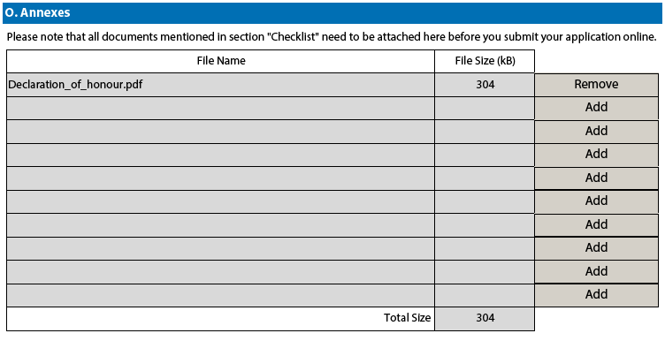

Submitting a form
After you have validated and annexed all documents needed to your electronic application form you are ready to submit it to your National Agency.
Different application deadlines will apply depending on the "Call", "Action Type" and the "Round" (where applicable) that you are applying for.
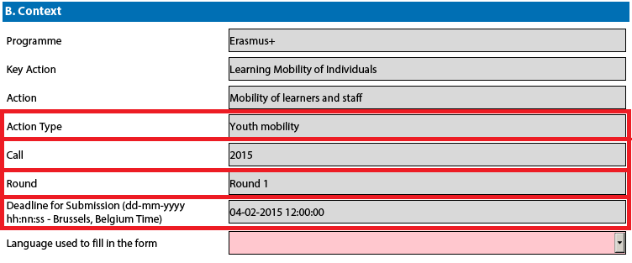
Because there are several rounds within a call for Youth action types, please make sure that you respect the deadline for the specific round that you are applying to (see Programme Guide for details on deadlines).
The submission of an electronic application form is done in the "Submission" section:
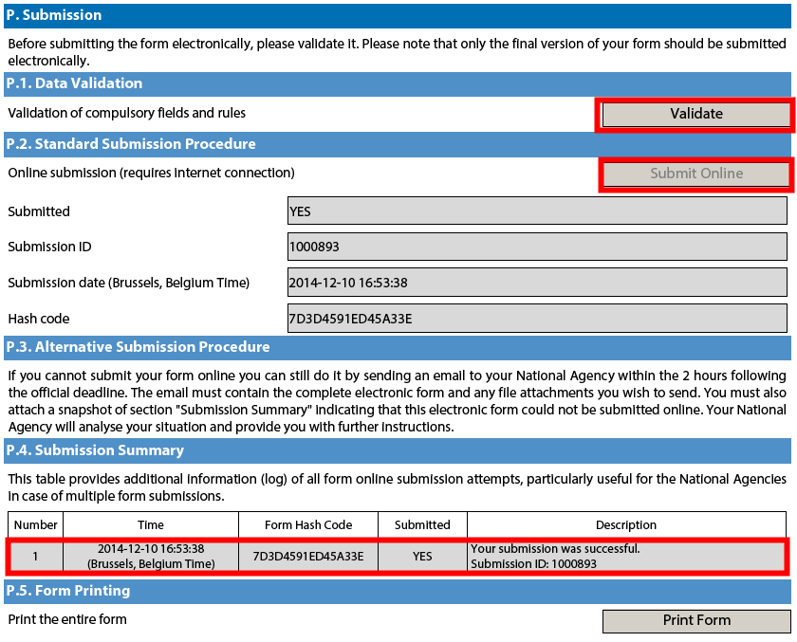
You should first make sure you have a valid application form by pressing the "Validate" button one last time.
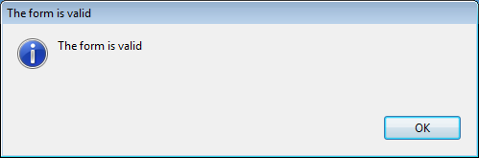
If everything is correctly filled in you can press the "Submit" button to have your electronic application sent to your National Agency. If all goes well, you will see the following screen:
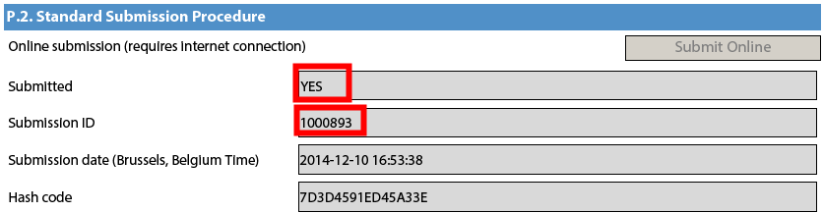
Let's look at each of these fields in order to understand their meaning and use:
- The "Submitted" column indicates if the submission was successful. A "YES" indicates a successful outcome.
- The "Submission ID" is an identifier returned automatically by the European Commission IT servers that uniquely identifies your specific submission. If you submit again you will get a new identifier.
- The "Submission Date" is the date and time at which your application was received by the European Commission IT servers. It is therefore specified in Brussels time as will be explained later in this chapter.
- Finally, the "Hash Code" is a code automatically generated by the electronic form to monitor changes in the contents of your form. Every time you change something in the form and save it, a new hash code is generated to reflect the changes. In this way you and your National Agency can quickly spot if there are content changes from one form submission to another and take the necessary actions.
Applications must be submitted to the National Agency only online. You don't have to send a printed version of the application, nor of the attachments. The print option is intended for your own use.

Submitting more than once
After you have submitted your form, the "Submit" button will no longer be available:
However, you can resubmit your form if you have found a problem with its contents and provided that you have detected the problem before the deadline for submission. In order to be able to submit again you need to save the form, close and reopen it:
The form will keep track of all your submissions and their status in the table "Submission summary":
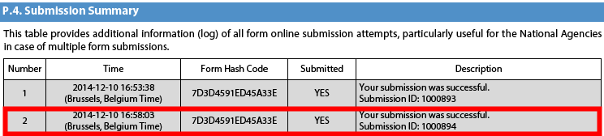
The "Time" column shows you the date and time at which you have submitted your form according to the Brussels time zone.

Late submission of the application
If you miss the official application deadlines you will not be able to apply. However, an exception is made if you can prove that you tried to apply before the official application deadline and were not able to do so due to technical reasons.
In the latter case, your National Agency may still consider your application, if all three conditions listed below are met:
- The date and time of your last submission attempt as mentioned in the electronic application form "Submission Summary" section are before the applicable official application deadline.
- You have informed your National Agency within 2 hours after the application deadline (Brussels time!). After this time, your application can no longer be considered.
- You have sent to your National Agency within 2 hours after the application deadline (Brussels time!), by email, your complete application form unmodified after your submission attempt.

Specific guidelines concerning the different Erasmus+ action types
The following section will emphasise certain specific characteristics of the application forms for KA1, KA2 and KA3 and the respective Action types.

Nota bene: the quality of your application will be assessed against the award criteria specified in the Programme Guide. Please make sure that in your application you provide all the necessary information that will allow experts to assess all elements of analysis of each award criterion. If you want more information on how experts will assess the award criteria, please consult the Erasmus+ Guide for Experts, which is available at the Erasmus+ website at http://ec.europa.eu/programmes/erasmus-plus/.

Please note that for higher education, applications for Mobility of learners and staff do not undergo quality assessment, as this has already taken place through the award of the Erasmus Charter for Higher Education;

Application forms for Accreditation

KA108 - Accreditation of Higher Education Mobility Consortia

Accreditation Section
For each of the higher education institutions holders of the ECHE that are either the applicant or members of the mobility consortium, the accreditation type is set to "Erasmus Charter for Higher Education (ERASPLUS-ECHE)" and the corresponding Erasmus Code of the HEI related to the PIC is prefilled as the accreditation reference on the right side (e.g. A WIEN01). This field is editable in case you consider that the Erasmus Code is not the correct one.

For organisations other than higher education institutions (i.e., non-holder of the ECHE) that are either the applicant or members of the mobility consortium, the accreditation type is also displayed as "Erasmus Charter for Higher Education (ERASPLUS-ECHE)" but the accreditation reference field on the right side is empty. In this case, you need to put "Not applicable" in the accreditation reference field. The field cannot be left empty.

Background and Experience Section
In contrast to the call 2014 application form, for each of the higher education institutions that are either the applicant or members of the consortium, the Background and Experience section is also displayed so that information relevant for the consortium can be entered. The information related to individual HEIs complements general information entered in the Section E.

Application forms for Mobility of learners and staff under KA1: Learning Mobility of Individuals

KA101 - School education staff mobility
Context Section
Mobility projects in school education should have as project start date the 1st June 2015 and can last for one or two years.

Partner Organisation Section
Depending on the characteristics of the Mobility project, there is a possibility of filling in information about your partner organisations in the Partner Organisation section.
In the case of school education and adult education, the receiving partner organisations may be identified in the application form, but this is not obligatory, even in the case of job shadowing and teaching assignments as specified in the Programme Guide. This is, however, possible and thus the application form allows for adding partner organisations. If the application is submitted by a national consortium, please provide details of each organisation taking part in the consortium.

European Development Plan Section
In the application form for School education staff mobility, there is a section called European Development Plan. This section requires specific information about the organisation's needs, plan for European mobility and the integration of acquired competences and knowledge by staff into the strategic development of the organisation. Moreover, an additional question concerning the use of the eTwinning platform should be answered when completing the form for School education staff mobility.

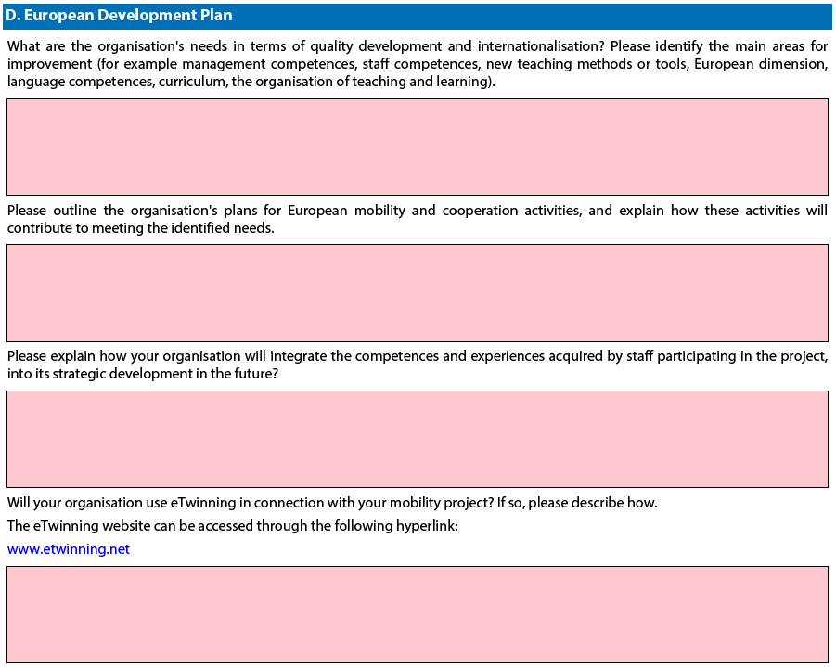

Follow-up Section
In the 'Follow-up' section you should provide information on the expected impact of your Mobility project, as well as dissemination and evaluation activities.

When describing the expected impact, applicants should include estimation in terms of quantity, i.e. how many people the organisation intends to reach through implementing the project.
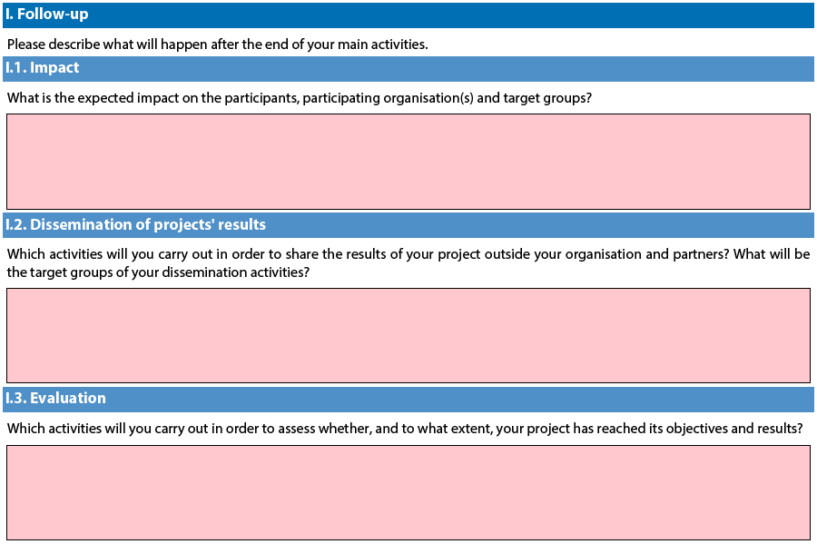

KA102 - VET learner and staff mobility

Context Section
Mobility projects in vocational education and training should have as project start date the 1st June 2015 and can last for one or two years.

Partner Organisation Section
Depending on the characteristics of the Mobility project, there is a possibility of filling in information about your partner organisations in the Partner Organisation section.
In the case of VET learner and staff mobility, if the application is made by a national consortium, please provide details of each sending organisation taking part in the consortium. In addition, applications should also mention at least one host organisation in the application. It is advisable to provide as many details as possible about the host organisations that you intend to use to show the scope of your project and the intended training activities as fully as possible.

European Development Plan Section
In the application form for VET mobility there is a section called European Development Plan. This section requires specific information about the organisation's needs, plan for European mobility and the integration of acquired competences and knowledge by staff into the strategic development of the organisation.
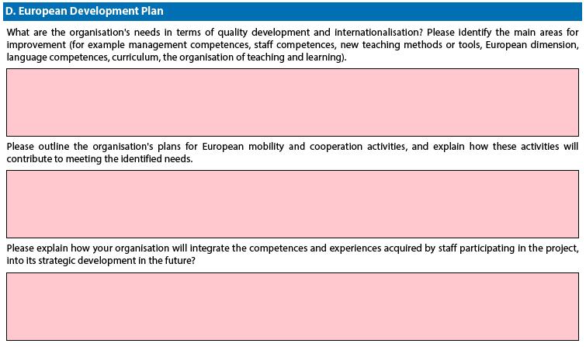

Follow-up Section
In the 'Follow-up' section you should provide information on the expected impact of your Mobility project, as well as dissemination and evaluation activities.
When describing the expected impact, applicants should include an estimate in terms of quantity – how many people the organisation intends to reach through implementing the project.
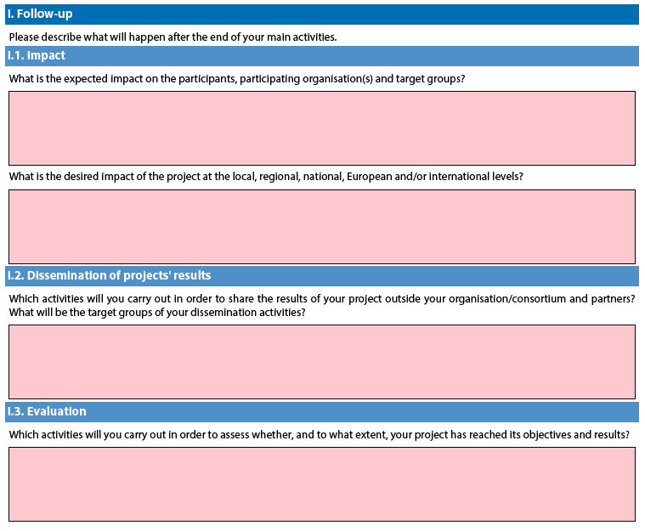
Budget Section – Linguistic Support Caveat
Linguistic Support is allowed for VET for mobility durations of at least 30 days excluding travel. However, in the e-Form, the Linguistic Support section is shown or hidden depending on the duration with travel. For flows of a duration of less than 30 days (as shown below) the applicant is not be entitled to Linguistic Support:

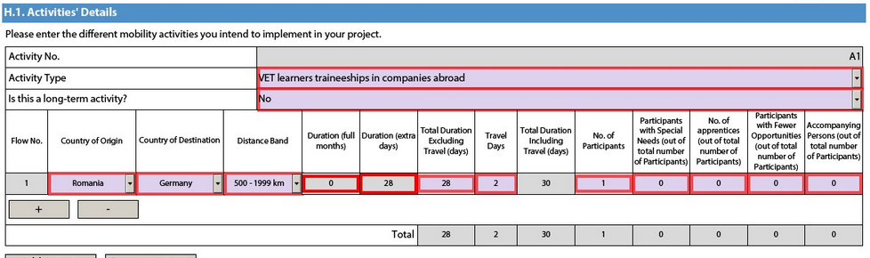
In that case the applicant should fill in the Linguistic Support section as follows:

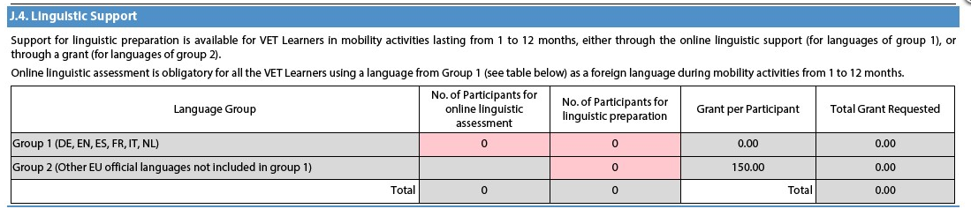

KA103 - Higher education student and staff mobility within Programme Countries

Context Section
Mobility projects in higher education should have as project start date the 1st June 2015. The project end date should be as follows: 30th September 2016 for a project of 16 months and 31st May 2017 for a project of 24 months.

Partner Organisation Section
For the KA103 mobility project type, no partner organisations are added in the Partner Organisation section.

In the case of national mobility consortia for Higher education student and staff mobility, the coordinator of the consortium applies on behalf of the whole consortium. The partner organisations members of the consortium do not need to be mentioned as they are already described in the accreditation application form (KA108).

Profile Section
If the Type of Organisation is prefilled with "Other", the correct organisation type should be selected from the list, e.g. "Higher education institution (tertiary level)" for HEIs.

Accreditation Section
Application from a single higher education institution (HEI): the field Accreditation Type is preset with "Erasmus Charter for Higher Education (ERASPLUS-ECHE)" and the Erasmus Code associated to the PIC of the HEI (e.g. A WIEN01) is prefilled on the right side. This field is editable in case you consider that the Erasmus Code is not the correct one.

Application from the coordinator of a mobility consortium: you must choose Yes in the Consortium section which presets the field Accreditation Type with "Higher Education Mobility Consortium Certificate (ERAPLUS-ERA-CONSORTIA)". If the accreditation reference number is not known at application stage, you should write "requested" in the free text field asking for the accreditation reference (in this case the consortium should submit in parallel an application for the accreditation of the consortium).

Main Activities Section
You should specify the number of mobilities to be funded from EU funding. In case you foresee a certain number of additional mobilities as "zero-grants" (funded from other sources of funding than the Erasmus+ Programme), this should be specified in an annex attached to the application form. This number will be used by the NA to estimate the budget for the organisational support grant. The annex should specify the following numbers of "zero-grant" participants: Requested / Estimated (2014/15) / Actual (2013/14).

Applicants on behalf of a mobility consortium should enter information on requested and former mobility activities based on the whole consortium. If the consortium was active under the Lifelong Learning Programme (LLP), it should indicate the past number of traineeships (work placements). If the consortium is new (without any prior experience from LLP Placement Consortia) the numbers for previous years should be zero.

Contrary to the 2014 application form, instead of the average duration of a mobility, you must enter the total duration of all requested/estimated/actual student mobility periods in full months and extra days and of all requested/estimated/actual staff mobility periods in days.

KA104 - Adult education staff mobility

Context Section
Mobility projects in adult education should have as project start date the 1st June 2015 and can last for one or two years.

Partner Organisation Section
Depending on the characteristics of the Mobility project, there is a possibility of filling in information about your partner organisations in the Partner Organisation section.
In the case of adult education, the receiving partner organisations may be identified in the application form, but this is not obligatory, even in the case of job shadowing and teaching assignments as specified in the Programme Guide. This is, however, possible and thus the application form allows for adding partner organisations.. If the application is submitted by a national consortium, please provide details of each organisation taking part in the consortium.

European Development Plan Section
In the application form for Adult education staff mobility, there is a section called European Development Plan. This section requires specific information about the organisation's needs, plan for European mobility and the integration of acquired competences and knowledge by staff into the strategic development of the organisation.

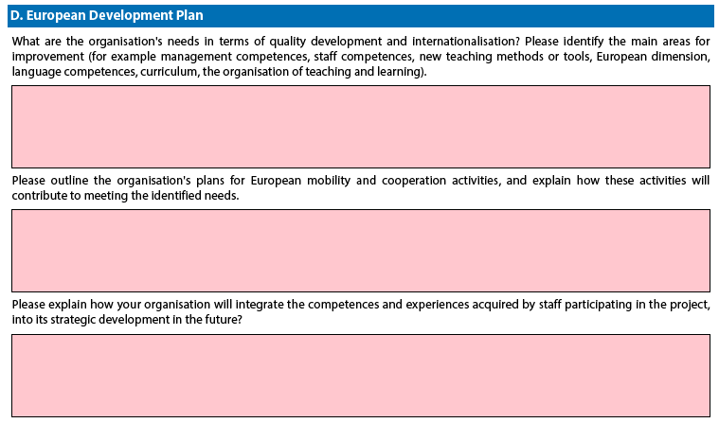

Follow-up Section
In the 'Follow-up' section you should provide information on the expected impact of your Mobility project, as well as dissemination and evaluation activities.

When describing the expected impact, applicants should include an estimate in terms of quantity – how many people the organisation intends to reach through implementing the project.
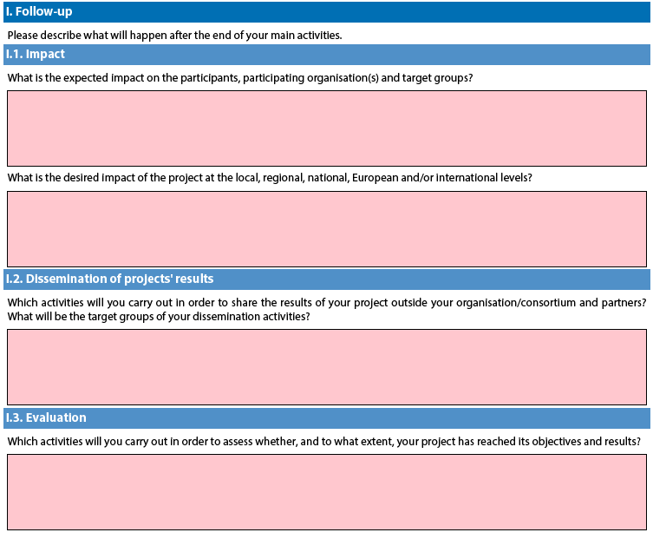

KA105 - Youth mobility
Application form in general
If you plan to organise several activities (Youth Exchanges, EVS, mobility of youth workers) within the same Youth mobility project, please keep in mind that there are often questions in the form where you need to provide information relating to all the activities planned in your project. In such cases, try as much as possible to do it in a structured way so that it is clear for which activity you are giving the information.

Context Section
There are three application rounds per year. For each year, please check the exact deadlines and project start/end dates in the Programme Guide.

Participating organisations Section
Accreditation Type – you can only choose one type of accreditation here "Accreditation of youth volunteering Organisations (ERAPLUS-EVS)". This is also valid for organisations accredited under the Youth in Action Programme.

Participants’ profile Section
For Youth Exchanges, please describe as precisely as possible the participants that will take part in each activity, including their age range.

Preparation Section
If your project will include young people with fewer opportunities, add information on the specificities related to the preparation, practical arrangements and project management.

In the case of Youth Exchanges and European Voluntary Service, please also describe under the preparation of the participants how your project will ensure the protection and safety of the young people involved.
If you plan any Advance Planning Visits, please specify to which activities they relate to.

Main Activities Section
In this part, you should also give information on how the participants will be actively involved in each stage of the project.

Activities' Details Section
Please create one table per Activity your plan to implement.
The start and end dates to be encoded are days where at least one activity is foreseen, you can then add up to 2 days for travel, if relevant. Please note that the eligible duration mentioned in the Programme Guide is the duration excluding travel days.

For Youth Exchanges, you need to give a number (1,2,3…) to each National Group in the activity.
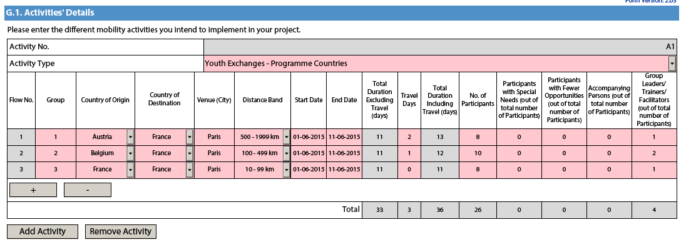
If needed, you can encode different flows for a given National Group as per the example below.
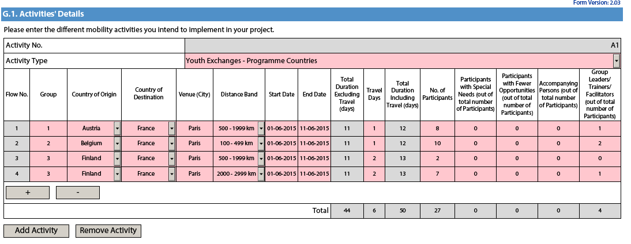

Follow-up Section
In the 'Follow-up' section you should provide information on the expected impact of your Mobility project, as well as dissemination and evaluation activities.

When describing the expected impact, applicants should include an estimation in terms of quantity – how many people the organisation intends to reach through implementing the project.

Annexing documents – Timetables of activities
If you plan to organise several activities (Youth Exchanges, EVS, mobility of youth workers) within the same Youth mobility project, you need to: 1) fill-in a timetable for each activity, 2) print and group all the activity tables in one document, 3) scan the single document and attach it. In this way you can fit with available slots for annexes. The same procedure must be followed for attaching the mandates of participating organisations involved in the project.

KA107 - Higher education student and staff mobility between Programme and Partner Countries

Accreditation Section
If you are applying on behalf of a consortium, you will be asked to introduce the reference of your ERAPLUS-ERA-CONSORTIA Higher Education Mobility Consortium Certificate. If you do not have this certificate yet, you will be able to indicate that you have applied for it.

Main Activities Section
You will be asked to enter the different outgoing and incoming mobility activities for each of the Partner Countries with which you intend to cooperate. If you choose “incoming”, the country of destination will be automatically prefilled with your country.

When filling in the activity table, remember to indicate the TOTAL duration of each planned mobility flow for ALL participants. For example, if you send 2 members of staff from Sweden to Chile for 16 days each, in the activity table, you should indicate the TOTAL duration for both staff: 32 days (28 days + 4 days travel). The budget will then be calculated automatically.

Bear in mind that, due to limited budget availability, National Agencies may limit: i) mobility flows in (a) particular degree level(s) (for example limiting applications to one or two cycles only – first, second or third cycle): ii) mobility for staff only or students only, iii) the duration of mobility periods. Please consult your National Agency's website to find out if any of limitations apply: http://ec.europa.eu/programmes/erasmus-plus/tools/national-agencies/index_en.htm

If you know the city of origin and the city of the venue for all mobility activities in a flow and they are the same for all mobility activities in that flow, you will introduce the travel distance between those cities; if there are several cities of origin and/or venue in a flow, you will introduce the average of the different travel distances. If the city of origin or the city of the venue is not yet known, you will introduce the travel distance from/to the capital of that country. Please use the distance calculator available here: http://ec.europa.eu/programmes/erasmus-plus/tools/distance_en.htm

Quality Questions Section
The name of the Partner Countries indicated in the “Activities’ details” table will appear automatically in the “Quality Questions” section. For each of these Partner Countries, the applicant organisation will be asked to answer four questions relating to i) the relevance of the strategy, ii) the quality of the cooperation arrangements, iii) the quality of project design and implementation and iv) its impact and dissemination. The names of the higher education institutions in each partner country, with which the applicant will organise mobility, should be indicated in the answer to the first qualitative question (relating to relevance). This section is crucially important as it will determine which projects will ultimately be selected.

Application forms for Strategic Partnerships under KA2: Cooperation for innovation and exchange of good practices
When filling-in an application form for a Strategic Partnership you should choose the relevant eForm according to the field in which you will be implementing your project. If you are interested in implementing a Strategic Partnership concerning several fields, you should choose the eForm relevant to the field at which your project will have most impact on. If you are applying for a project in the field of school education, you should also choose appropriately between the eForm provided for projects which involve only schools and the eForm for all other Strategic Partnerships in the field of school education.

Context Section
For Strategic Partnerships in education and training, there is only one selection round per year. For Strategic Partnerships in the youth field, there are three selection rounds.
For Strategic Partnerships in education and training, applicants have to submit their grant application by:
- 31 March at 12pm (midday Brussels time) for projects starting between 1 September and 31 December 2015:
For Strategic Partnerships in the youth field, applicants have to submit their grant application by:
- 4 February 2015 at 12pm (midday Brussels time) for projects starting between 1 June and 30 September of the same year;
- 30 April at 12pm (midday Brussels time) for projects starting between 1 September of the same year and 31 December of the same year;
- 1 October at 12pm (midday Brussels time) for projects starting between 1 January and 31 May of the following year.
Strategic Partnerships in the youth field can last between 6 and 36 months, while other types of Strategic Partnerships can last between 24 and 36 months. In all cases, projects must end not later than 31 August 2018.

Priorities Section
Please note that in this part of the application form you can select compulsorily one main priority (either horizontal or sector specific). Optionally, you can select two additional priorities (either horizontal or sector specific) relevant to the objectives of your project.

Regardless of the chosen priorities, the whole project application should be relevant to the chosen field, (as specified in page 1 of the Form).
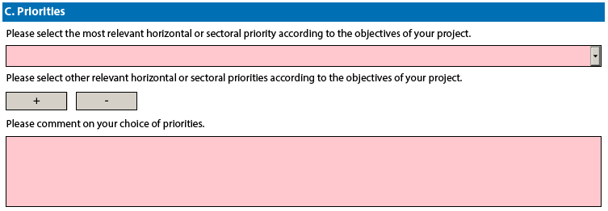
Please note that if you try to add more than two other relevant horizontal or sectoral priorities, the application form will not allow you to do so as shown on the screen below:
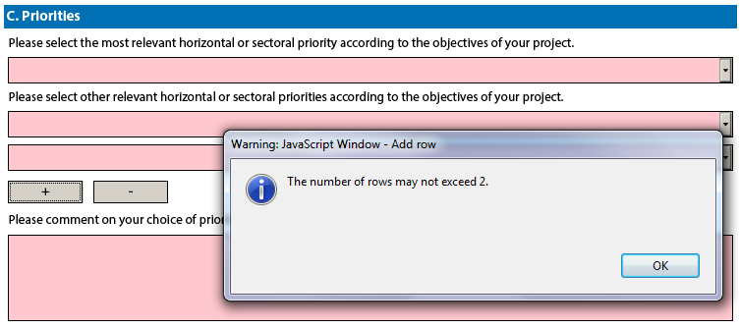

Participating organisation(s) Section
School education
Please note that if you are applying for a partnership between Local or Regional authorities, all participant organisations need to be entered in the application form. The proposed partnership needs to include at least three organisations from each of the countries involved, with the following breakdown: at least one Local or Regional Authority per country, at least one school per country, and at least one other organisation active in the field education, training and youth or in the labour market per country. In addition to that, at least two Programme Countries (therefore at least six organisations) must be involved.

If your project is unable to meet such criteria, the project may still be submitted as a standard Strategic Partnership in the field of school education in case there were at least 3 participating organisations from 3 different Programme Countries involved. In this case you should select "No" in the field for "Partnership between regions" of the form in order to validly submit your application.

Nota bene: Local and Regional Authorities may also take part in Strategic Partnerships of the standard format. In that case the minimum membership of three organisations from three Programme countries applies.

Description of the Project Section
Please note that you can select maximum three topics in this part of the application form.
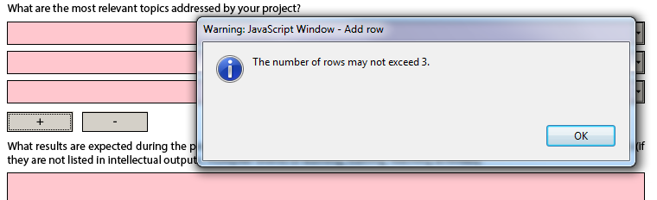

Implementation Section
It is of utmost importance that you provide as detailed information as possible concerning the project activities. The section on implementation of the project is the core element of the application and particular attention should be drawn to it. You should also clearly state the role of each project partner, especially in case you do not plan the production of Intellectual Outputs and the organisation of Multiplier Events.
For Strategic Partnerships in the youth field, if you plan a Transnational Youth Initiative and do not foresee the production of Intellectual Outputs, please give detailed information on your project and the activities you plan to implement under the question "Please elaborate on the methodology you intend to apply in your project. Please also provide detailed information about the project activities that you will carry out with the support of the grant requested under the item "Project Management and Implementation".

In this section of the application form, you will have to first select whether or not your project will include intellectual outputs. If you choose "No" you will only have to provide information on the activities that your project will organise and the methods you intend to use. If you choose "Yes" you will have to provide information about the project activities you will support under the "Project Management and Implementation" budget item and in addition you will have to describe the intellectual output(s) your project will produce.

Intellectual Outputs Section
As specified in the Programme Guide, the grant item Intellectual outputs aims at supporting the development of intellectual outputs/tangible deliverables such as curricula, pedagogical and youth work materials, Open Educational Resources, IT tools, etc. that are substantial in quality and quantity.
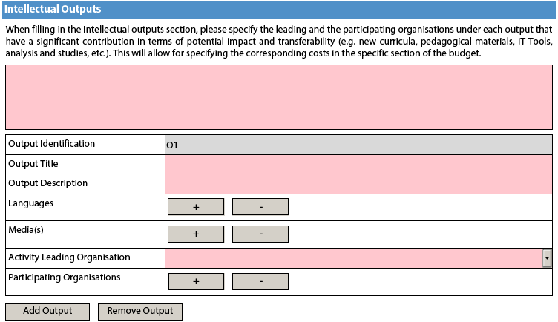

This grant item can therefore not be used to contribute to staff costs for activities already covered by the grant item "Project management and implementation", which will cover a wide variety of activities and smaller scale outputs of the project, including the tasks related to programme management. Therefore, additional staff costs for management and administrative support staff can only be applied for in the Budget section for Intellectual Outputs in exceptional and duly justified cases. The need for such additional costs must be well explained in the Project Activities section - Intellectual Outputs of the application form.

IMPORTANT! When including an Intellectual Output, please bear in mind that all activities related to its development should be well detailed and described in the main text box. This is the only section in the form from which the evaluators will judge the relevance and quality of your Intellectual Output.

When filling in the Intellectual Outputs section, you have to clearly specify the Leading and the participating organisations for each of the activities under each of the outputs; otherwise you will not have the possibility to specify the corresponding costs in the specific section of the Budget.

Please also note that you cannot insert new intellectual outputs between the outputs already introduced in your application form. So when filling in the form, make sure that you list the intellectual outputs in the logical order.

Multiplier Events Section
You can apply for grant support for Multiplier Events only if you intend to produce substantial Intellectual Outputs. For other dissemination activities, the support from the grant item "Project management and implementation" has to be used.

When describing a Multiplier event, you should indicate in the Event's description the country in which it is going to take place.
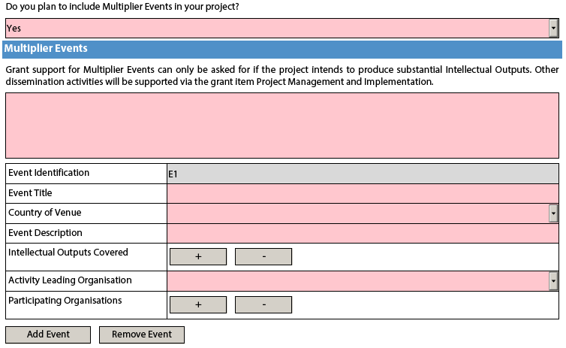

Learning/Teaching/Training Activities Section
As the Programme Guide presents general information on the possible Learning/Teaching/Training activities there are small differences between the types of activities listed and the corresponding activities in the eForm depending on the given field. The table below explains these differences:

Field | Type of activity as per Programme Guide | Corresponding activity in the eForms
School education | Blended mobility of learners combining short-term physical mobility | Blended mobility of school learners
School education | Long-term study mobility of pupils | Long-term study mobility of pupils
School education | Long-term teaching or training assignments | Long-term teaching assignments
School education | Short-term exchanges of groups of pupils | Short-term exchanges of groups of pupils
School education | Short-term joint staff training events | Short-term joint staff training events
Vocational education and training | Blended mobility of learners combining short-term physical mobility | Blended mobility of VET learners
Vocational education and training | Long-term teaching or training assignments | Long-term teaching or training assignments
Vocational education and training | Short-term joint staff training events | Short-term joint staff training events
Higher education | Blended mobility of learners combining short-term physical mobility | Blended mobility of higher education students
Higher education | Long-term teaching or training assignments | Long-term teaching assignments
Higher education | Intensive Study Programmes | Intensive programmes for higher education learners
Higher education | Intensive Study Programmes | Intensive programmes for teaching staff
Higher education | Intensive Study Programmes | Invited teachers at higher education Intensive Study Programmes
Higher education | Short-term joint staff training events | Short-term joint staff training events
Adult education | Blended mobility of learners combining short-term physical mobility | Blended mobility of adult learners
Adult education | Long-term teaching or training assignments | Long-term teaching or training assignments
Adult education | Short-term joint staff training events | Short-term joint staff training events
Youth | Blended mobility of learners combining short-term physical mobility | Blended mobility of young people
Youth | Long-term teaching or training assignments | Long-term mobility of youth workers
Youth | Short-term joint staff training events | Short-term training events for youth workers

Higher education
As regards the Learning/Teaching/Training activities "Intensive programmes for teaching staff" and "Invited teachers at higher education Intensive Study Programmes", the duration of the activity could be less than 5 working days.

Youth
Please also describe in this section if you plan to use Youthpass or any other recognition and validation tool in the planned Learning/Teaching/Training Activities (this can be done either under the main question or in each activity table in the description field).

Budget Section
Please check if the amount is respected as mentioned in the relevant budget tables.

Project Management and Implementation
As detailed in the Programme Guide, there is no maximum number of partners. However, in case of projects involving more than 10 participating organisations, the grant support for project management and implementation will be limited to the amount equivalent to 10 participating organisations (1 coordinating and 9 partner organisations) for the project duration.

Transnational Project Meetings
As detailed in the Programme Guide, the grant support for transnational project meetings will be limited to a maximum amount of 23.000 EUR per project for a period of 12 months. For shorter project durations, the maximum amount will be reduced proportionally to the actual project duration in number of months.

Multiplier Events
As detailed in the Programme Guide, the grant support for multiplier events will be limited to a maximum amount of 30.000 EUR per project regardless of its duration.

Exceptional Costs
As detailed in the Programme Guide, the grant support for exceptional costs will be limited to a maximum amount of 50.000 EUR (with the exception of costs providing a financial guarantee) per project and to a proportion of 75% of the eligible costs. Please note that in the application form you should enter the grant amount requested, corresponding to maximum 75% of the eligible costs.

Project Total Grant
As detailed in the Programme Guide, the total grant support for Strategic Partnerships is limited to 450.000 EUR for three-year projects, 300.00 EUR for two-year projects and 150.000 EUR for one-year projects. For projects lasting in-between a pro-rata approach is meant to be followed, so that a maximum grant of 12 500 EUR per month is awarded.

Application form for Stakeholder dialogue and policy promotion under KA3: Support for Policy Reform (relevant only for the field of Youth)

Application form in general
If you plan to organise several activities within the project, please keep in mind that there are often questions in the form where you need to provide information relating to all the activities planned in your project. In such cases, try as much as possible to do it in a structured way so that it is clear for which activity you are giving the information.

Context Section
There are three application rounds per year. For each year, please check the exact deadlines and project start/end dates in the Programme Guide.

Main Activities Section
In this part, you should also give information on how the participants will be actively involved in each stage of the project.

Activities' Details Section
The start and end dates to be encoded here are the days where at least one activity is foreseen, you can then add up to 2 days for travel, if relevant.

Follow-up Section
In the 'Follow-up' section you should provide information on the expected impact of your Mobility project, as well as dissemination and evaluation activities.
When describing the expected impact, applicants should include estimation in terms of quantity – how many people the organisation intends to reach through implementing the project.

Annexing documents – Timetables of activities
If you plan to organise several activities within the same project, you need to: 1) fill-in a timetable for each activity, 2) print and group all the activity tables in one document, 3) scan the single document and attach it. In this way you can fit with available slots for annexes. The same procedure must be followed for attaching the mandates of participating organisations involved in the project.

Registering your organisation in the European Commission's Participant Portal
All organisations that are to be included in any application form under the Erasmus+ decentralised actions, whether they act as applicant or partner, are required to register in the Unique Registration Facility (URF) through the Participant Portal.
For applications to international mobility in Higher education, only the applicant organisation in a Programme Country is required to register during the application stage. The Partner Country organisation will be required to do so only once the project has been selected.
Therefore, to register organisations for participation in the Erasmus+ Programme, you need to go to the following web site:
http://ec.europa.eu/education/participants/portal/
The registration should be done only once on behalf of a legal entity as a whole. Exceptionally:
- schools that fall under the scope of a local or regional public authority as legal entity should register separately from the legal entity of which they are part; they should in that case also upload the necessary supporting documents proving their legal relation with this legal entity.
- organisations active in the youth field may register separately from the legal entity of which they are part; in that case they should also upload the necessary supporting documents proving their legal relation with this legal entity. After the successful registration the organisation will receive a unique 9-digit Participant Identification Code (PIC) which has to be typed in each application form the organisation fills.
It is strongly recommended to start the registration process as early as possible and if possible well before the submission deadline. Most often the registration process is quick and easy. However, in some cases (i.e. organisation previously registered but with data that needs to be updated) the process can be lengthy.

Logging into the Participant Portal
To have access to the Participant Portal you will need to login as depicted below:
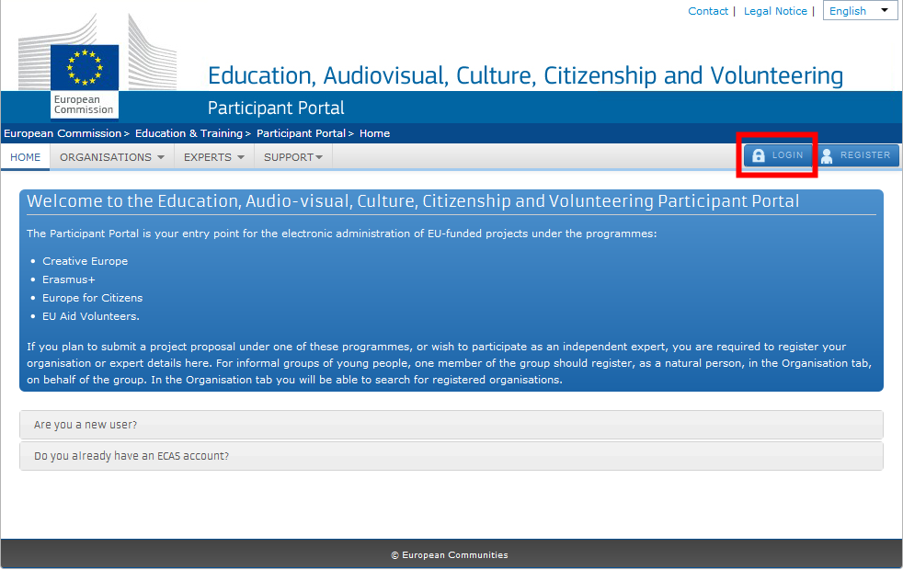
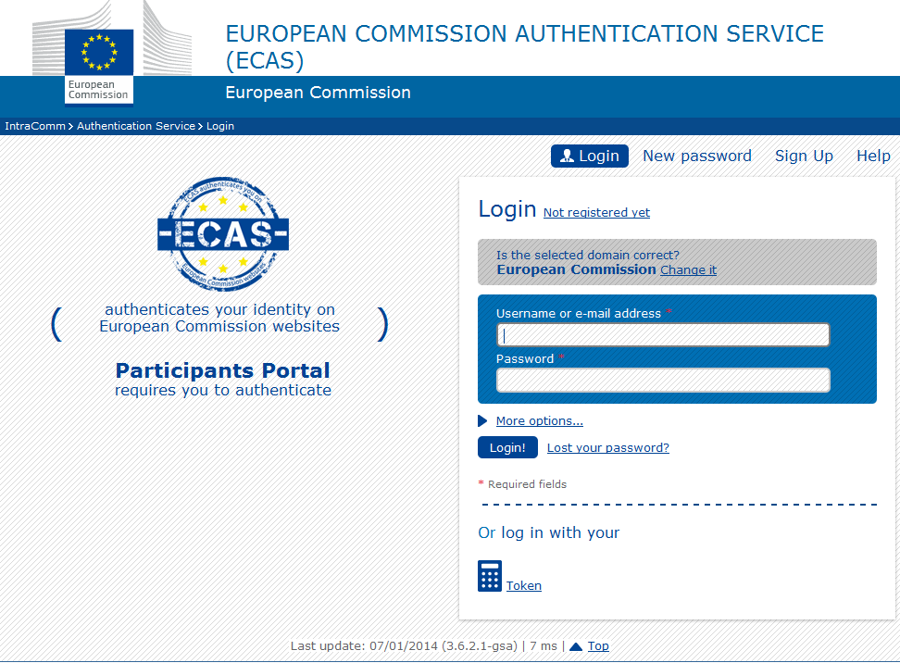

Register yourself in ECAS (European Commission Authentication Service)
If you have never used any European Commission's web platform, it is very likely that you need first to create your ECAS account (ECAS = European Commission Authentication Service). The ECAS account is your personal account through which you register your organisation. This is a simple registration that you can start by choosing the option "Register":

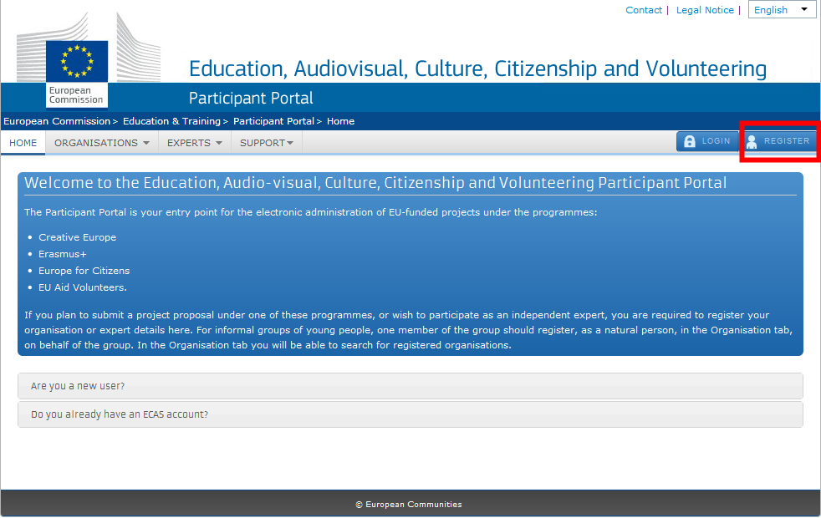

Then you have to enter your authentication details in the following screen:

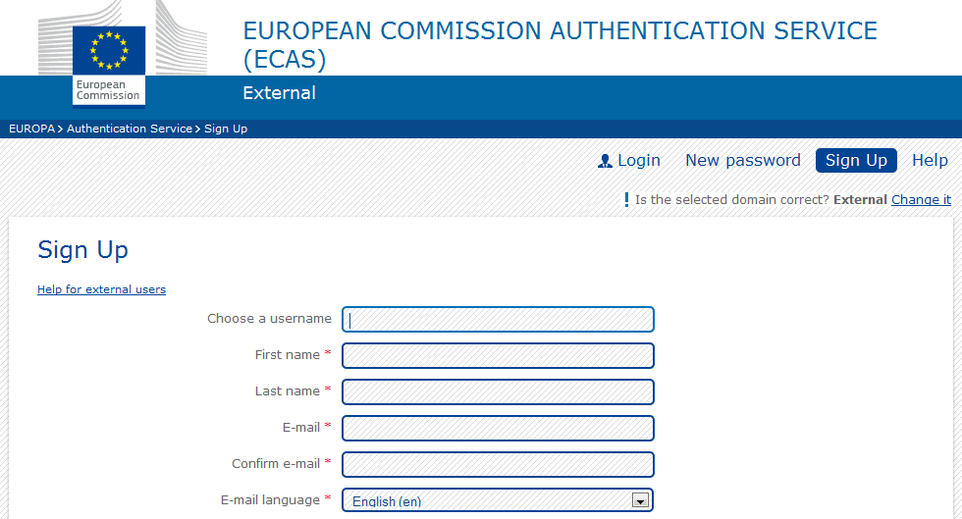
Once you have registered with ECAS, you will be able to access the Participant Portal by logging into your ECAS account. You can find more information about ECAS on this hyperlink:
https://webgate.ec.europa.eu/cas/help.html

Enter your organisation's details
Now that you have access to the Participant Portal, you can start registering your organisation:

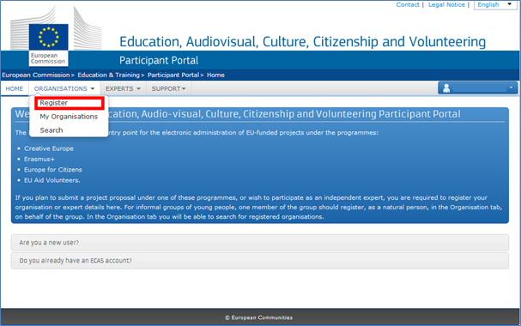

Once you click on the "Register" button you will be redirected to the following page:
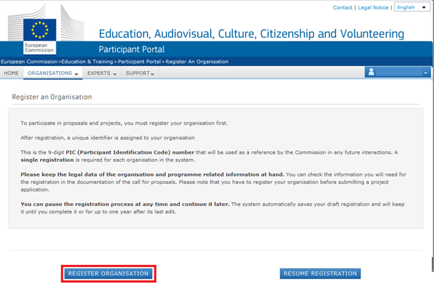
You have two main options on the screen: Register organisation and Resume registration. In the normal case, you should click on the "Register organisation" button in order to start the registration process from the beginning. The other option allows you to continue the registration if due to a certain reason you haven't finished in the last time you visited the Participant Portal.

After clicking on "Register organisation" a new window will pop-up. There are several screens that you will need to go through in order to enter all the information on your organisation. You can follow where you are in the entire process by looking to the progress bar located at the top of each page.

The first screen "Welcome" will ask you for the following main data:

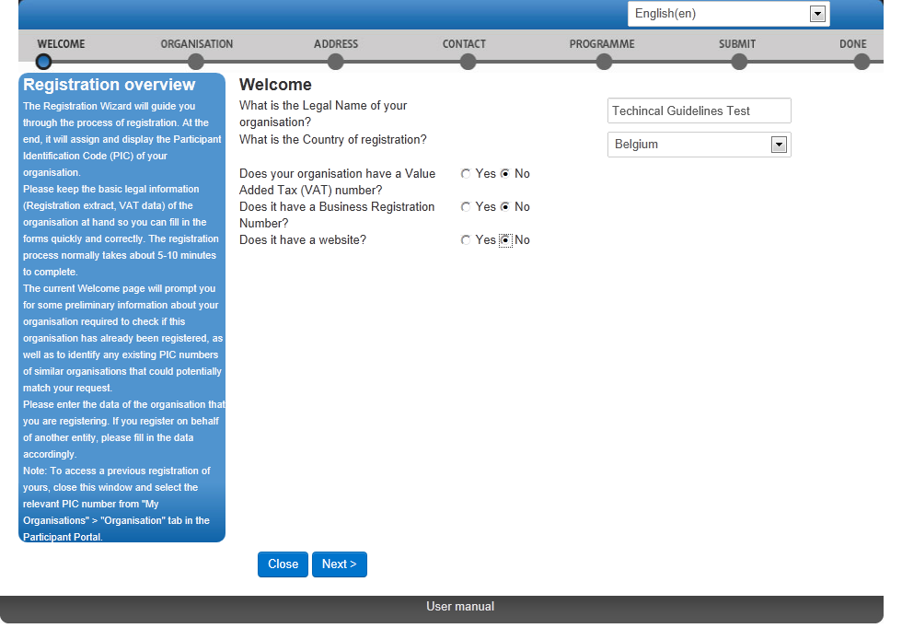
The first screen "Organisation" will ask you for the following core data:

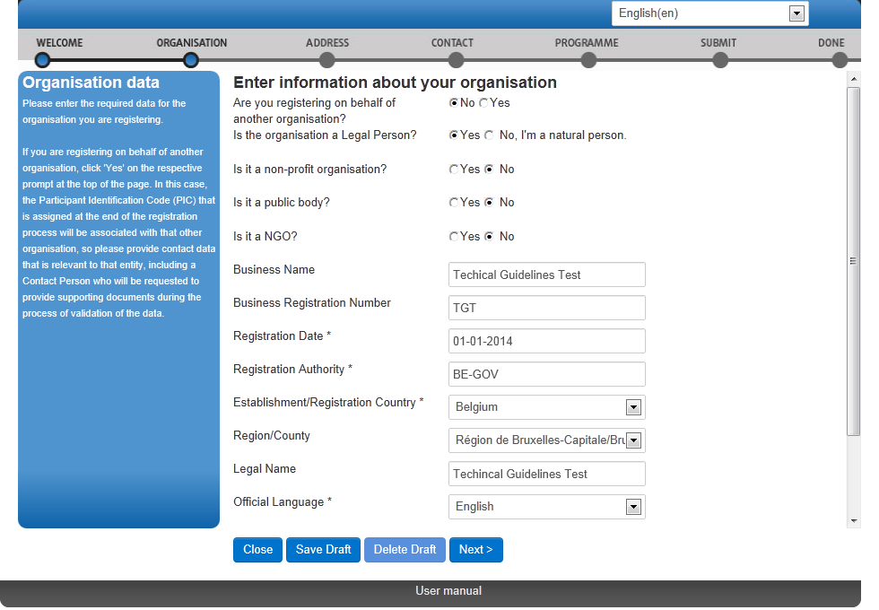

From this point on you should select "Next" to advance and complete each screen in turn. The data you enter on each screen will be saved automatically when you click 'Next'.

Finishing your registration
At a certain moment in the process, you will be confronted with a screen allowing you to finish your registration:
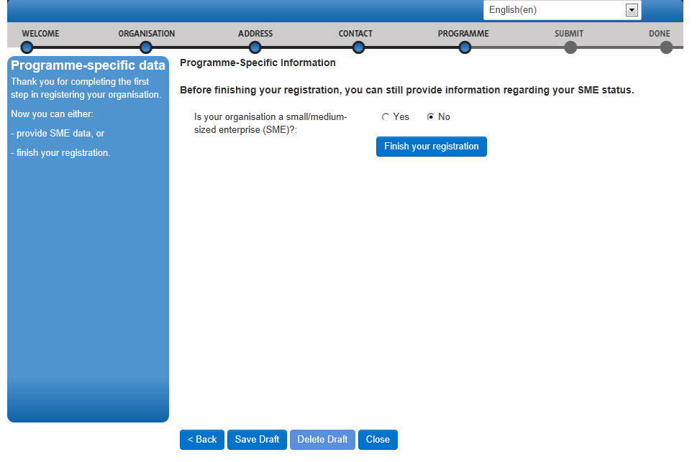
In this screen you must select whether your organisation is a small/medium-sized enterprise (SME).

You can find more complete instruction on how to use Participant Portal at the following location:

http://ec.europa.eu/programmes/erasmus-plus/documents/manualurf_en.pdf

Note that if you don't fill in this information, your organisation's data in the Participant Portal will not be complete and it will not be possible to submit any application in which your organisation is listed as applicant of partner.

Wrapping up
Now that you have entered all required data about your organisation, you can finalise the registration process by clicking on the "Finish your registration" button:

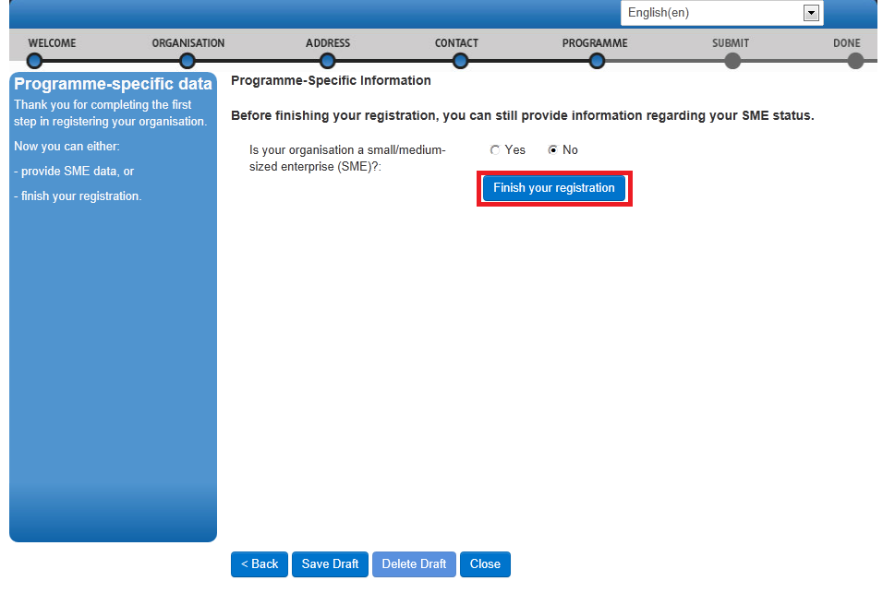

You will be given the opportunity to do a final check on the information you've entered. If you are sure that all is in order, you can finalise the process by pressing the "Confirm" button.
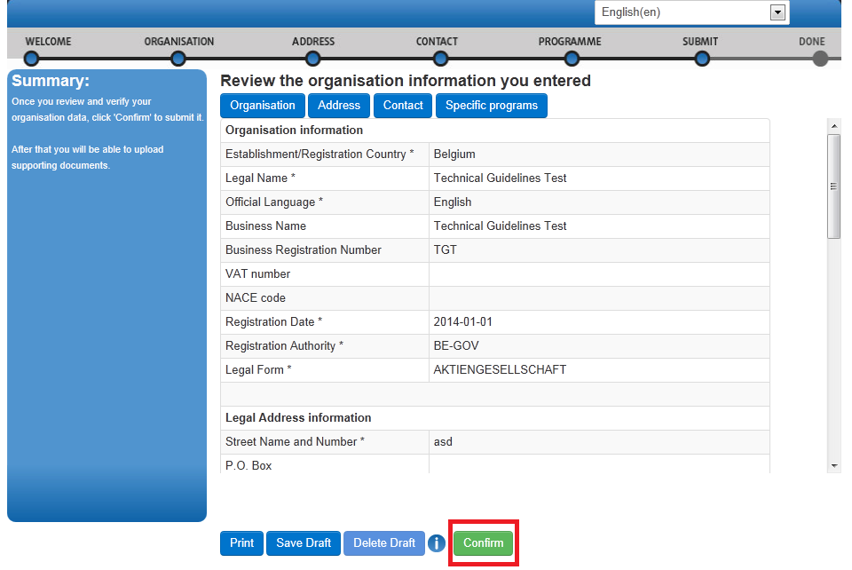

The Participant Portal will store all information and provide you with your PIC (your organisation's unique registration code), which you should use in the electronic application forms to apply for an Erasmus+ grant or accreditation:

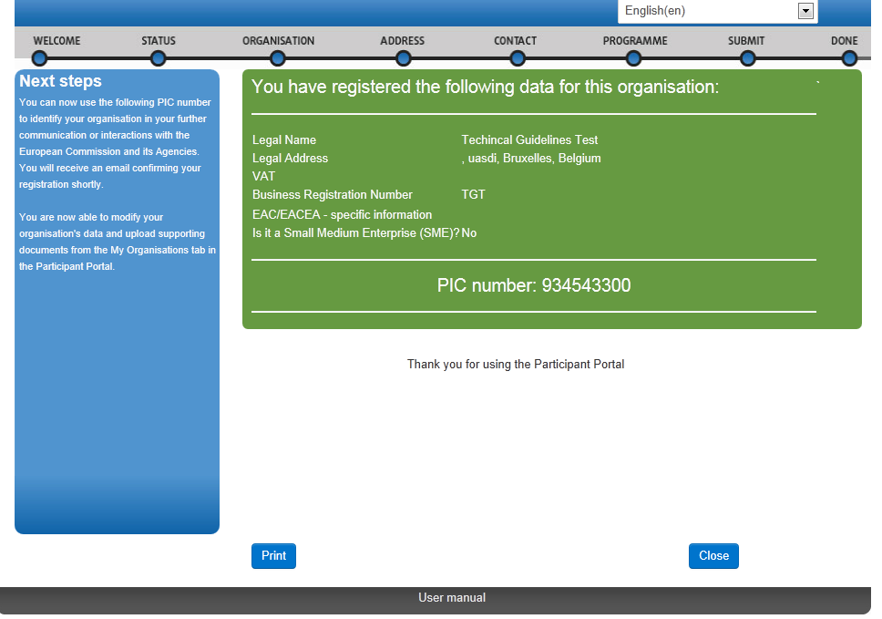

After the successful registration of your organisation, you will receive an email containing the information you provided and your unique PIC. You are also advised to print the page or write down the PIC number for further reference.

Note that you must enter a PIC for every organisation listed in the application form in order to complete it, with the sole exception of organisations from Partner Countries participating in mobility projects in Higher education. You will not be able to submit the application form without a PIC for every organisation included in the application form.

Uploading supporting documents in the Participant Portal
Once you have registered your organisation, you have to upload specific supporting documents. The Legal Entities Form is required for all organisations, whereas the Financial Identification Form is necessary only for the applicant organisation.

In case you are applying for a grant exceeding 60.000 EUR and your organisation is not a public body or international organisation, you must upload documents to give proof of your financial capacity. These documents must be available to your National Agency before signing the grant agreement in case your project is selected.

To upload the supporting documents, you should access the Participant Portal. In the Participant Portal, go to the 'Organisations' tab in the main menu and click on 'My Organisations'.

Then click the orange "VO" button on the same line of the organisation for which you want to upload documents.
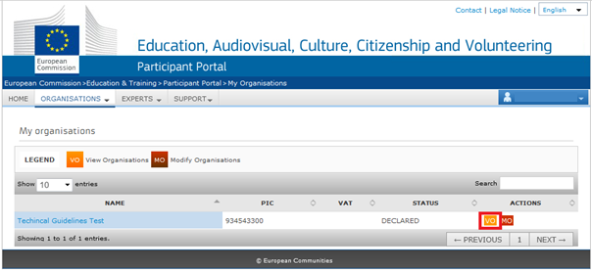

For more detailed guidelines on uploading the supporting documents, please check the User's Guide of the Unique Registration Facility (URF) and Participant Portal:

http://ec.europa.eu/programmes/erasmus-plus/documents/manualurf_en.pdf

