ERASMUS+

Technical guidelines
for completing
electronic PDF Forms:
KA102 and KA116
Call 2018

For actions managed by
National Agencies

For actions managed by
National Agencies

For actions managed by National Agencies

Version 1 of 18/12/2017

Table of Contents

Introduction 4
Preparation 4
Technical requirements and settings needed to use an electronic PDF form 4
Adobe Reader and Acrobat Reader DC 4
Incompatible Readers 5
Incompatible Acrobat Reader DC Versions 5
Operating Systems 6
Security and Java Script Settings 6
New security feature introduced in the Acrobat Reader DC 15.9 9
How to fill an electronic PDF form 12
Checking that you have downloaded the correct form 12
Choosing the correct National Agency 13
Using your PIC in an electronic PDF form 15
Mandatory fields 17
Lists of values 17
Dynamic sections 18
Manually adding entire sections and entries 20
Participating Organisations 20
Adding new entries in lists of values 22
Filling in the budget section 23
Activities' Details 23
Completing the Budget 25
Checklist 30
Validating a form 30
Compulsory fields 31
Duplicated PICs in participating organisations 32
Double entries in lists 32
Invalid flow duration for a given activity type 33
Annexing documents 34
Annexing a Declaration of Honour 36
Submitting a form 38
Submitting more than once 40
Late submission of the application 40
Specific guidelines 42
Registering your organisation in the European Commission's Participant Portal 45

Introduction
This document describes the use of the electronic PDF forms for the Erasmus+ programme KA102 - VET learner and staff mobility and KA116 - VET learner and staff mobility with VET mobility charter within programme countries managed by the National Agencies in the Programme Countries

Preparation

Technical requirements and settings needed to use an electronic PDF form

Adobe Reader and Acrobat Reader DC
The Erasmus+ decentralised actions electronic PDF forms were built using Adobe Forms technology. You need Adobe Reader or Adobe Acrobat Reader DC to use the forms.
In order to be able to properly use an Erasmus+ electronic PDF form you will need to use the following versions of Adobe Reader:
Minimum Adobe Reader version | Adobe Reader 9.3.3 or higher (except Adobe Reader DC version 15.8)
Recommended Adobe Reader version | Acrobat Reader DC version 15.20
Adobe Reader and Acrobat Reader DC can be downloaded for free from the internet at the following location:
http://get.adobe.com/reader/otherversions/
If you are using Windows 10 this is how the download page should look like:
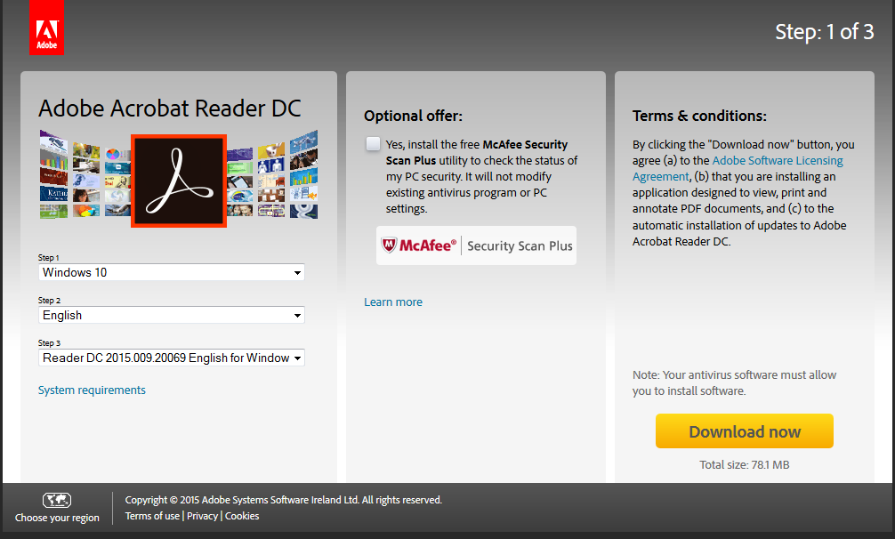

If you are using a different version than the above mentioned ones you will not be able to properly use the form and will be confronted with the following screen:
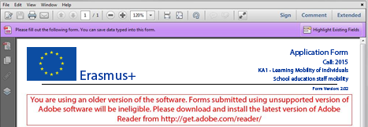

Incompatible Readers
Adobe Reader and Acrobat Reader DC are the only accepted readers. If you happen to use another reader such as "Foxit" or Adobe Acrobat X PRO you will not be able to use the electronic PDF form and may even corrupt it as the following message shows:
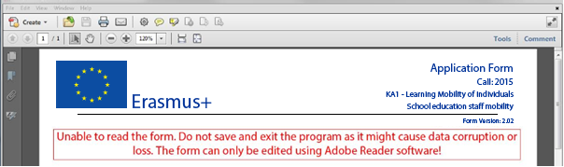

Incompatible Acrobat Reader DC Versions
The above mentioned Acrobat Reader DC version 15.8 released by Adobe on the 14th of July 2015 has introduced several issues with the Erasmus+ PDF forms and must not be used.
If you happen to open one of the electronic PDF forms still using Acrobat Reader DC 15.8 the electronic PDF form will be blocked and you will not be able to fill it in.
If you are still using Acrobat Reader DC 15.8 please make sure that you uninstall it and install instead latest Acrobat Acrobat DC version as explained above.

There are other Acrobar Reader DC Versions that introduce blocking issues with the Erasmus+ PDF forms and must not be used.

Adobe Reader DC Version 2015.023.20053
Adobe Reader DC Version 2015.006.30279

If you open one of the electronic PDF forms using one of these versions mentioned above will be blocked and you will not be able to fill it in. The following message will be retrieve:
The Acrobat Reader version you are using has known issues with display or calculation of the form data. Please download and install the latest version of Adobe Reader from http://get.adobe.com/reader/

Operating Systems
The above mentioned Adobe Reader and Acrobat Reader DC versions are supported on Microsoft Windows and Apple OS X. Mobile platforms such as iOS, Android, Microsoft Windows RT, Windows Phone and BlackBerry are not supported by the electronic PDF forms.
Please note that Windows XP is no more supported by Microsoft since 8th April 2014. This is explained clearly on Microsoft webpage: https://www.microsoft.com/en-us/WindowsForBusiness/end-of-xp-support.
However, it is true that you can easily found on Internet some ways to make some updates to make Adobe Reader working with the PDF forms. If you consider them you must know the exact consequences and weaknesses on your computer and also all potential related legal issues. If you have any doubt or have some legal issues on the solution, we strongly advise you to consider another platform fully supported.

Electronic PDF forms can be opened on Linux platform only with Adobe Reader version 9.1.
Please note that Adobe was providing a native Reader version on Linux until the version 9.5.5 (26/06/2013). This version is no more available on Adobe website. However, different versions of the package are still downloadable on Internet with the procedure to install them. Please note that we strongly discourage you to use these old versions with unknown PDFs as no more security patches are applied on it.

Security and Java Script Settings
When an electronic PDF form is downloaded from the internet for the first time, Adobe Reader and Acrobat Reader will detect that the form has originated from a potentially unsafe location and ask you to confirm the safeness of the file:
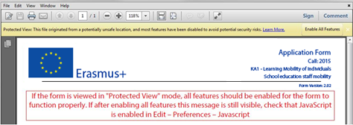
In this case you should press button "Options", choose "Trust this document always" and save the electronic PDF form:
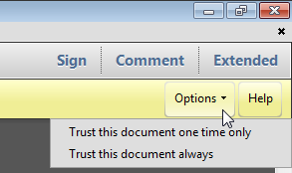

If the problem persists, check your Java Script settings in Adobe Reader and Acrobat Reader:
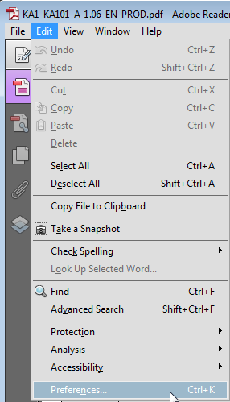
You should have the following configuration:
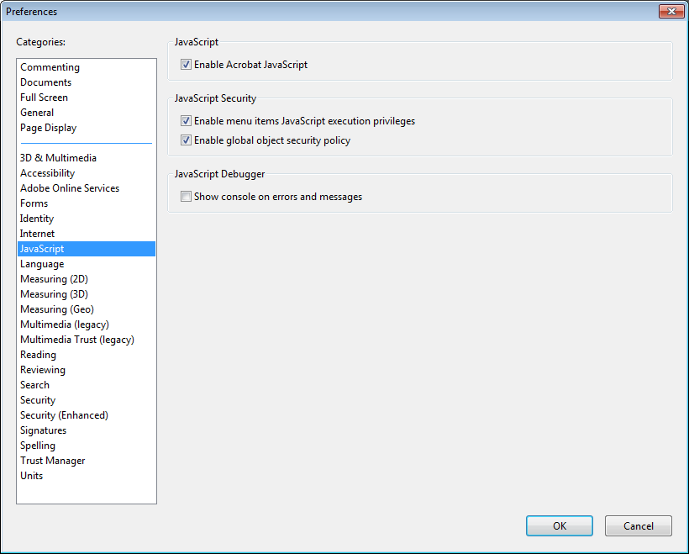
On top of what is written above, Adobe Reader and Acrobat Reader uses an enhanced security feature that detects when the electronic PDF form is attempting to connect to the internet. Such situation will happen every time you need to input and validate a PIC (Participant Identification Code, provided to the organisation upon registration in the Participant Portal (see section on "Registering your organisation in the European Commission's Participant Portal" at the end of this document) for a participating organisation, or when you have changed a piece of data that impacts the budget section, such as a distance band in the "Travel" budget section. In both scenarios the electronic PDF form will contact central European Commission servers to fetch the latest data and information. The message displayed by Adobe Reader and Acrobat Reader is as follows:
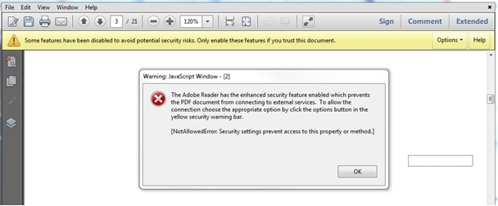
When confronted with this message you should press button "Options", select "I trust this document always" and, when asked, save the form with the same name. This process is sometimes a bit slow, so just let it finish before proceeding.

New security feature introduced in the Acrobat Reader DC 15.9
When the user uses Acrobat Reader DC 15.9 for the first time with an electronic PDF form which is not stored in an already trusted folder, Acrobat Reader will prompt the user with a new security question asking if the user trusts the "europa.eu" domain (it could happen on Check PIC, on budget change or on submission).
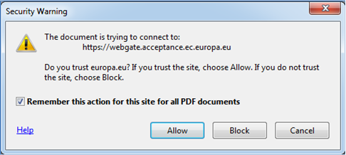

It is compulsory for the user to answer "Allow" so that the domain "europa.eu" is a trusted domain and the form works properly.

If by mistake the user answers "Block" on the prompt about the "europa.eu" domain then that answer will be applied to all electronic PDF forms and none will properly work in that specific computer. The expected behaviour of the forms will be to show the following error message every time the domain "europa.eu" needs to be accessed e.g. when checking a PIC or computing budget:

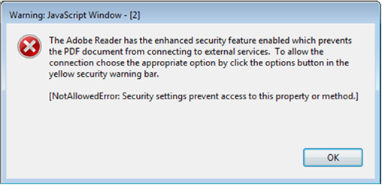
In order to revert the previous decision to block the "europa.eu" domain and make the electronic PDF forms work normally, the user needs to:

1) Access Menu "Edit" -> "Preferences…" or Ctrl + K

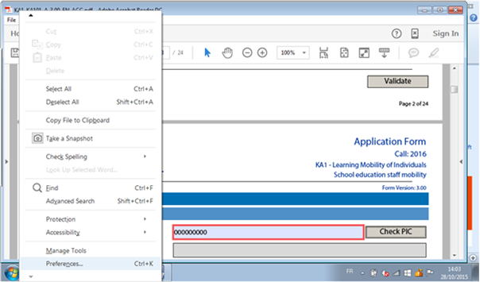

2) Choose "Trust Manager" and "Change Settings…" button

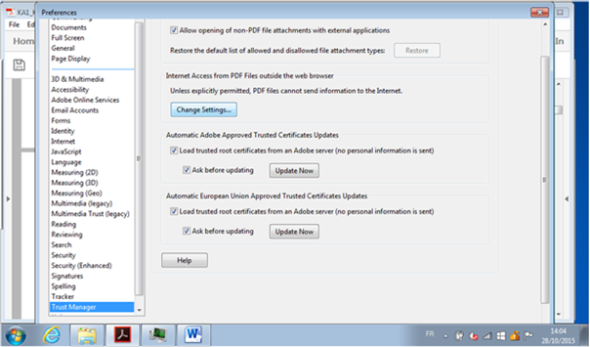

3) In the Web Sites table select row "europa.eu" "Always Block" and click on "Delete" button

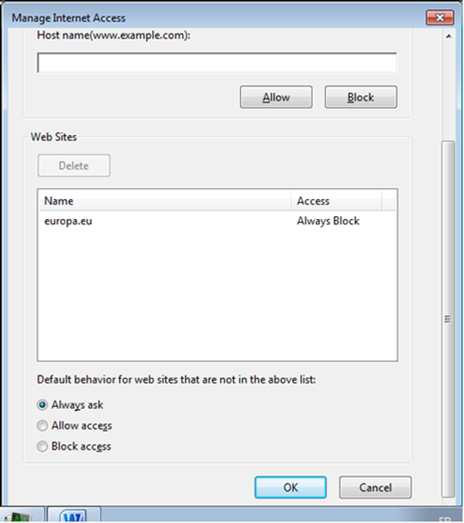

4) Finally click on "OK" buttons to apply the changes and close the properties' windows.
After that try to open the electronic PDF form and make sure that this time you choose the option "Allow" when prompted to trust the "europa.eu" domain.

How to fill an electronic PDF form
This section will guide you through the main aspects to consider when filling an electronic PDF form for applying for a grant under an Erasmus+ action managed by the National Agencies.

Checking that you have downloaded the correct form
Before you start working on your application and filling in your project's data, it is important that you check that you have the right form for the right "Action Type", "Call" and "Round". Page 1 of every electronic PDF form contains this information:
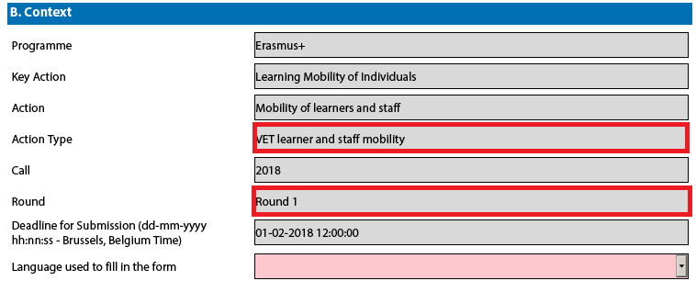
Field "Action Type" will show you the action type and the field of education, training and youth which the electronic PDF form concerns. Do make sure you are using the right one as your application will not display all fields that apply to your project if you submit it through a different form and may be considered as ineligible as a consequence.
Field "Call" is another important piece of information, as it indicates the year of the Erasmus+ Call for proposals concerned.
In some cases, more than one application round may be organised within the same call. Therefore, it is also important to check the selected application "Round" to which you want to apply, since selecting an inactive round, i.e. one that is already closed, will not allow you to submit your application.
Note that you cannot change the content of these three fields. If you find out that you have selected the wrong electronic PDF form, you need to close it and download the correct form from your National Agency's website.

Choosing the correct National Agency
Another important aspect to take into account is the National Agency to which you want to submit your application. The selection of the National Agency is normally done on page 2 of an electronic PDF form. There you can find a drop-down list with the allowed Erasmus+ National Agencies covering each field of education, training and youth. In the list of values below, each National Agency is identified by a unique code accompanied by the name of the country in the national language:
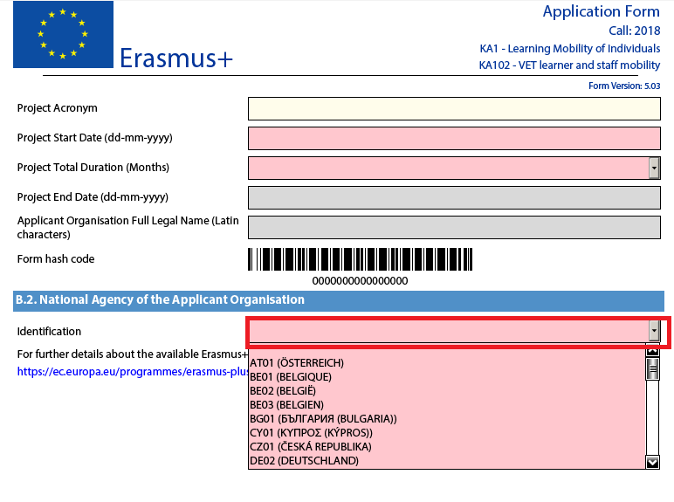
If a country has more than one National Agency, use the following hyperlink to consult the full list of National Agencies, and find out the code of the National Agency responsible for your field of education, training and youth to which you should submit your application:
https://ec.europa.eu/programmes/erasmus-plus/contact
The information to look for is illustrated in the screen shots below and includes the National Agency code and the fields in which it is active.
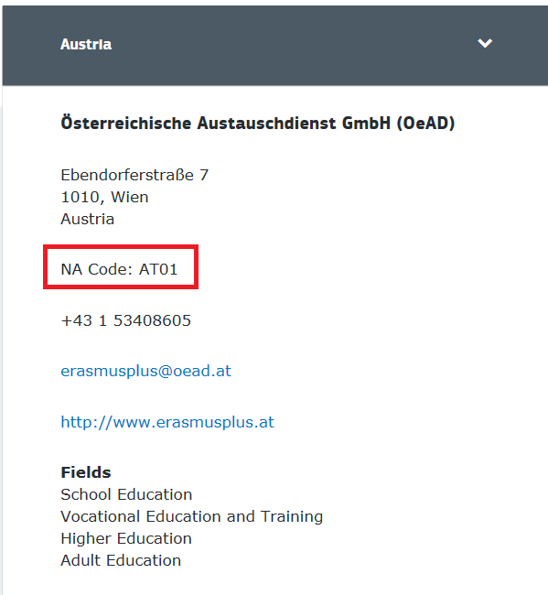
The last aspect concerning the field(s) for which a National Agency has been designated is of particular importance as this needs to match the electronic PDF form you have chosen. In order to help you, the electronic PDF forms will only show you the relevant National Agency reference according to the field of education, training and youth that you want to submit your project to.

Using your PIC in an electronic PDF form
For most actions, all participating organisations should be registered in URF and should use their PIC (Participant Identification Code) when filling-in an e-Form (please see section on "Registering your organisation in the European Commission's Participant Portal" at the end of this document and User's Guide of the Unique Registration Facility (URF) and User's Guide of the Unique Registration Facility (URF) and Participant Portal for Education, Audio-visual, Culture, Citizenship and Volunteering).
When you and your partner organisations or consortium members have a PIC, you can start using these identifiers in your electronic PDF forms.
The PIC field name is the place where you need to enter your organisation's identification:
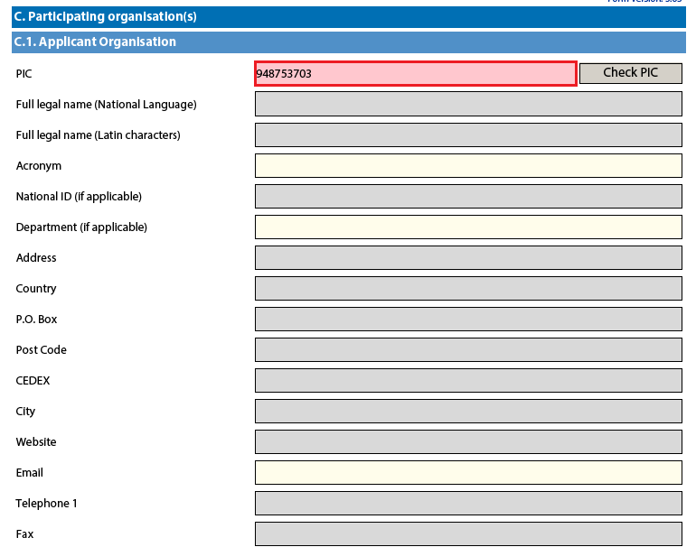

After you have entered it, press button "Check PIC" so that the electronic PDF form fetches the organisation's data from the Participant Portal. In other words, you do not need to enter again in the electronic PDF form the organisation data that are already registered in the Participant Portal.
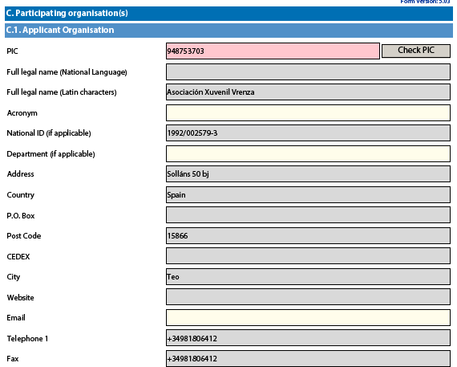
Once you have entered the PIC and the eForm has fetched the relevant information in section C.1., you will also see that part of the information in section C.1.1 has also changed:
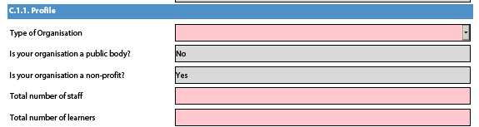

In the 2018 PDF Forms the applicants can indicate the type of the organisation as this information is no longer filled in the Participants Portal. Please note that, as the field Type of Organisation is a compulsory one, the applicant cannot leave it empty and should pick one option from the drop-down menu. If you cannot find the right organisation type in the list of the drop-down menu, the organisation type can stay "Other" in the electronic PDF form. If you have already applied for Erasmus+ the field type of Organisation will be already prefilled. Please check if the value displayed is correct. In case the value in not correct, please choose another option from the drop-down menu.

Mandatory fields
Mandatory (compulsory) fields are clearly identified in electronic PDF forms through a pink colour as depicted below:
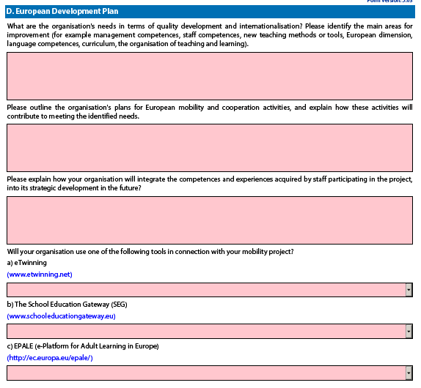

They need to be filled in, otherwise you will not be able to validate and submit your electronic PDF form.

Lists of values
Lists of values represent closed questions that you will need to answer by choosing one or more entries from the ones available in the list. The example below represents the selection of the language used to fill in the electronic PDF form i.e. the language used by the applicant to enter the project information:

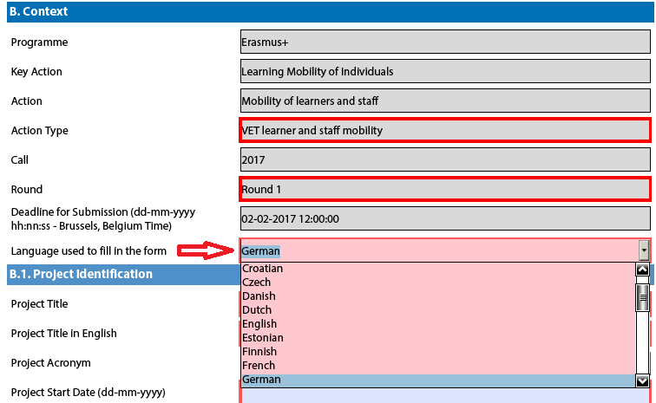

Dynamic sections
Some selections made in an electronic PDF form will trigger the appearance or disappearance of fields or sections following them. A typical example of this is the "Consortium" section where an applicant can enter if it is applying on behalf of a consortium:
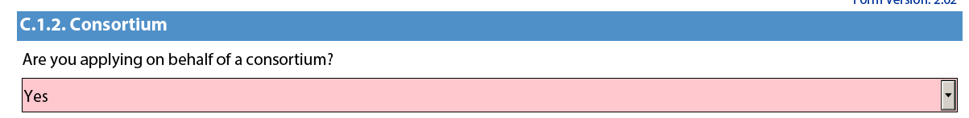

If the applicant enters "Yes" then a new "Consortium Member" section will be shown where the members of the consortium can be identified:
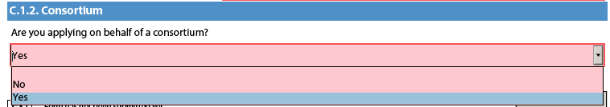
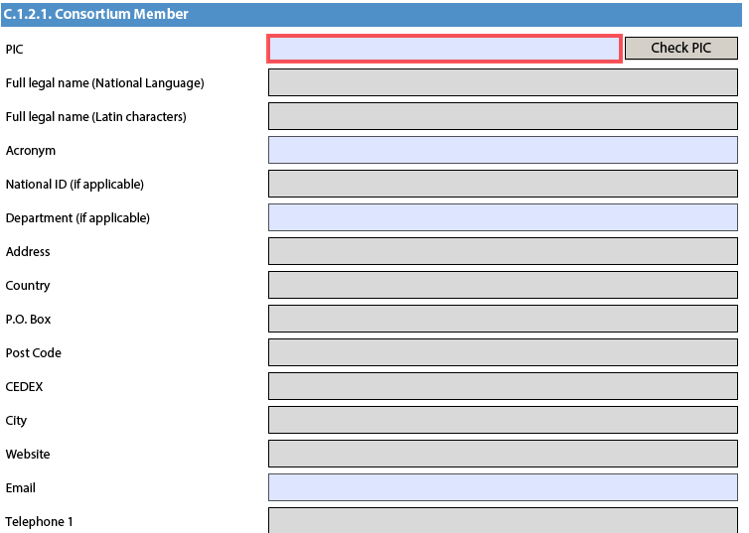

Manually adding entire sections and entries
In certain places, you can add entire sections to the form, if they are relevant and necessary for you. An example is adding project Partners.

Participating Organisations
In this section the data about your organisation is already available in the sub-section "Applicant Organisation":

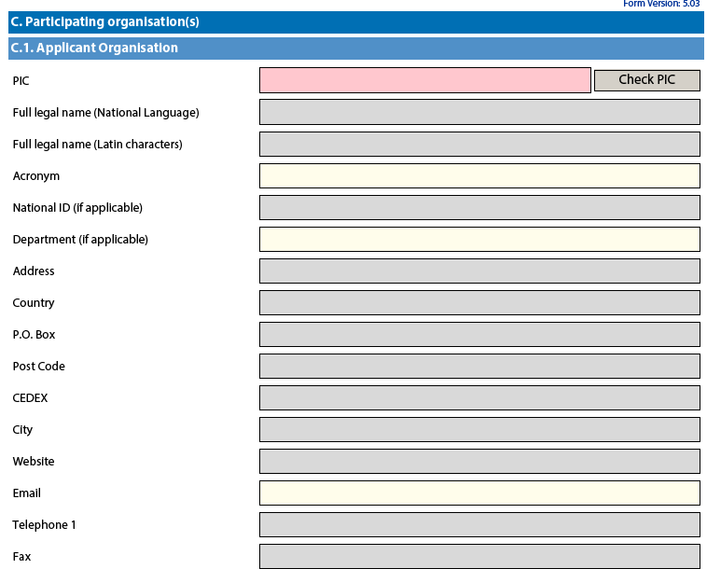

If you need to add partner organisations to your application, you can do so by pressing the button "Add Partner" located at the end of the "Applicant Organisation" sub-section:


For some actions, a new sub-section will then appear, called "Partner Organisation", where you can enter all needed details:

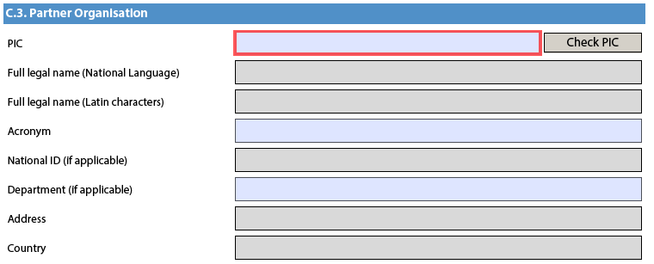

Partner organisations can be removed by pressing the button "Remove Partner" located at the end of the last partner organisation:



Please note that you can only add partners at the end of the already introduced partner sections, e.g. you cannot add partners between partners 2 and 3, if you have already included 3 partners.
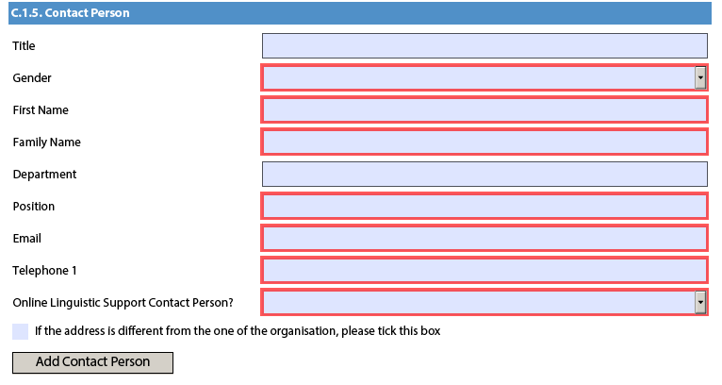

In the sections for the contact persons, the field "Online Linguistic Support Contact Person?" has been introduced to indicate whether a contact person is also responsible for Online Linguistic Support.

To be able to validate the forms, one of the contact persons must be flagged as Online Linguistic Support contact person. It is not possible to flag more than one person. The Online Linguistic Support contact person receives a notification by email when licences for language assessments and language courses are available in the Online Linguistic Support (OLS) system, and is responsible for sending invitations to mobility participants to take the language assessment and start the language course, if awarded. The Online Linguistic Support contact person is also responsible for monitoring the usage of licences and can create additional Online Linguistic Support users (aliases) with the same access rights if needed.

Adding new entries in lists of values
You can add new entries by clicking a button. For example, the question about the list of topics that is most relevant to a given application:

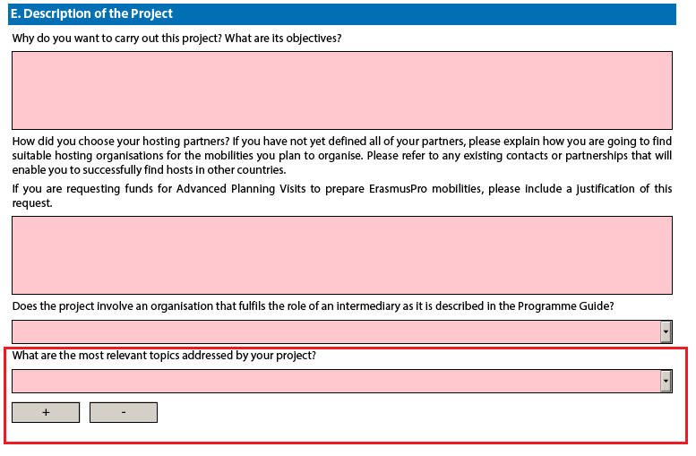

You should press the "+" button to add new entries or the "-" to delete existing ones. Please note that the question is compulsory, so once you add a new entry you will need to fill it in with one of the available options:

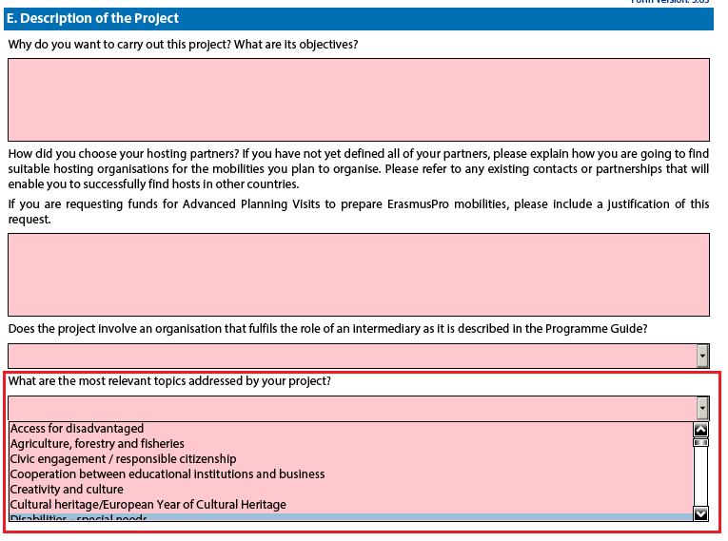
You can enter the same topic only once.

Filling in the budget section
The budget is one of the most important sections of your electronic PDF form. It is partly completed based on what you have entered before in the content related questions of the form.
For "KA1 - Learning Mobility of Individuals", the "Activities' Details" section will be the most important.

Activities' Details
Bellow you will find an example on how to fill the section Activities' details for one of the actions. Please note that there are some differences in information requested across actions and business rules may be different.
Let's assume the following scenario:

Mobility Activity Type | Origin | Destination | Duration Excluding Travel | Total No. of Participants | Participants With special needs (out of total number of Participants) | No. of apprentices (out of total number of Participants) | Participants with Fewer Opportunities (out of total number of Participants) | Acc. Persons (out of total number of Participants)
Teaching/training assignments abroad | Austria | Belgium | 30 days | 10 | 4 | 3 | 1 | 2
Teaching/training assignments abroad | Austria | Portugal | 60 days | 10 | 4 | 3 | 1 | 2
Staff training abroad | Austria | France | 60 days | 10 | 4 |  |  | 2

The first step is to create the needed activities for both types mentioned above: "VET learners traineeships in companies abroad" and "Staff training abroad". You can start with the first two flows that will cater for the "VET learners in companies abroad" type:

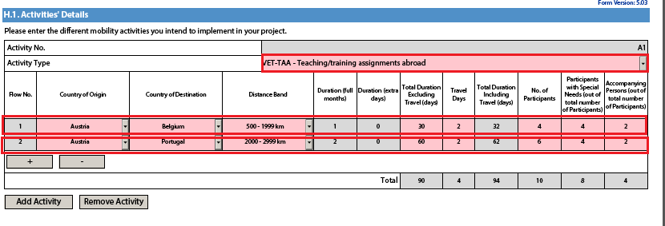
The first activity will cater for the 4 participants going to Belgium for 30 days and the remaining 6 participants going to Portugal for 60 days. Please note that, in this activity type, column "No. of Participants" refers to the total number of persons within the flow which also includes participants with special needs, accompanying persons, etc. The different destinations and corresponding flow durations are handled by breaking down the total number of participants in the activity into two different flows. In the given example, all flows include two additional days accommodating the travel time to and from both destinations.

Finally, you have to create a new activity to cater for the flow for all other relevant staff participants that are going from Austria to France for 60 days:

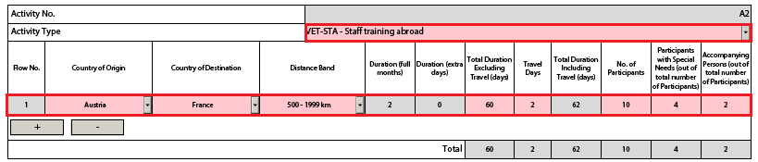

Completing the Budget
Now that you have entered the needed activities and other relevant information, it's time to look into the budget section where the funds needed to support your project are to be specified.
One of the most important principles of Erasmus+ is the wide use of unit cost based grant items. In the case of unit costs, you do not have to calculate the real cost of expenses, but instead indicate the number of units (number of days or number of participants) for a given grant item; based on that number, the form then calculates automatically the grant amount that can be requested, multiplying the number of units with the unit cost concerned. You can find all information in the Programme Guide to verify the type of costs eligible under each grant item, the unit cost levels and rules of allocation.
It is also very important to bear in mind that each project activity must be assigned to a specific organisation in order for the grant to be allocated and calculated correctly. This means that if you enter activities but don’t state which participating organisations will implement them, they will not appear in the budget section.

Travel
The first section you need to check is "Travel". The electronic PDF form should have retrieved the proper travel grant per participant depending on the correct distance band entered for each of the previously created flows.
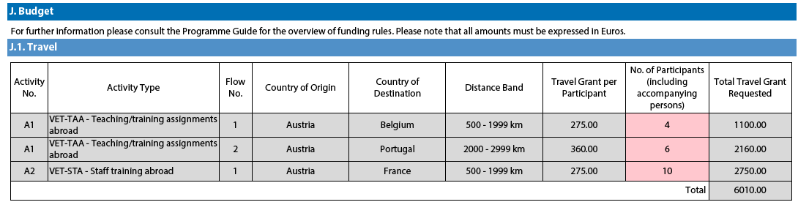
Some participants may not need to receive a grant for travel purposes. In that case you can decrease the No. of Participants and fund less than the total number of participants indicated previously:
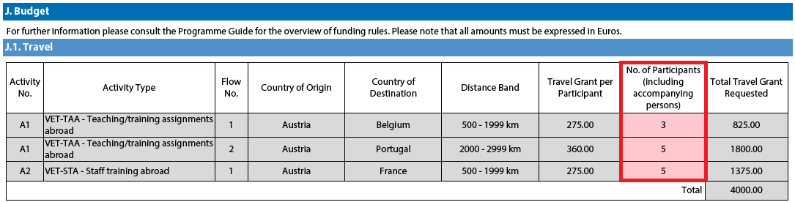
In order to select the correct distance band, you need to get the distance calculated by the web tool that you can access via this hyperlink:
http://ec.europa.eu/programmes/erasmus-plus/resources_en#tab-1-4
http://ec.europa.eu/programmes/erasmus-plus/resources/distance-calculator_en

With this tool you can enter the Origin and Destination cities in two given countries and get the calculation of the distance in one direction. On the basis of this information you have to select the corresponding distance band. If the participant needs to go to a farther city to get to his/her final destination (to reach the airport for example) it is possible to take this city as departure point.
The distance band chosen will determine the grant amount available for that distance, as specified in the Erasmus+ Programme Guide. You only need to enter the distance band: the correct grant amount corresponding to the distance band is completed automatically.

Nota bene: When calculating the actual distance you should fill in only the distance from the place of origin to the place of destination and not both ways. The unit cost is calculated on the basis of one way distance; however, the related grant is a contribution to the expenses for travelling in both directions.

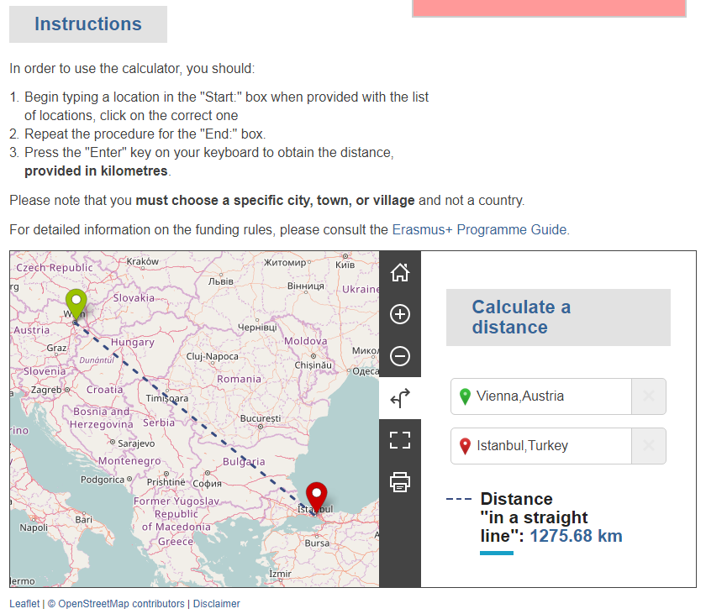

The distance band calculator calculates the actual distance. As a consequence, you may get a situation whereby travelling from one country to another may result in the use of different distance bands depending on the actual place of origin and arrival for each mobility. In such cases, you can, if you wish, create several flows with the same Countries of Origin and Destination in order to get the breakdown that you will need to indicate different distance bands in the budget section.

If for example, you have two groups of participants both going from Wien, Austria to two different cities in Turkey that are quite distant from each other like Istanbul and Trabzon, you use this approach to request the right travel grant for both groups of participants:

Origin | Destination | Distance (from Distance Calculator Web Tool) | Corresponding Distance Band | Travel Grant per Participant
Vienna, Austria | Istanbul, Turkey | 1274 km | Band [500 – 1999] km | 275€
Vienna, Austria | Trabzon, Turkey | 2004 km | Band [2000 – 2999] km | 360€

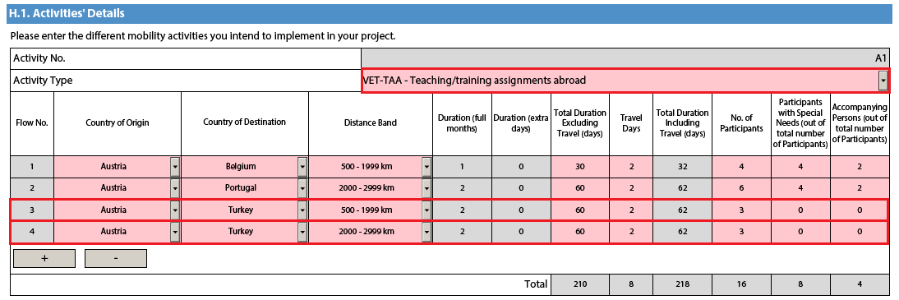
This approach will allow you, in the budget section, to specify a different distance band for the two different groups of participants, even if they share the same Origin and Destination countries:
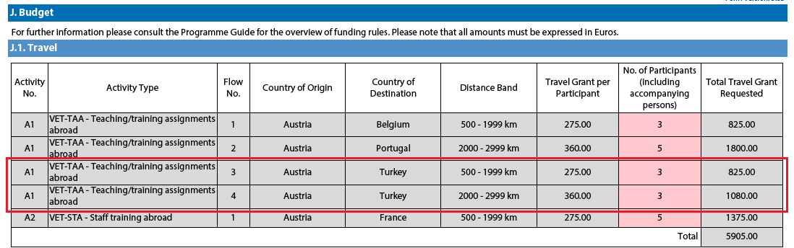
In the Country of Origin you should specify the country from which the participants will travel, i.e. the country in which the sending organisation is based.

When applying for a structured course for School education staff mobility or Adult education staff mobility, it is possible that the exact distance cannot be specified at application stage. The sending institution might have a realistic idea about the place of destination but in case it doesn't, the average distance for the chosen country should be inserted. At final report stage, the actual final destination will have to be used to select the correct distance band.

Individual Support
Some cells in the budget tables do not require you to enter any values. This is because the information you have entered before in the Activities' Details section allows the electronic PDF form to calculate automatically the grant amounts that you can request. Please note that here you can request funding for a lower number of participants by changing the units which in this case are the number of participants (excluding accompanying persons) and the number of accompanying persons. The budget section Individual Support is one such example as you can see below:

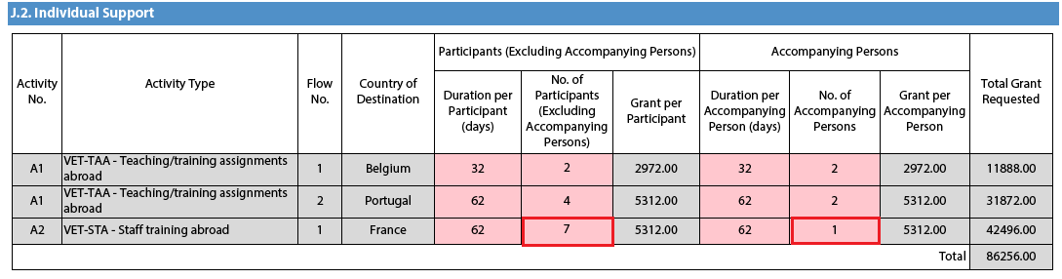

Normal Participants vs Accompanying Persons Mobility Durations
Sometimes the accompanying persons stay for a shorter period than the normal participants. If this is the case, you can simply amend the duration of the accompanying persons in the budget section to a lower value:
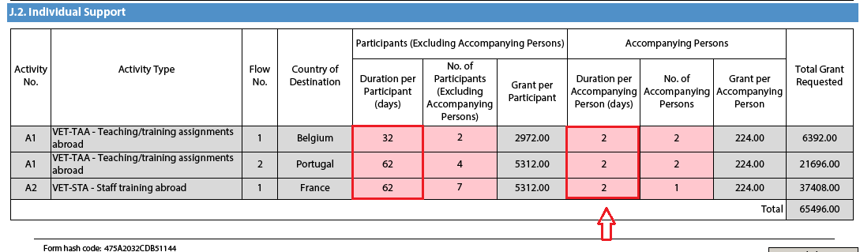

Special Needs Support
This budget section is different from the ones mentioned above because here the electronic PDF form will not perform any automatic calculations. You will therefore have to indicate the additional amount you wish to receive as a grant for those mobility activities that include participants with special needs. Please note that "participants with special needs" refers exclusively to persons with disabilities as specified in the Erasmus+ Programme Guide. The number of participants indicated per activity cannot exceed the total number of participants with special needs mentioned in Activities' Details section.

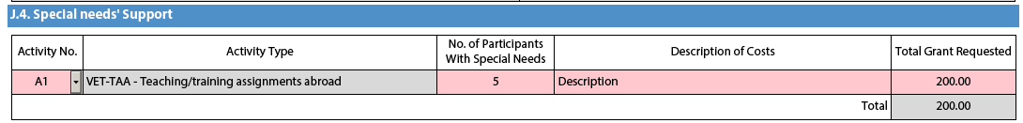

Nota bene: As regards special needs support for Strategic Partnerships, it concerns any additional costs related to involvement of participants with special needs, i.e. it is not limited to additional costs of persons with special needs taking part only in teaching/training/learning activities.

Budget Summary
The budget summary will give you a complete overview of your project's budget, broken down per activity and per budget section:

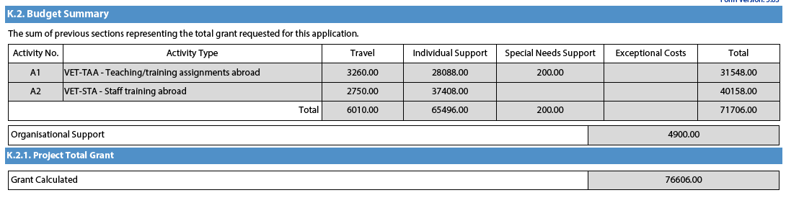
The values shown in the Budget Summary are calculated automatically on the basis of the values calculated and/or entered in the detailed budget sections. Any corrections (for example because you forgot to introduce a certain grant request) have to be made in the detailed budget sections, not in the Budget Summary. Please note that in the above given example Organisational Support and Linguistic support are also shown for completeness reasons.

Project Total Grant
Finally, the electronic PDF form will show you the total calculated grant requested in your electronic PDF form:

Checklist
After you have completed the electronic PDF form but before you validate it and submit it to the National Agency, it is highly recommended that you check the points listed in the Checklist to make sure that your application fulfils all basic requirements.

Please note that the attachment of mandates for each partner organisation is required for partner organisations in national consortia in vocational education and training.

In case you are applying for a grant exceeding 60.000 EUR and your organisation is not a public body or an international organisation, you must have uploaded the required documents to give proof of your financial capacity in the Participants' Portal where you registered your organisation. These documents must be available to your National Agency at the latest before signing the grant agreement in case your project is selected.
Concerning the attachment of supporting documents, you should only attach the documents that are required for the type of organisation in question. For further reference, please check the national requirements that your National Agency may have set and the applicable rules for your type of organisation.

Validating a form
In order to ensure correctness of the data entered into the form, the electronic PDF form will apply the relevant Erasmus+ rules as much as possible. The following non-exhaustive list shows the major types of validations carried out:

Compulsory fields
If you do not enter an answer in a compulsory field, you will not be able to submit your application, and the electronic PDF form will ask you to enter the missing information.

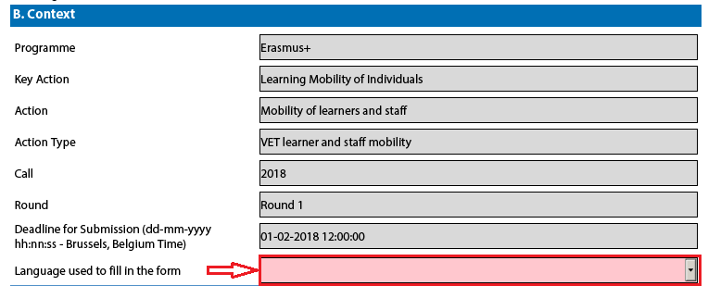

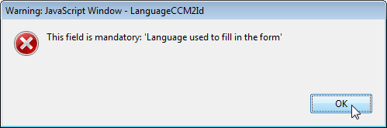

Duplicated PICs in participating organisations
Once a PIC is used for one of the participating organisations, the same PIC cannot be used for another organisation.

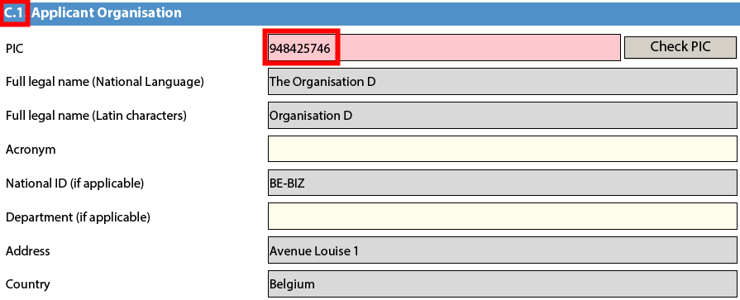
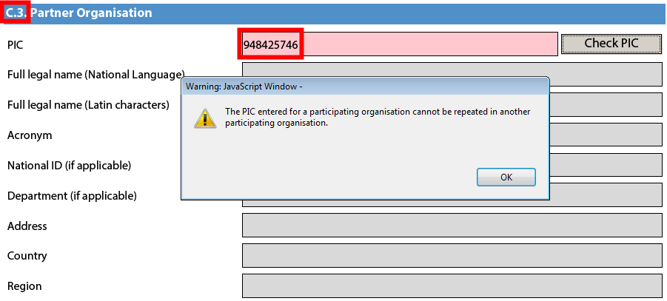

Double entries in lists
If you are confronted with a closed question asking you to select one or more items from a list, you cannot choose the same entry twice.

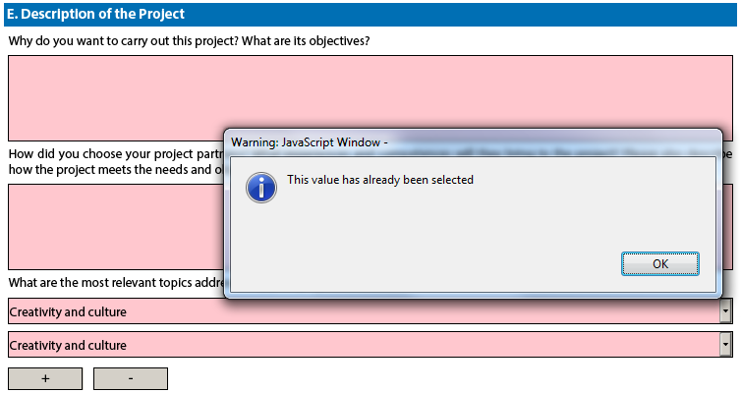

Invalid flow duration for a given activity type
Each flow within an activity type is constrained by several rules that guarantee the respect of the eligible duration per type of activity.

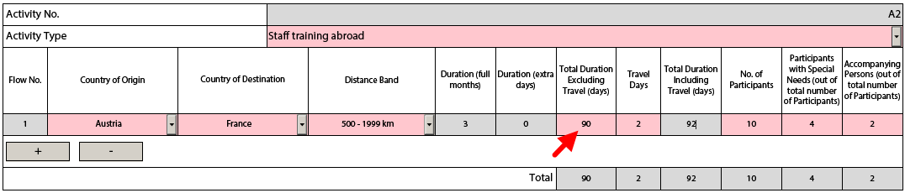
If you enter a duration that is under the minimum or above the maximum allowed, the form will not be valid.

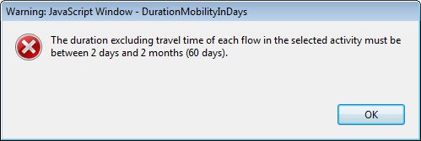

You will also not see any grant amounts in the budget section for such an activity.

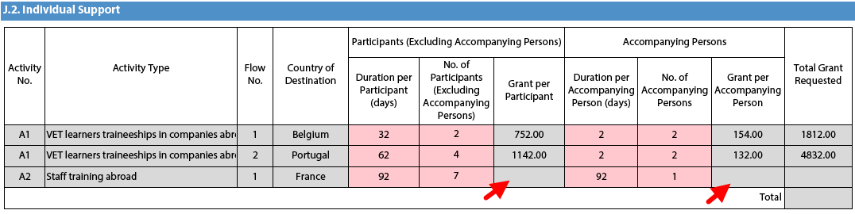
If any such issue is present in a form, the validation process will detect it and redirect you to the question where the issue was identified. You should correct your input and validate the form again.

This process needs to be repeated until all validation rules are met and the form is in a validated status, at which moment you will see the following message:
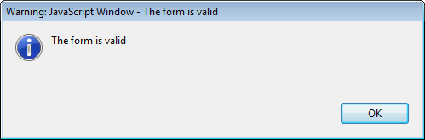

Annexing documents
You need to attach some files to your application.
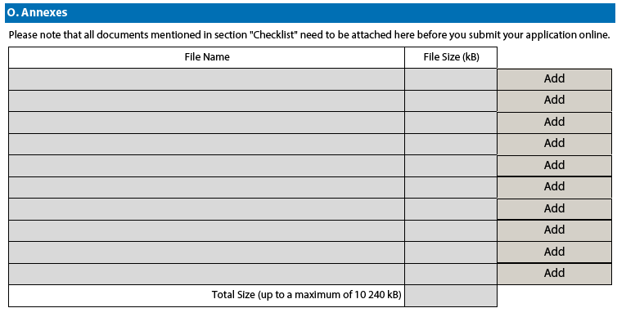
There are, however, constraints that need to be observed, such as the allowed number of attachments, the file types used and the total size of all attached files.
The allowed number of attachments is constrained by the number of rows in the above table to a maximum of 10 files.
Concerning the attachment of mandates to the applicant organisation, the documents should be scanned together with the Declaration of Honour in a single file. The file types allowed are the following:
[MAXIMUM NUMBER OF attachment: 10]
[MAXIMUM TOTAL SIZE OF ATTACHMENTS: 10 MB]
[Allowed file types, CDOC,DDOC,BDOC]
- PDF
- DOC (a pre-2007 word document)
- DOCX (a post-2007 word document)
- XLS (a pre-2007 excel file)
- XLSX (a post-2007 excel file)
- JPG (an image file in jpeg format)
- TXT (a text document)
- ODT (open office word processor document)
- ODS (open office spreadsheet document)
- CDOC,DDOC,BDOC ( electronic signature)
In 2018 you can use a maximum of 10.240 kB for all your attachments, meaning that you can have files of different sizes as long as their total combined size does not exceed this limit. If you do exceed this limit your form will not be valid and you will get the following message:

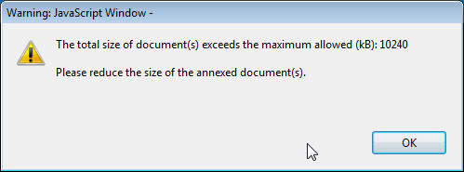

If you need to attach a lot of documents to your electronic PDF form, you should scan, group and attach them so that they fit the 10 available slots for annexes. An example of this case would be the participating organisations' mandates. In this example you can perfectly well group all scanned mandates into a single PDF file and attach it to the form.

Please find some advices how to decrease the total size of documents.

Often the big size of a document is due to images. These images can be a direct file or attached inside a document like a word document or PDF document (a scan).

WARNINGS:
- Before implementing any of these following solutions, please make a backup copy of your documents.
- After applying the solutions, please check the quality of the result and be sure that the documents are still readable without difficulty.

PDF files:
WARNING: Don't use this solution with the PDF form itself. It will break it definitely.
It exists a lot of free online tools to compress big PDF files. You can easily find some of them by searching "compress PDF file" on Internet. So you can use the convenient one with your criteria: using your language, with more or less warranty of confidentiality, etc.
Some PDF tools (other than the Acrobat Reader) have the option to save as "optimized PDF". These tools must not be used with the PDF form.

DOC/DOCX Word document with image embedded:
Recent version of Microsoft word has an option to compress one selected image or all images of the documents. The place of this option is changing from one version to another, so we cannot explain here how to reach it. Please have a look on your documentation or on Internet for your specific version.

ODF documents
Since version 4.0, LibreOffice has the option to compress all images like Microsoft Word.

Scanned documents
If you still have the original file, you can consider rescanning the document with a lower quality. This can be done by answering these questions:
- Do you need colour? Grayscale or Black and White is enough?
- Do you need a good resolution (ppm/ppi)? Generally 300 are enough for images and even less for text.
- Do you save the file in a compressed format? Depending of the tool you use it could be difficult to know the answer and you may need to make some different tests to compare the resulted file size. Please note that the .JPG is a compressed image file format. The output in PDF could be or not compressed (if it is not compressed, you can apply the solution above).

Remarks: Additional effect to reduce the size of the documents will be to make the submission faster as less data need to be transferred through Internet.

Annexing a Declaration of Honour
One of the files you are required to annex to your electronic PDF form is a duly signed Declaration of Honour, partially depicted here:
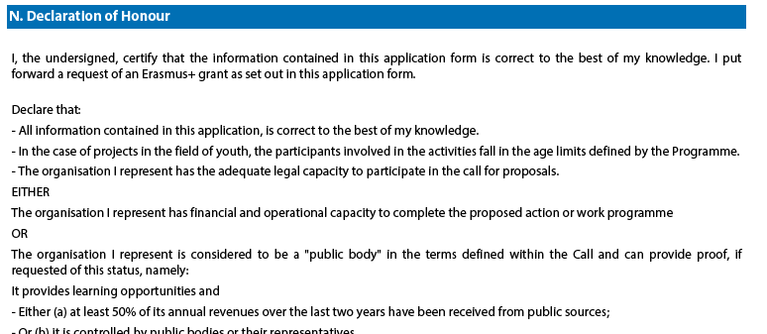
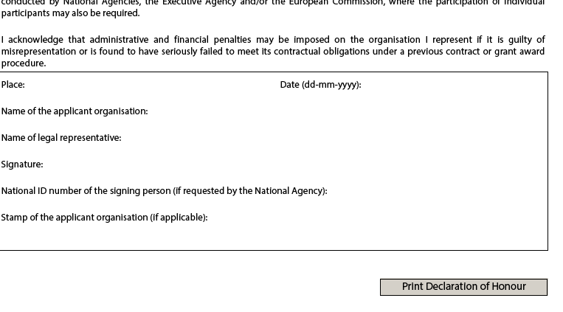To do so you first need to print it. This can be done by using the "Print Declaration of Honour" button as illustrated above. You must then have it signed by the person who is legally authorised to represent your organisation.

For mobility project applications, the attachment of mandates for each partner organisation is required only for applications in the youth field and for partner organisations in national consortia in the fields of school education, higher education, vocational education and training, and adult education.

Finally, you must scan the signed document to a PDF or JPG format so that you can attach it to your electronic PDF form. In case mandates from the partner organisations are required (see "Checklist" above) you are advised to scan them together with the Declaration of Honour to limit the number of annexes to the form. The final result should be somewhat like the one depicted below with your own filename specified:

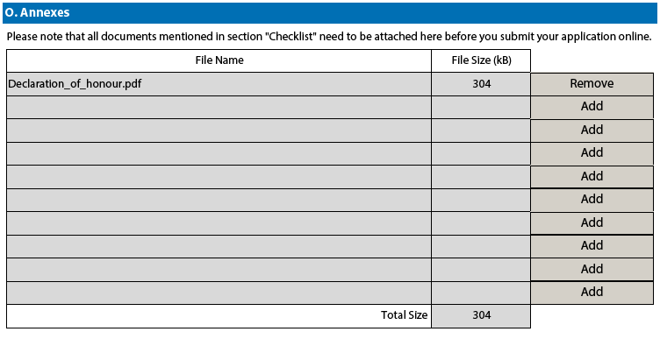

Submitting a form
After you have validated and annexed all documents needed to your electronic PDF form you are ready to submit it to your National Agency.
Different application deadlines will apply depending on the "Call", "Action Type" and the "Round" (where applicable) that you are applying for.
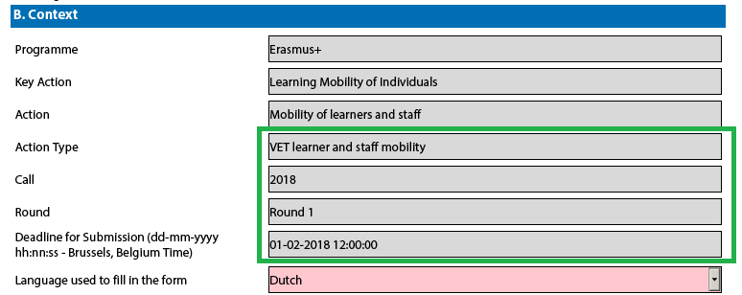
Because there are several rounds within a call for Youth action types, please make sure that you respect the deadline for the specific round that you are applying to (see Programme Guide for details on deadlines).
The submission of an electronic PDF form is done in the "Submission" section:
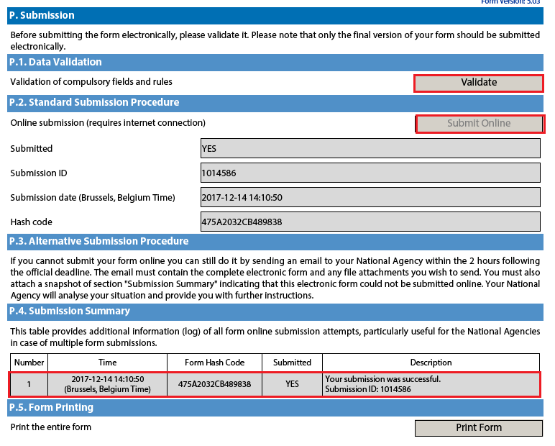
You should first make sure you have a valid application form by pressing the "Validate" button one last time.
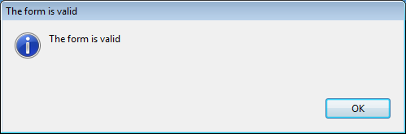
If everything is correctly filled in you can press the "Submit" button to have your electronic application sent to your National Agency. If all goes well, you will see the following screen:
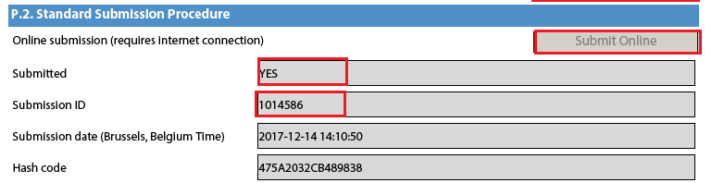
Let's look at each of these fields in order to understand their meaning and use:
- The "Submitted" column indicates if the submission was successful. A "YES" indicates a successful outcome.
- The "Submission ID" is an identifier returned automatically by the European Commission IT servers that uniquely identifies your specific submission. If you submit again you will get a new identifier.
- The "Submission Date" is the date and time at which your application was received by the European Commission IT servers. It is therefore specified in Brussels time as will be explained later in this chapter.
- Finally, the "Hash Code" is a code automatically generated by the electronic PDF form to monitor changes in the contents of your form. Every time you change something in the form and save it, a new hash code is generated to reflect the changes. In this way you and your National Agency can quickly spot if there are content changes from one form submission to another and take the necessary actions.
Applications must be submitted to the National Agency only online. You don't have to send a printed version of the application, nor of the attachments. The print option is intended for your own use.

Submitting more than once
After you have submitted your form, the "Submit" button will no longer be available:
However, you can resubmit your form if you have found a problem with its contents and provided that you have detected the problem before the deadline for submission. In order to be able to submit again you need to save the form, close and reopen it:
The form will keep track of all your submissions and their status in the table "Submission summary":
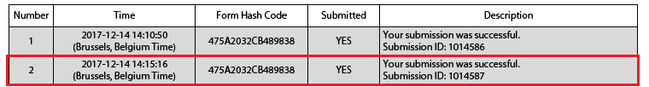
The "Time" column shows you the date and time at which you have submitted your form according to the Brussels time zone.

Late submission of the application
If you miss the official application deadlines you will not be able to apply. However, an exception is made if you can prove that you tried to apply before the official application deadline and were not able to do so due to technical reasons.
In the latter case, your National Agency may still consider your application, if all three conditions listed below are met:
- The date and time of your last submission attempt as mentioned in the electronic PDF form "Submission Summary" section are before the applicable official application deadline.
- You have informed your National Agency within 2 hours after the application deadline (Brussels time!). After this time, your application can no longer be considered.
- You have sent to your National Agency within 2 hours after the application deadline (Brussels time!), by email, your complete electronic PDF form unmodified after your submission attempt.

Specific guidelines

Nota bene: the quality of your application will be assessed against the award criteria specified in the Programme Guide. Please make sure that in your application you provide all the necessary information that will allow experts to assess all elements of analysis of each award criterion. If you want more information on how experts will assess the award criteria, please consult the Erasmus+ Guide for Experts, which is available at the Erasmus+ website at http://ec.europa.eu/programmes/erasmus-plus/resources_en

Context Section
Mobility projects in vocational education and training should have as project start date the 1st June 2018 and can last for one to two years.

Participating Organisations Section
Depending on the characteristics of the Mobility project, there is a possibility of filling in information about your consortium member organisations. In the case of VET learner and staff mobility, if the application is made by a national consortium, please provide details of each sending organisation taking part in the consortium. Please note that all members of your national consortium should be mentioned including intermediary organisations

Partner Organisation Section
In addition, applications should also mention at least one host organisation in the application. It is advisable to provide as many details as possible about the host organisations that you intend to use to show the scope of your project and the intended training activities as fully as possible.

European Development Plan Section
In the electronic PDF form for VET mobility there is a section called European Development Plan. This section requires specific information about the organisation's needs, plan for European mobility and the integration of acquired competences and knowledge by staff into the strategic development of the organisation.
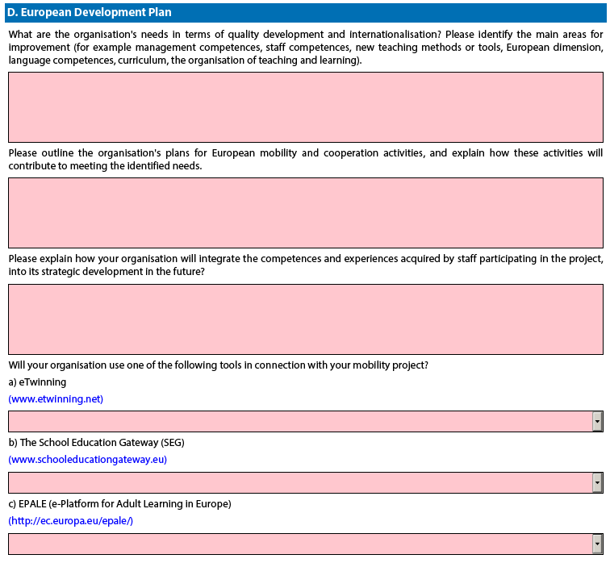

Activities details section
Warning!
Please be aware that although Serbia appears on the list of possible destination countries, it is not an eligible destination under this action.

Follow-up Section
In the 'Follow-up' section you should provide information on the expected impact of your Mobility project, as well as dissemination and evaluation activities.
When describing the expected impact, applicants should include an estimate in terms of quantity – how many people the organisation intends to reach through implementing the project.
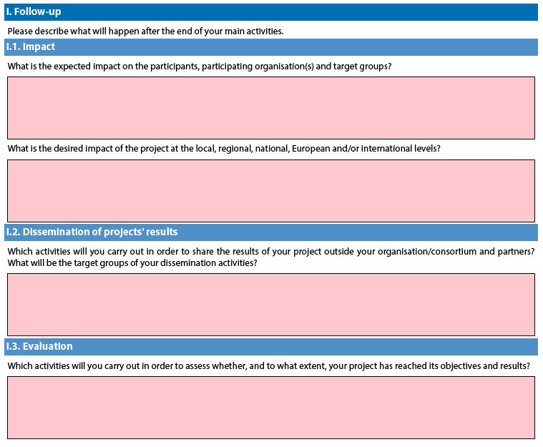

Registering your organisation in the European Commission's Participant Portal
All organisations that are to be included in any electronic PDF form under the Erasmus+ decentralised actions, whether they act as applicant or partner, are required to register in the Unique Registration Facility (URF) through the Participant Portal.
For applications to international mobility in Higher education, only the applicant organisation in a Programme Country is required to register during the application stage. The Partner Country organisation will be required to do so only once the project has been selected.
Therefore, to register organisations for participation in the Erasmus+ Programme, you need to go to the following web site:
http://ec.europa.eu/education/participants/portal/

The registration should be done only once on behalf of a legal entity as a whole. Exceptionally:
- schools that fall under the scope of a local or regional public authority as legal entity should register separately from the legal entity of which they are part; they should in that case also upload the necessary supporting documents proving their legal relation with this legal entity.
- organisations active in the youth field may register separately from the legal entity of which they are part; in that case they should also upload the necessary supporting documents proving their legal relation with this legal entity. After the successful registration the organisation will receive a unique 9-digit Participant Identification Code (PIC) which has to be typed in each electronic PDF form the organisation fills.
It is strongly recommended to start the registration process as early as possible and if possible well before the submission deadline. Most often the registration process is quick and easy. However, in some cases (i.e. organisation previously registered but with data that needs to be updated) the process can be lengthy.
You will find detail guidelines here

http://ec.europa.eu/programmes/erasmus-plus/sites/erasmusplus/files/2017-manual-urf.pdf

