Explanation of video tutorial packages
  - Title of Package: Managing Mobilities in MT+
  - Audience: Beneficiary users
This package contains 4 video tutorials:
- How to add a mobility
- How to export and import mobilities
- How to read the error log
- How to work with CSV
We recommend that these files are watched in the order indicated above. A word document is available for each video showing the step by step process.
It has been provided in 4 formats, so that the National Agency may disseminate these videos, in whatever means deemed best, to their beneficiary user groups.
The 4 formats are:
Individual mp4 files
The National Agency is free to upload these files to a website, reuse or repackage the files as they see fit.

SWF combined package
This package offers an introduction to the 4 video tutorials and instructions of how to navigate through the package. All files contained within the package should be placed in the same location on a webserver or share. The .htm file may be used as the link to the full package. The .htm with "FS", mentioned in the file name should be used if the video tutorial is to be opened in full screen mode. The flash player plugin is required to play this
SCORM compliant:
File format suitable for integration within a Learning Management System (LMS). This package can only be used for those National Agencies that have a LMS and wish to use it to provide the learning material to the beneficiaries. Please, provide these files to the administrator of your learning management system in order to upload them.
Captivate files:
Captivate files are the unpublished files for each video tutorial. They can only be used in Adobe Captivate. They are provided so that the National Agency may apply the translation of the text captions to the videos. An experienced Captivate user should be able to apply the translation. Any issues with the translations of the captivate file should be handled by the National Agency's IT department and should not be escalated to DG EAC. These files can only be opened in the Captivate version 8.
In order to apply the translation to the files, first export all text captions. To do this, in Captivate go to File ExportProject Captions and Closed Captions…
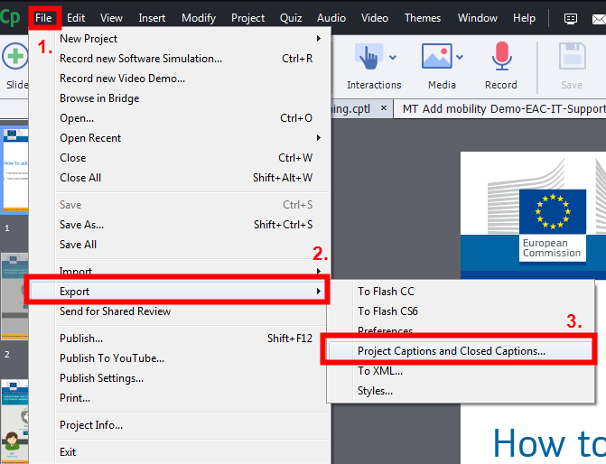
Save the file to a location on your PC.
In the Word file, under Updated Text Caption Data column replace the text with the translated text. Do not edit any other fields in the document.
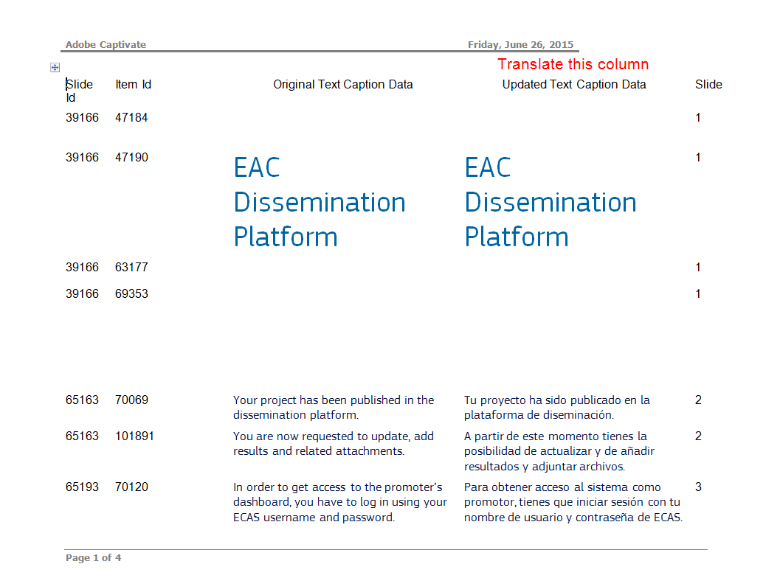
Do not change the layout of the document or format. Do not change the slide ID, Item ID or Slide number.
3. Do not translate beyond the line indicating the Audio Item Id. This text belongs to the voice-over and cannot be translated.
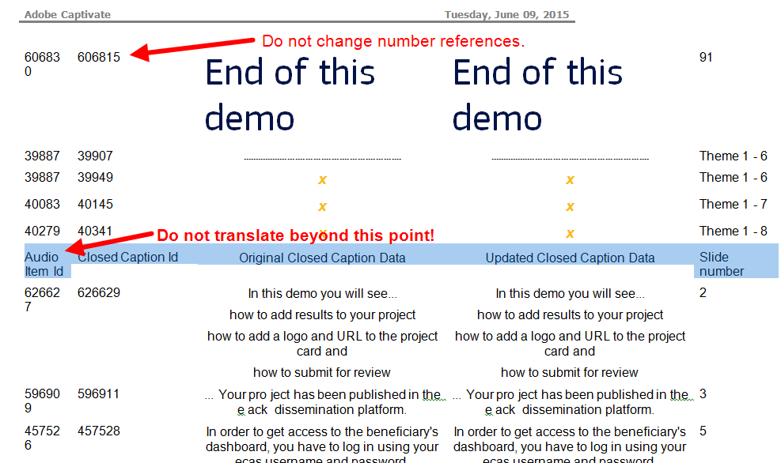
Once translated, import the file into Captivate. Go to File ImportProject Captions and Closed Captions…
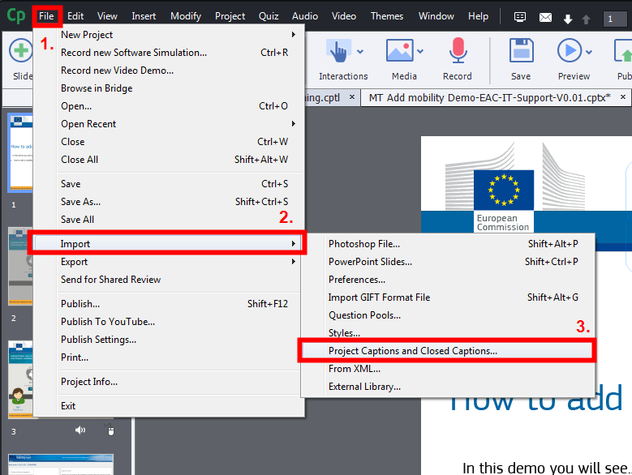

Once imported, check all text captions to ensure that the text is legible and not extending beyond the captions' defined limits.
The below example shows one slide after the text caption is imported. In this example the words "la tarjeta" should be moved to a second text caption on the same slide. Review the slide timing to ensure that the translated text is timed correctly to the length of the slide and the movement of the mouse or the appearance of highlight boxes or arrows.
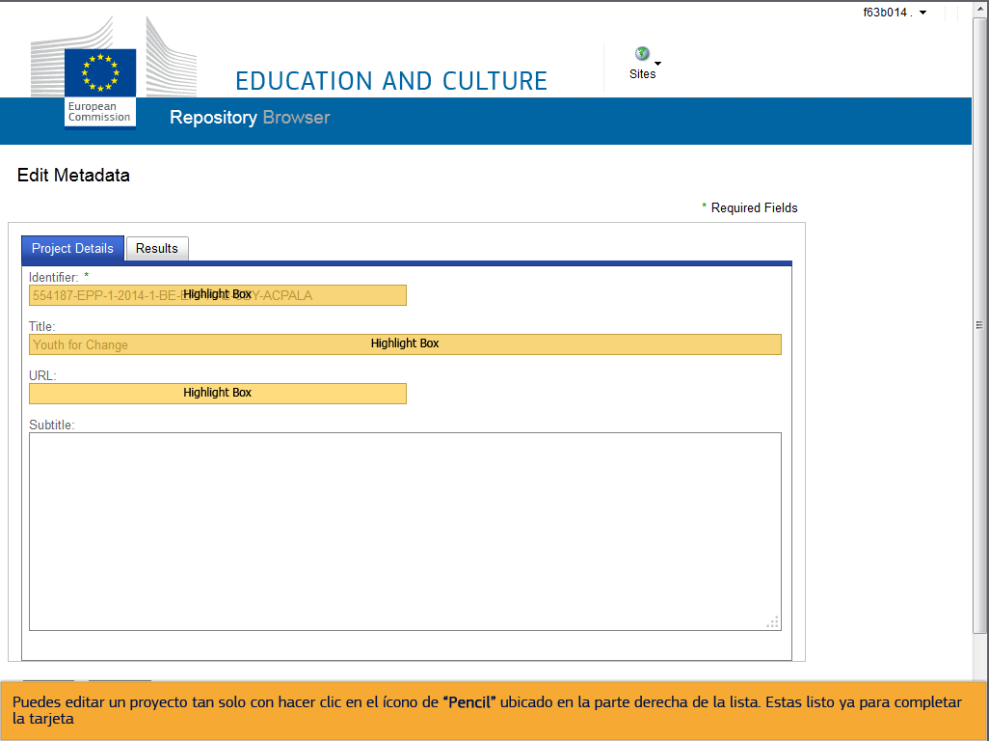
Save the file and publish to the desired settings.

