Slide 1 - Slide 1
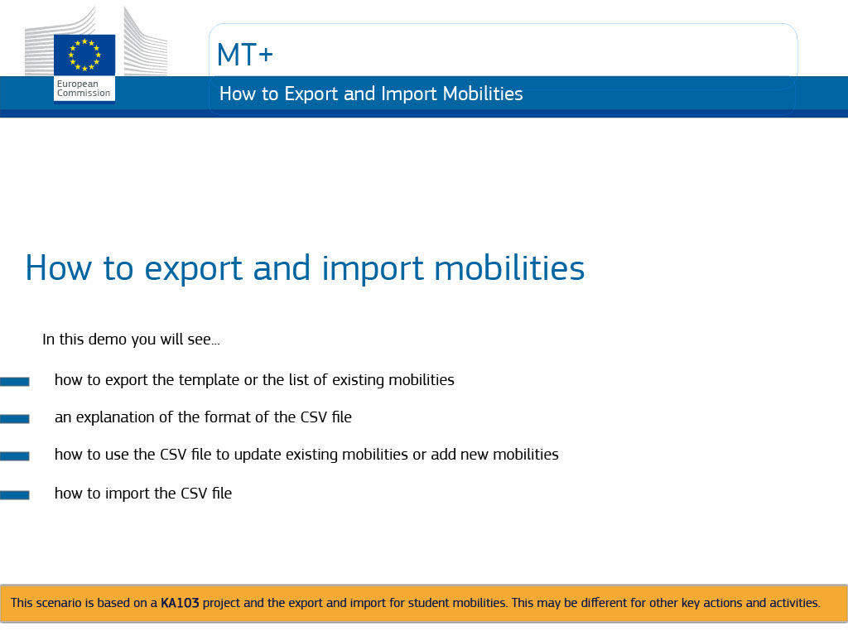
Text Captions

MT+

How to export and import mobilities

In this demo you will see how to export the template or the list of existing mobilities, an explanation of the format of the CSV file how to use the CSV file to update existing mobilities or add new mobilities, and how to import the CSV file.

This scenario is based on a KA103 project and the export and import for student mobilities. This may be different for other key actions and activities.

Slide 2 - Slide 2
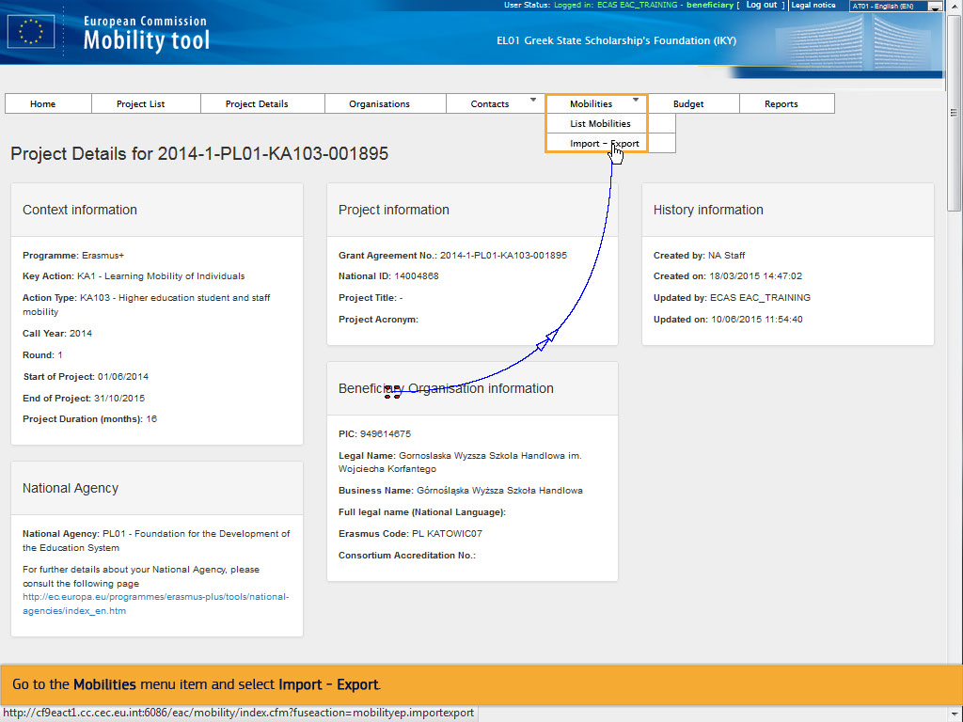
Text Captions

Go to the Mobilities menu item and select Import - Export.

Slide 3 - Slide 3
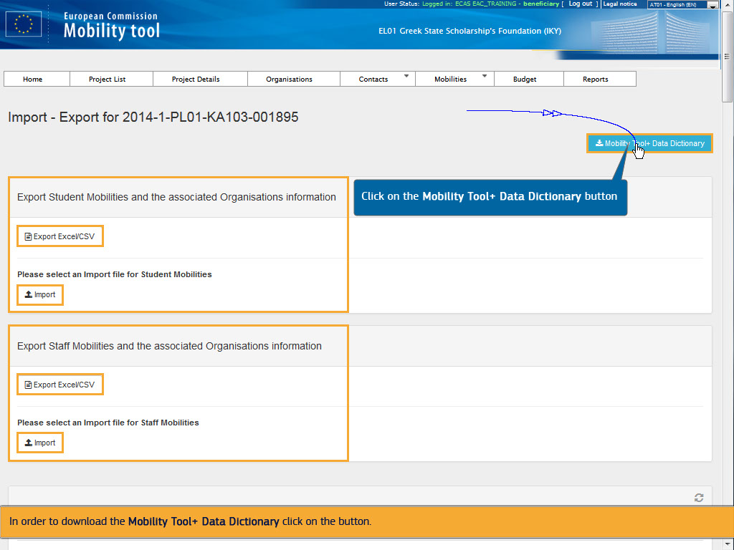
Text Captions

On this screen, you can perform the export and import of student mobilities and of staff mobilities.

Due to the fact that these two types of mobilities contain different fields, there are two separate functionalities which allow the import and export of these types of mobilities.

In order to download the Mobility Tool+ Data Dictionary click on the button.

Click on the Mobility Tool+ Data Dictionary button

Slide 4 - Slide 4
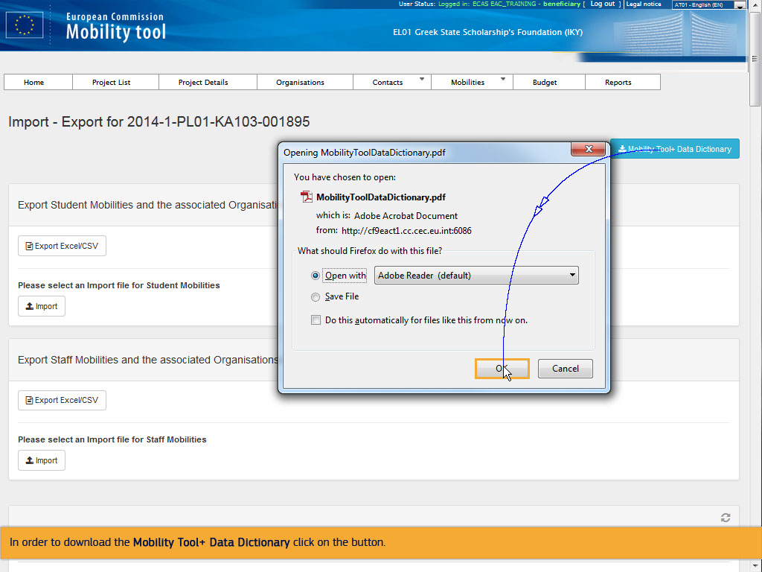
Text Captions

In order to download the Mobility Tool+ Data Dictionary click on the button.

Slide 5 - Slide 5
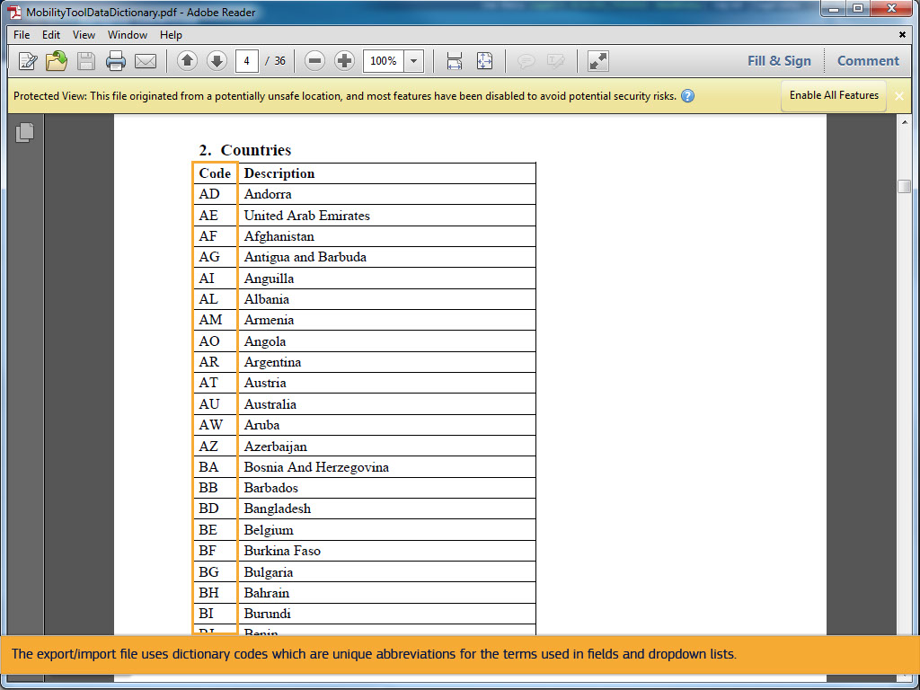
Text Captions

The export/import file uses dictionary codes which are unique abbreviations for the terms used in fields and dropdown lists.

Slide 6 - Slide 6
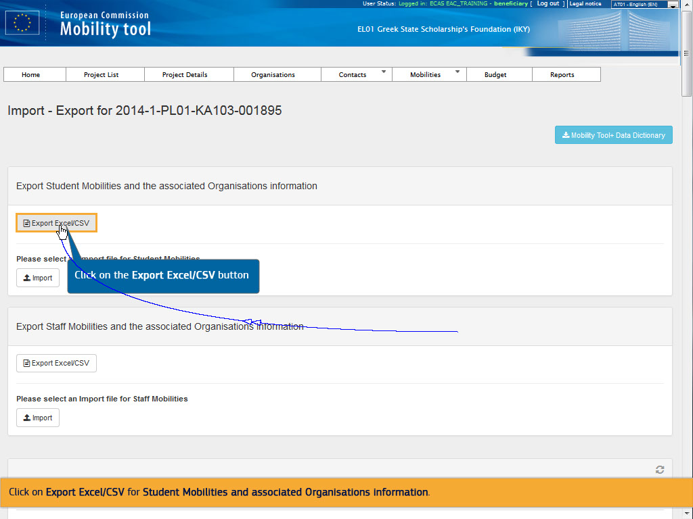
Text Captions

Click on the Export Excel/CSV button

Click on Export Excel/CSV for Student Mobilities and associated Organisations information.

Slide 7 - Slide 7
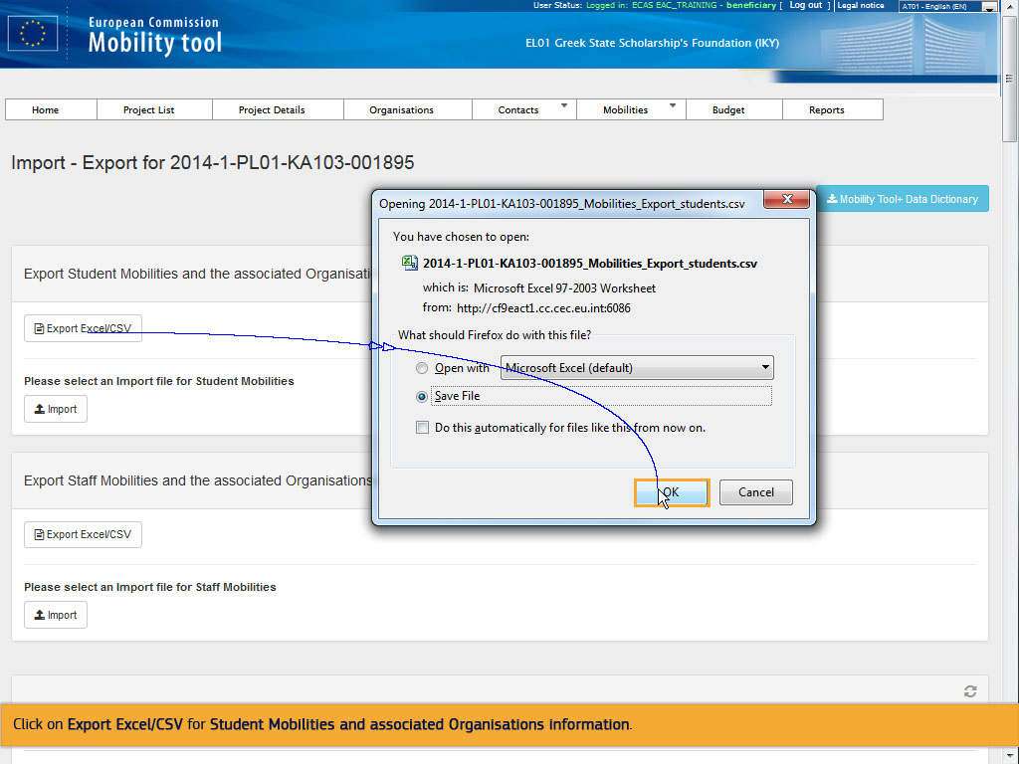
Text Captions

Click on Export Excel/CSV for Student Mobilities and associated Organisations information.

Slide 8 - Slide 8
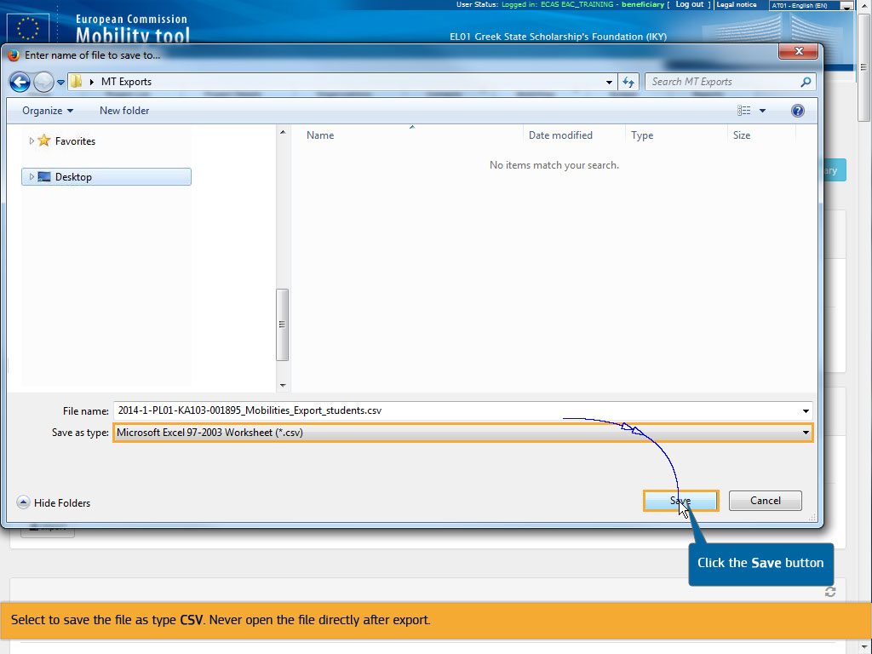
Text Captions

Select to save the file as type CSV. Never open the file directly after export.

Click the Save button

Slide 9 - Slide 9
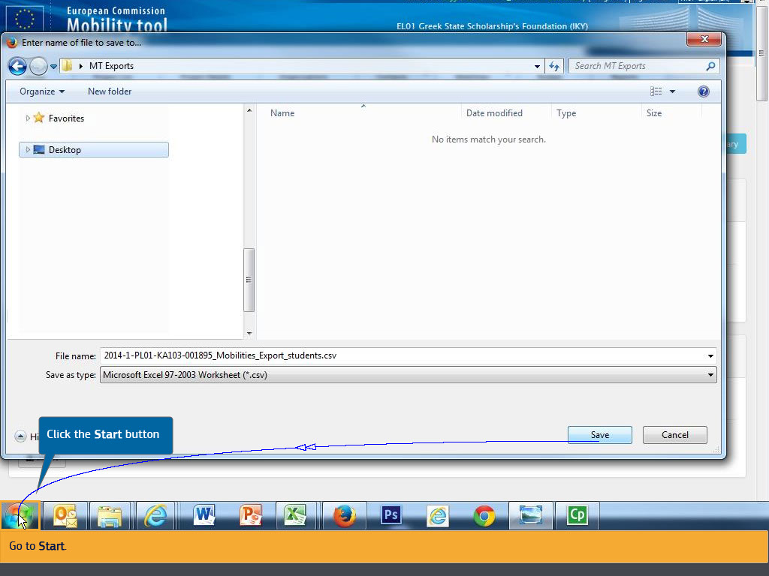
Text Captions

Click the Start button

Go to Start.

Slide 10 - Slide 10
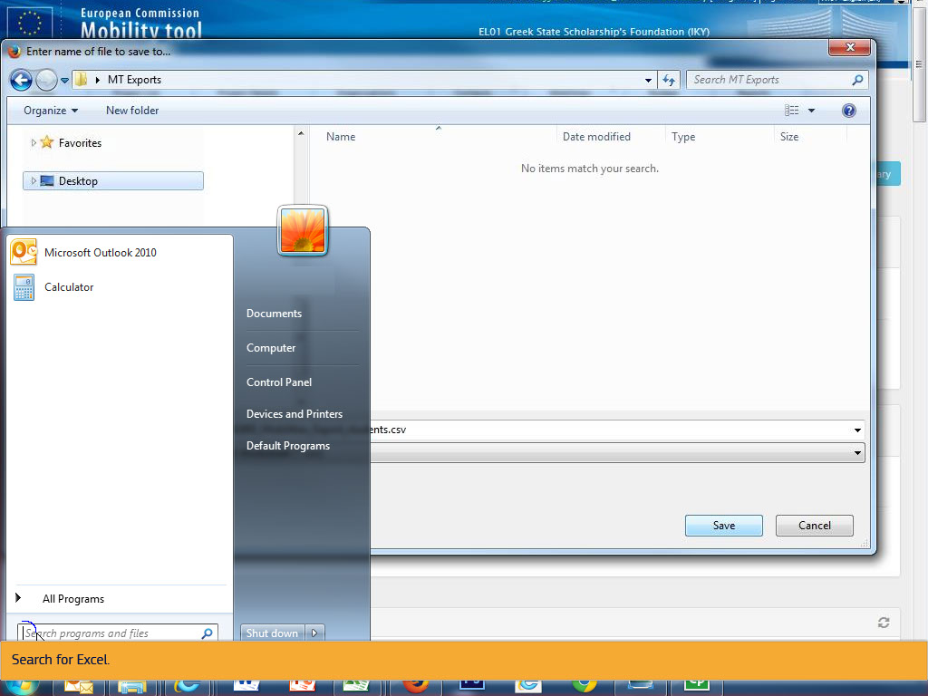
Text Captions

Search for Excel.

Slide 12 - Slide 12
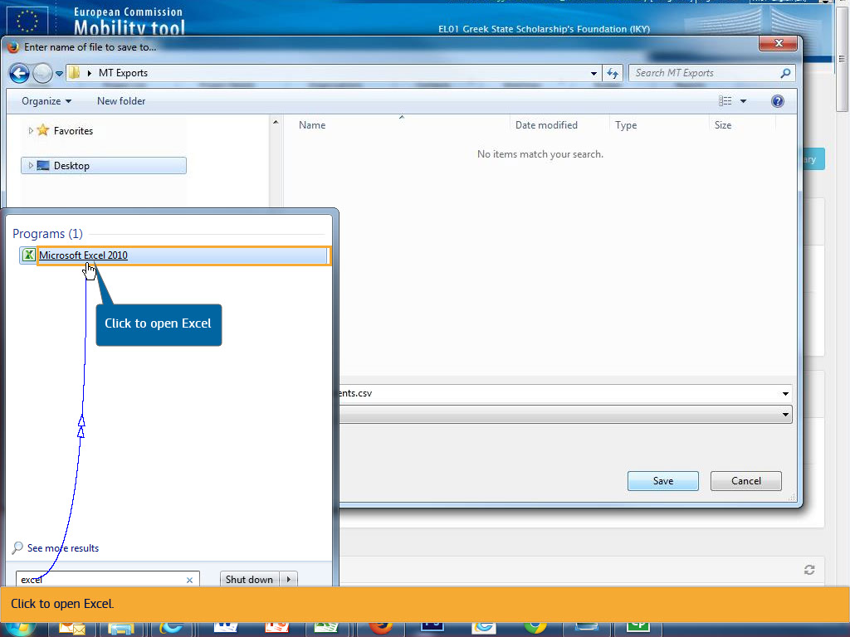
Text Captions

Click to open Excel

Click to open Excel.

Slide 13 - Slide 13
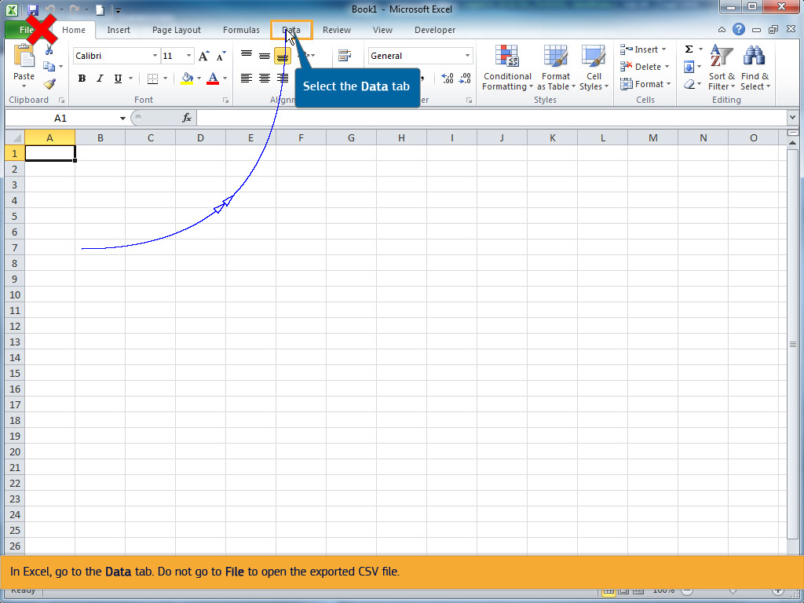
Text Captions

Select the Data tab

In Excel, go to the Data tab. Do not go to File to open the exported CSV file.

Slide 14 - Slide 14
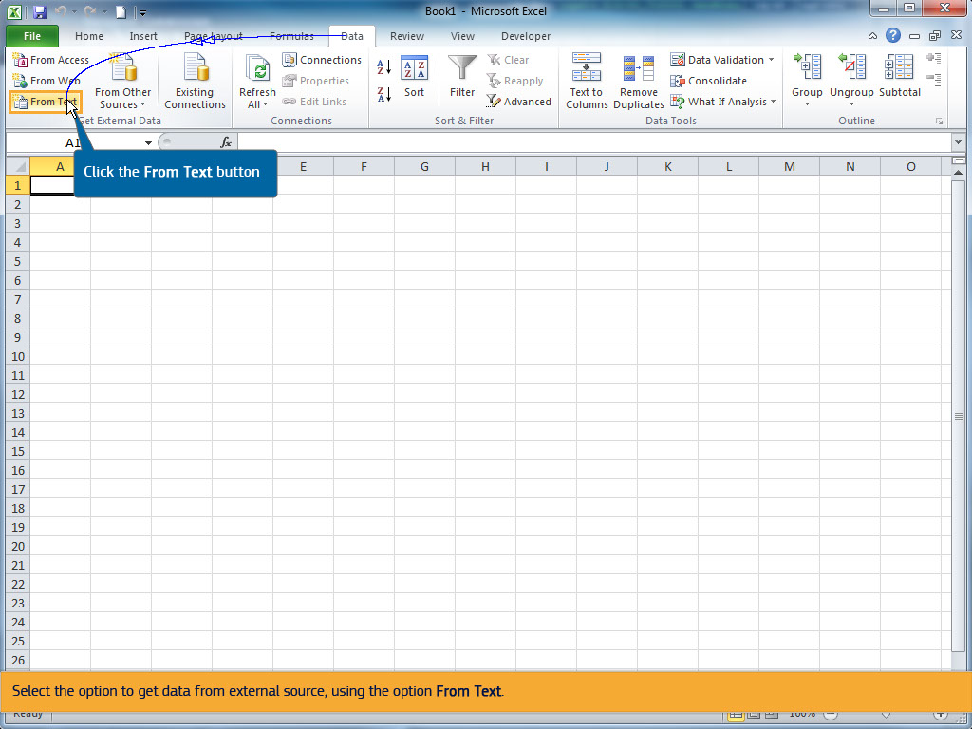
Text Captions

Click the From Text button

Select the option to get data from external source, using the option From Text.

Slide 15 - Slide 15
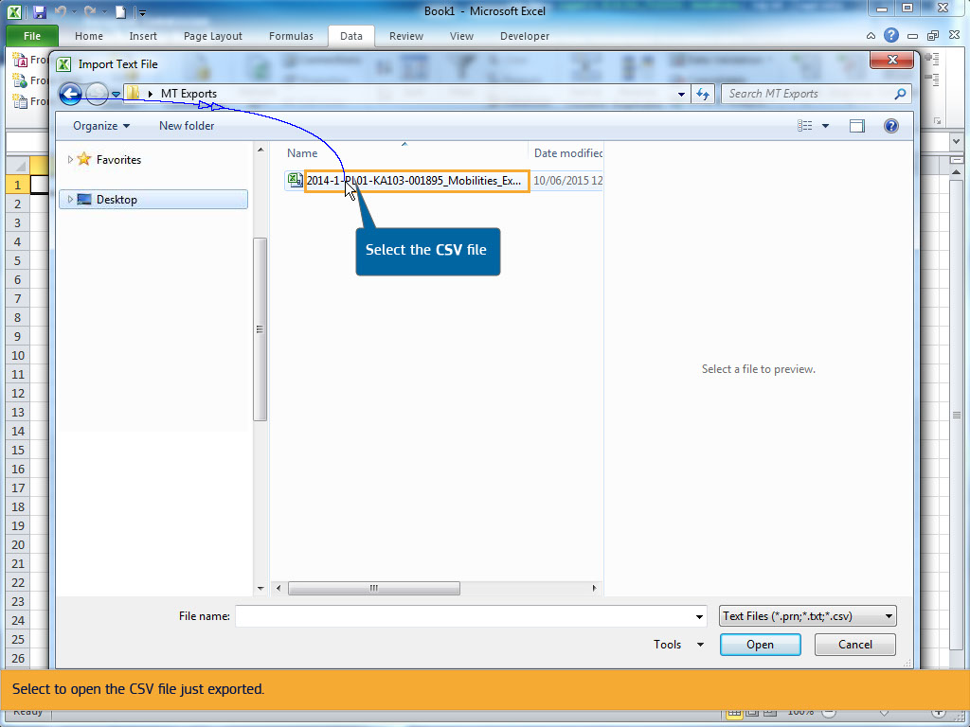
Text Captions

Select the CSV file

Select to open the CSV file just exported.

Slide 17 - Slide 17
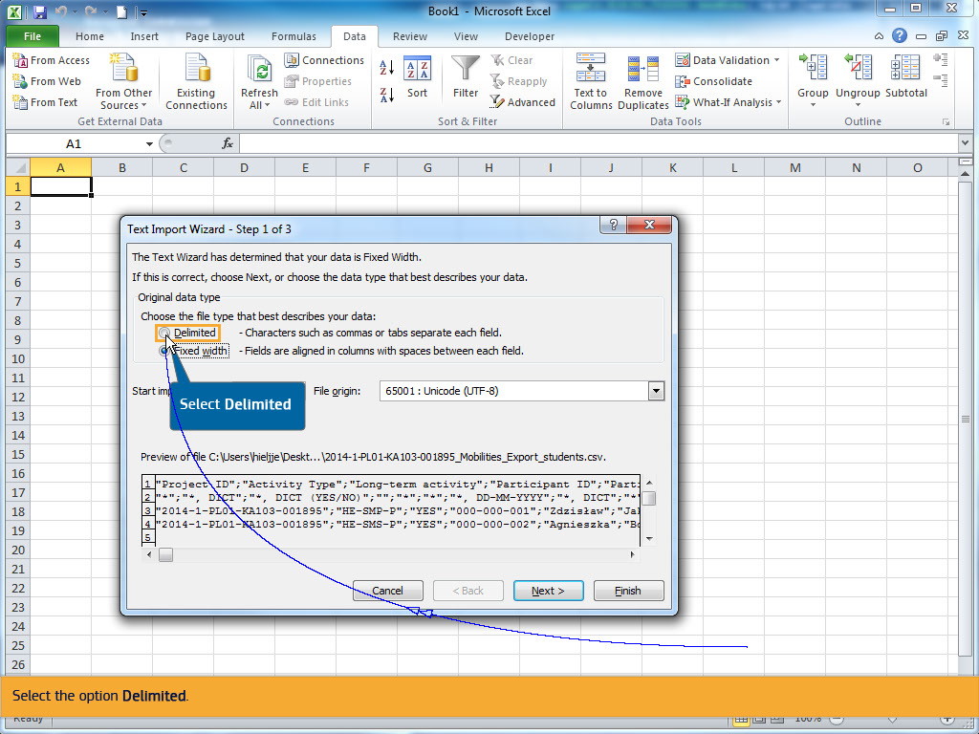
Text Captions

Select the option Delimited.

Select Delimited

Slide 18 - Slide 18
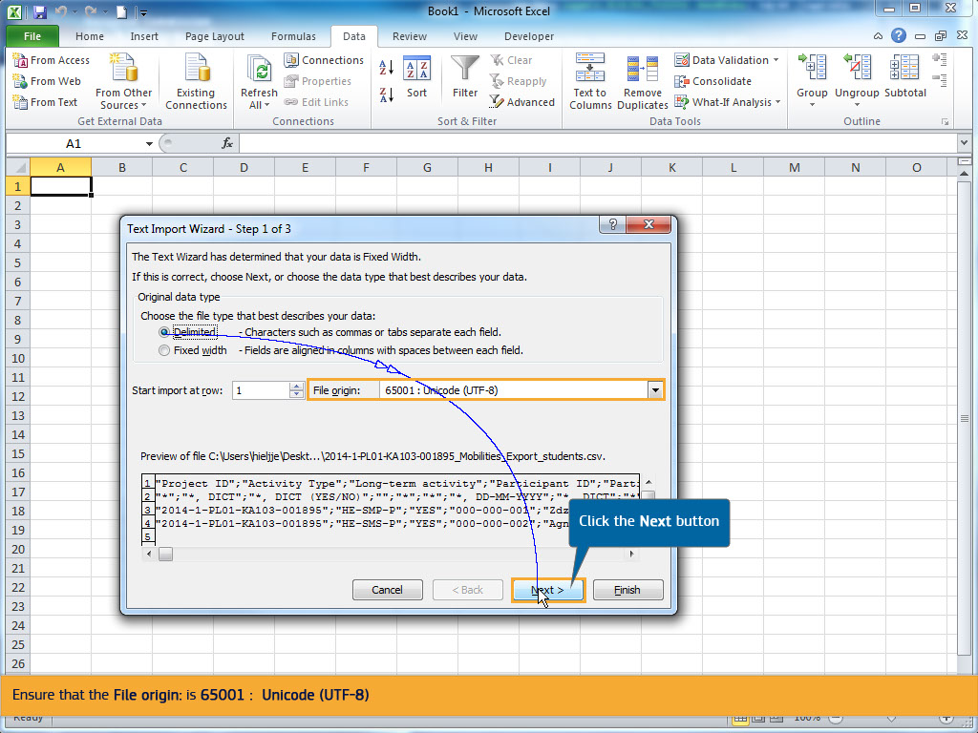
Text Captions

Click the Next button

Ensure that the File origin: is 65001 : Unicode (UTF-8)

Click on Next.

Slide 19 - Slide 19
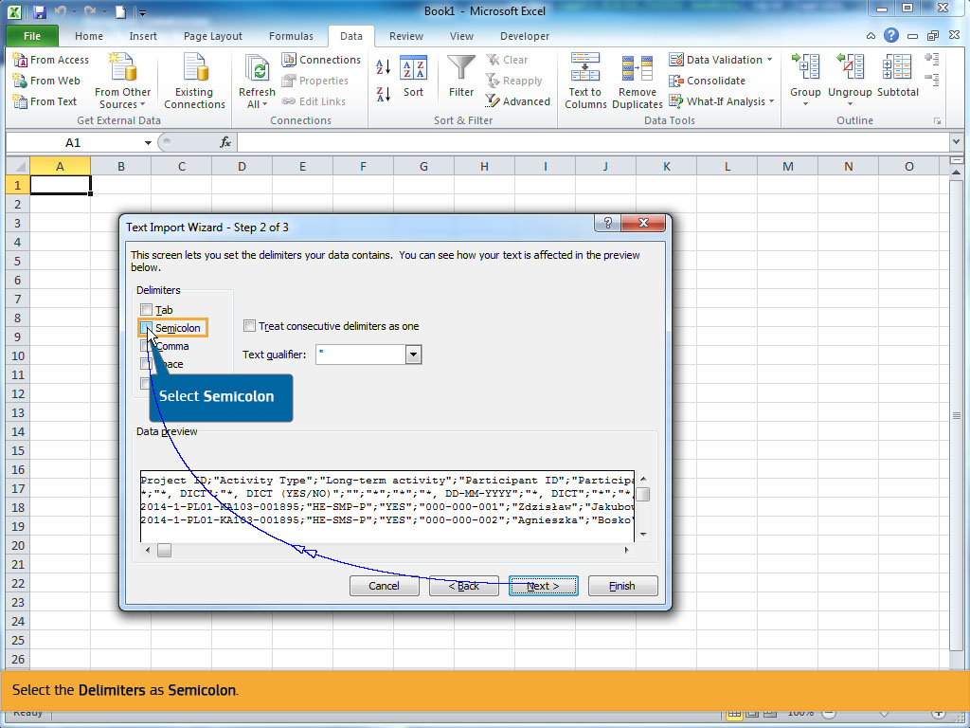
Text Captions

Select Semicolon

Select the Delimiters as Semicolon.

Slide 20 - Slide 20
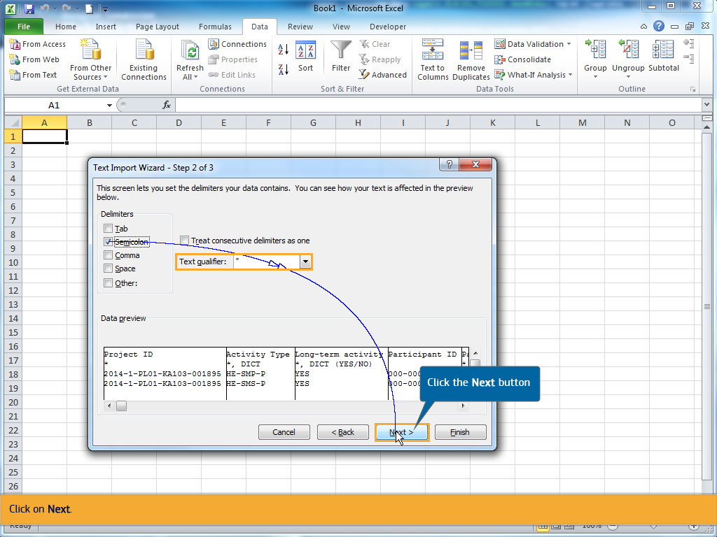
Text Captions

Click the Next button

The text qualifier as a " quotation mark.

Click on Next.

Slide 21 - Slide 21
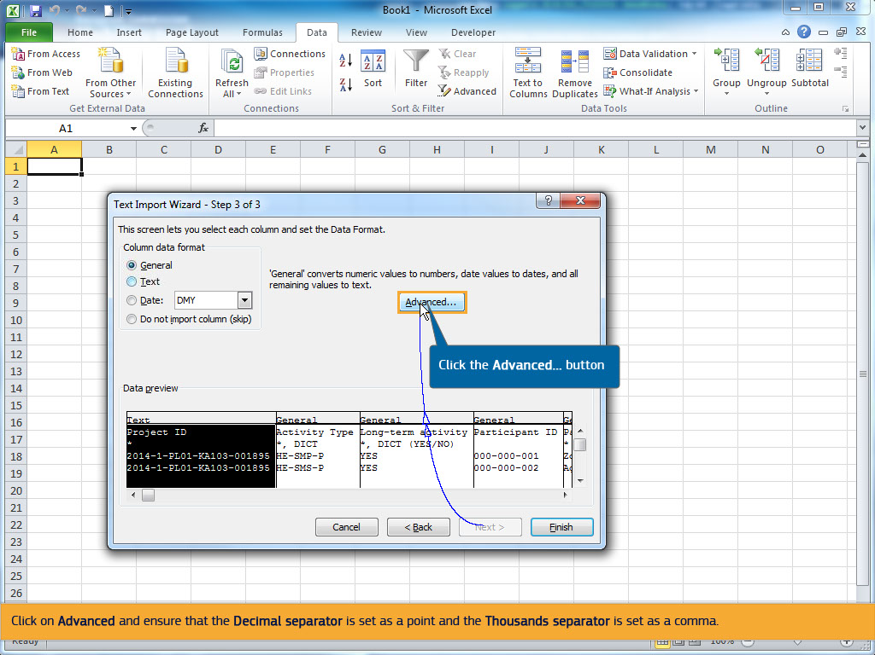
Text Captions

Click the Advanced... button

Click on Advanced and ensure that the Decimal separator is set as a point and the Thousands separator is set as a comma.

Slide 22 - Slide 22
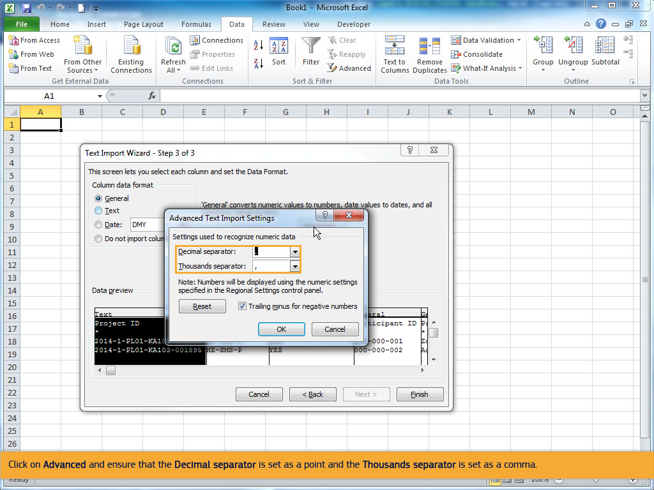
Text Captions

Click on Advanced and ensure that the Decimal separator is set as a point and the Thousands separator is set as a comma.

Slide 23 - Slide 23
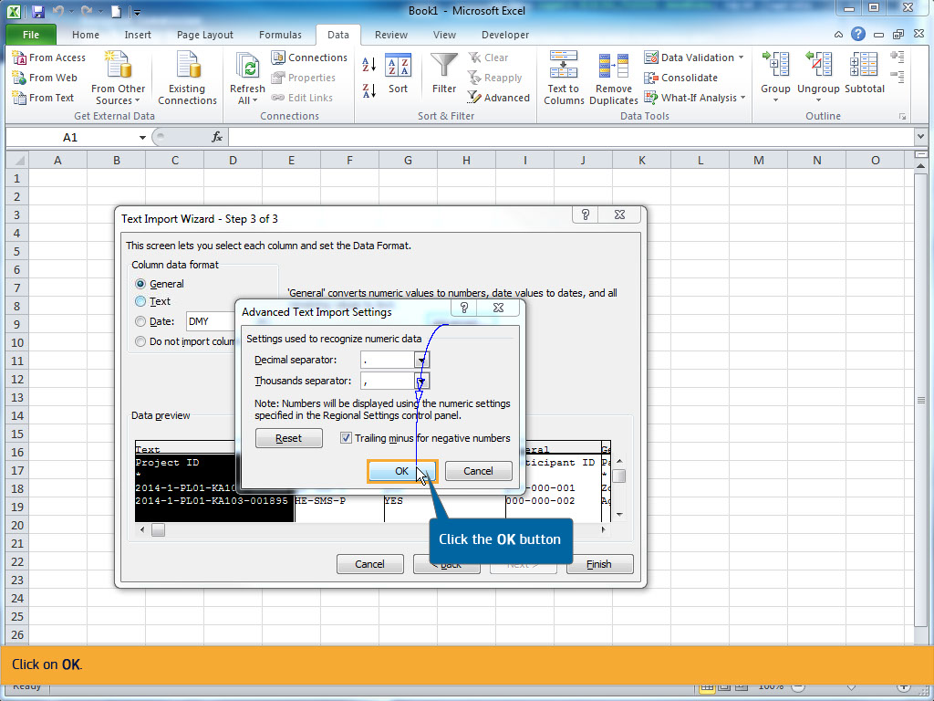
Text Captions

Click the OK button

Click on OK.

Slide 24 - Slide 24
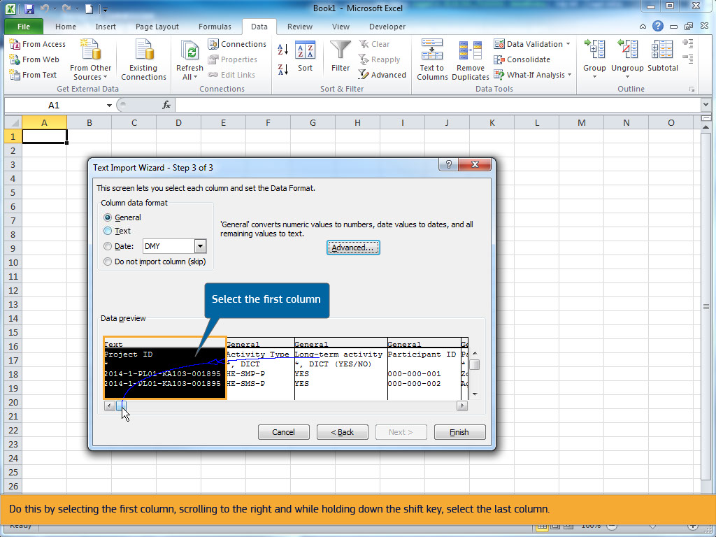
Text Captions

In the Data preview, select all columns.

Do this by selecting the first column, scrolling to the right and while holding down the shift key, select the last column.

Select the first column

Select the first column

Slide 26 - Slide 26
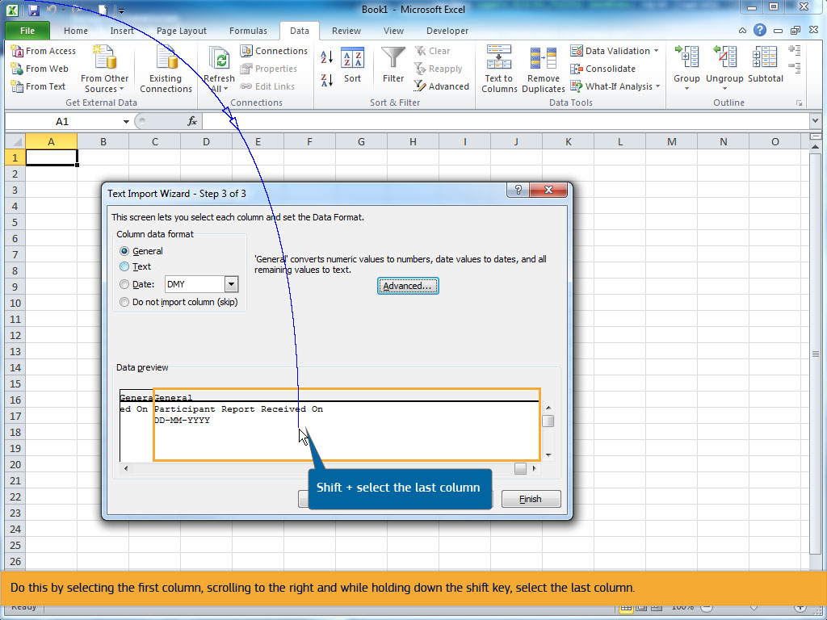
Text Captions

Shift + select the last column

Do this by selecting the first column, scrolling to the right and while holding down the shift key, select the last column.

Slide 27 - Slide 27
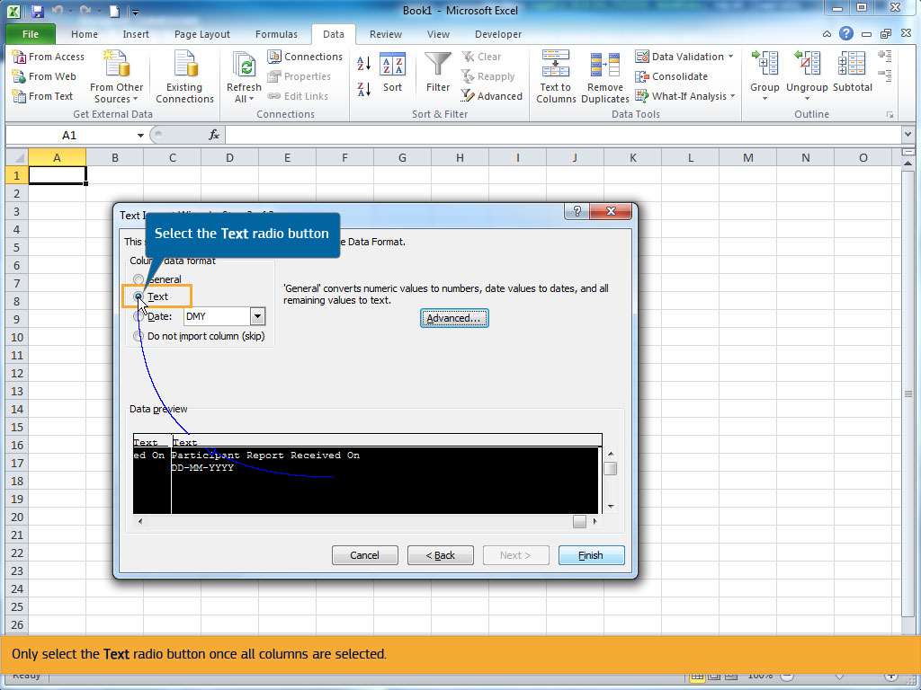
Text Captions

Select the Text radio button

Only select the Text radio button once all columns are selected.

Slide 28 - Slide 28
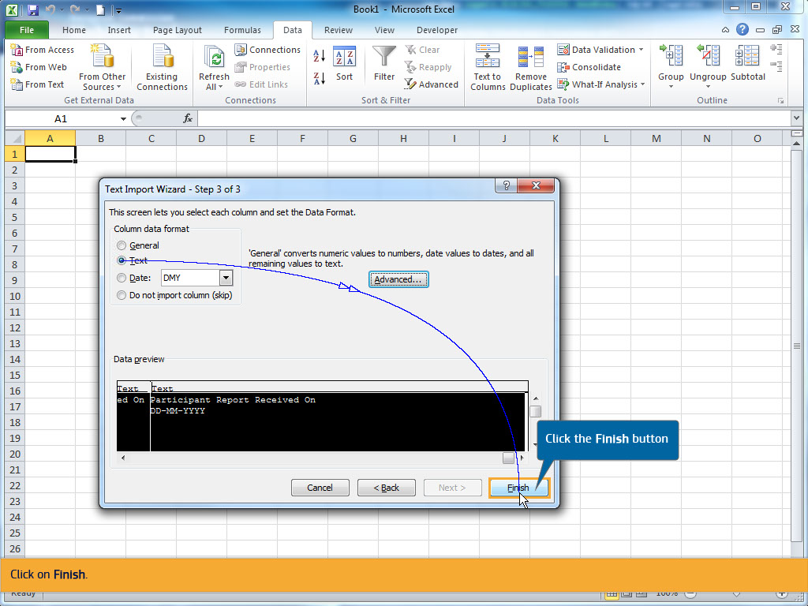
Text Captions

Click the Finish button

Click on Finish.

Slide 29 - Slide 29
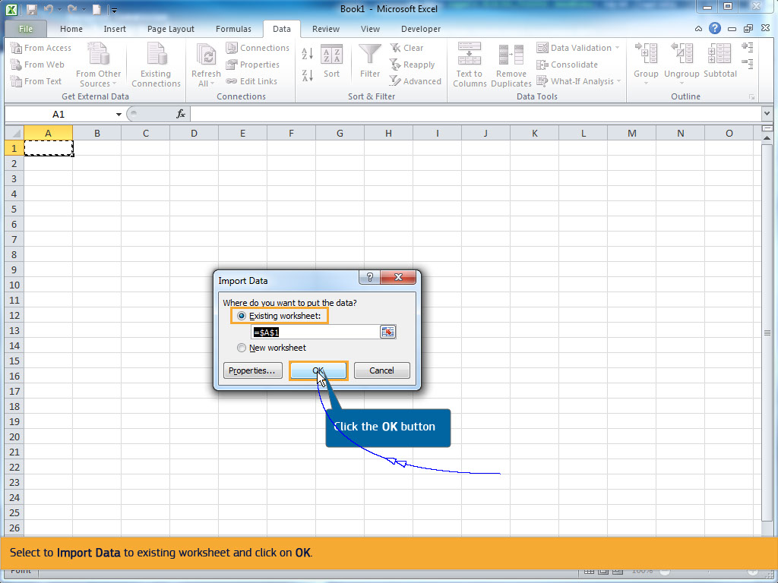
Text Captions

Click the OK button

Select to Import Data to existing worksheet and click on OK.

Slide 30 - Slide 30
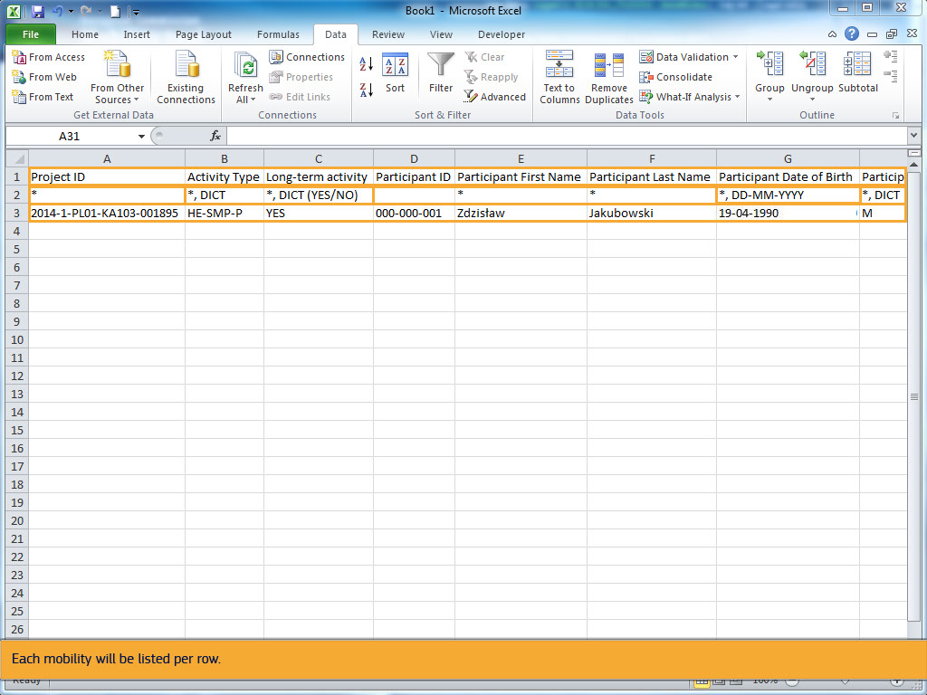
Text Captions

In this example, there is already one mobility added. The first row details the names of the fields.

The second row indicates if the field is mandatory, by the presence of an asterisk. It also indicates if a dictionary value is required or whether special formatting, such as the format for dates or decimal places, is required.

Each mobility will be listed per row.

Slide 31 - Slide 31
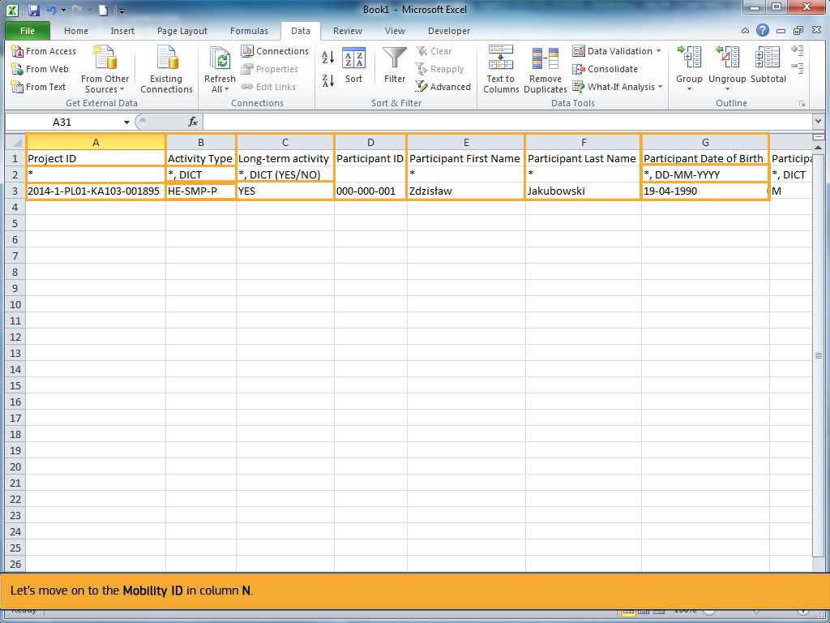
Text Captions

The first column shown is the Project ID. You can note that this is a mandatory field by the presence of an asterisk in the 2nd row.

The second column, Activity Type, is also mandatory and must contain a valid dictionary value.

In this case, it indicates HE-SMP-P for Student mobility for studies between Programme Countries.

The Long-term activity column uses the dictionary value (YES/NO).

Only YES or NO can be used in this cell to indicate if the mobility is a long term activity or not.

The Participant ID column is neither mandatory and no dictionary value or special formatting is required.

The next columns deal with the participant details, First Name, Last Name and Date of Birth.

The Date of Birth field indicates that the value must be entered in the format DD-MM-YYYY.

Let’s move on to the Mobility ID in column N.
Slide 32 - Slide 32
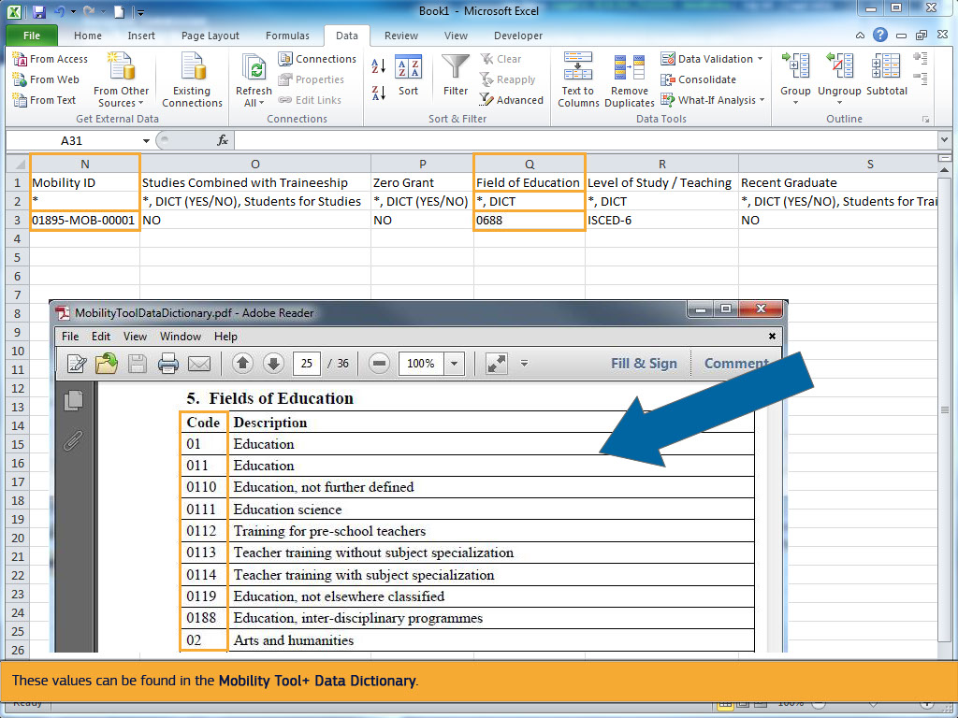
Text Captions

This field is mandatory and must be unique for each mobility entered in the Excel file and for the project.

Changing the Mobility ID slightly, for example replacing the dash with a dot, will create a new mobility.

Changing all other details of the mobility: participant's name, address, etc., but keeping the Mobility ID the same, will overwrite all previous details for that Mobility.

The Field of Education in column Q, is mandatory, and only accepts the dictionary value.

These values can be found in the Mobility Tool+ Data Dictionary.

Slide 33 - Slide 33
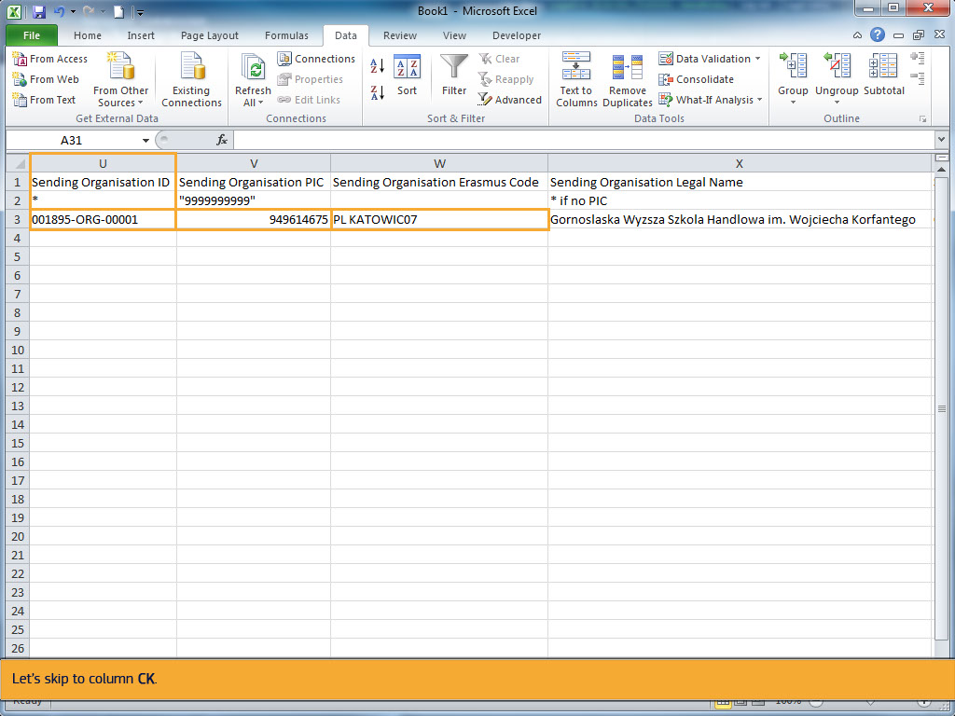
Text Captions

All organisations that have been created in MT+ will have an Organisation ID.

If the Organisation ID is not changed or updated in the project in MT+, then the system will automatically generate the Organisation ID.

It will be composed of the Project ID, the letters ORG and a sequential number. The Organisation ID must be unique for each organisation in the project.

The Organisation ID is linked with both the Erasmus Code and the PIC.

When the Organisation ID, and either the PIC or Erasmus Code are entered, the organisation's remaining details are not required to be completed

in the Import file. This is true for both the sending and receiving organisations details.

Let’s skip to column CK.

Slide 34 - Slide 34
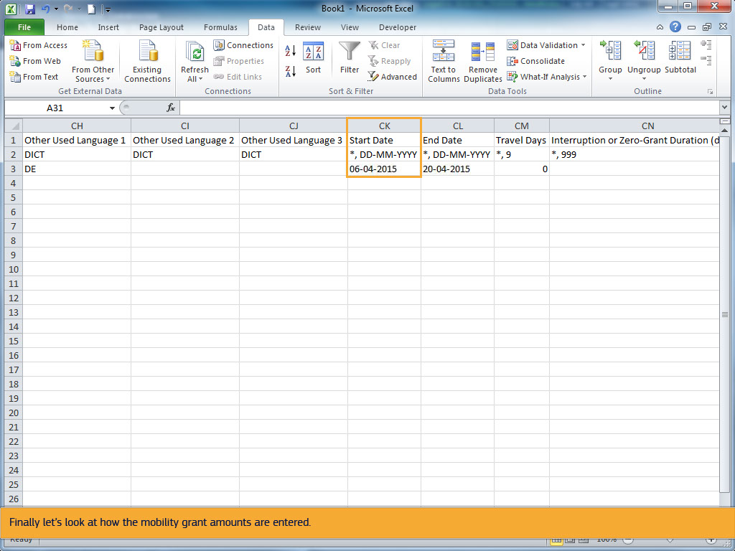
Text Captions

The Start Date of the mobility must have the format DD-MM-YYYY, using a dash as separator.

Finally let’s look at how the mobility grant amounts are entered.

Slide 35 - Slide 35
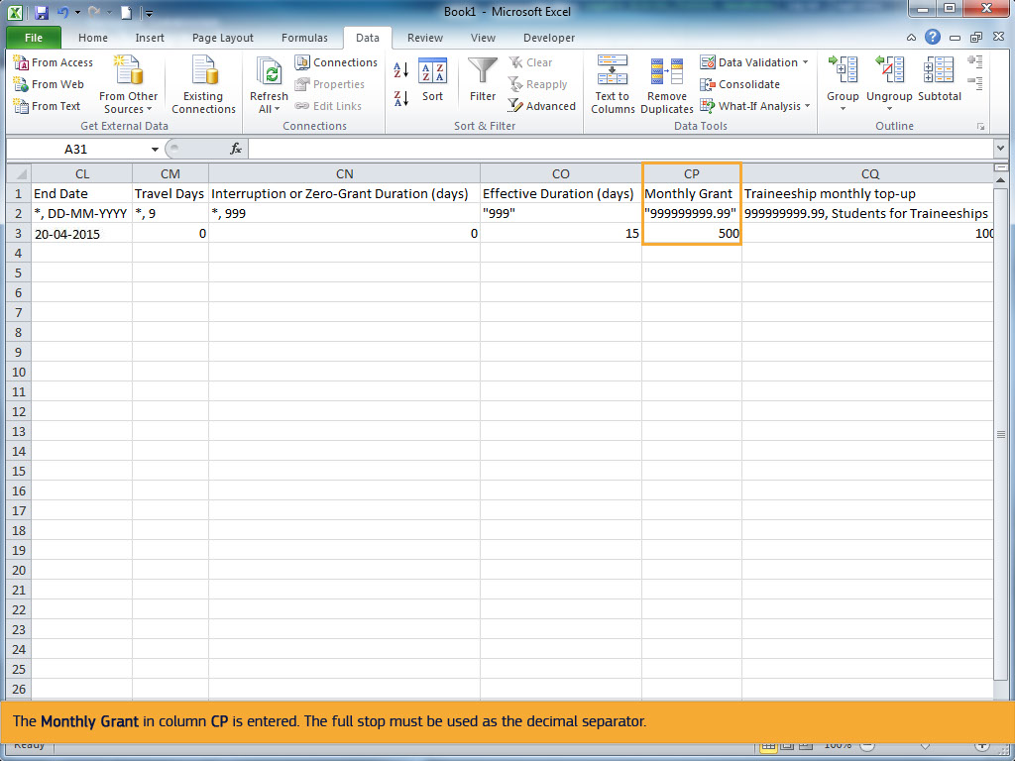
Text Captions

The Monthly Grant in column CP is entered. The full stop must be used as the decimal separator.

Slide 36 - Slide 36
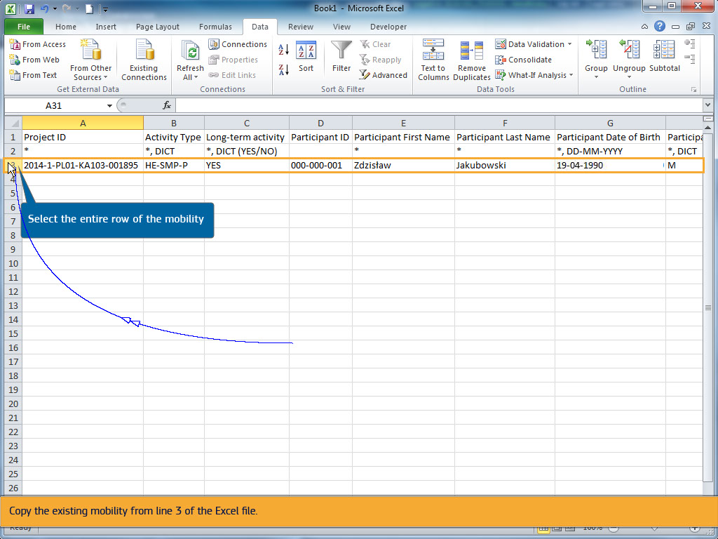
Text Captions

Select the entire row of the mobility

In order to explain how to add new mobilities, we will look at a simple scenario where 5 new mobilities are added.

Each mobility will have a different participant coming from the same organisation and going to the same location.

The mobility budget is also the same for each mobility.

Copy the existing mobility from line 3 of the Excel file.

Slide 37 - Slide 37
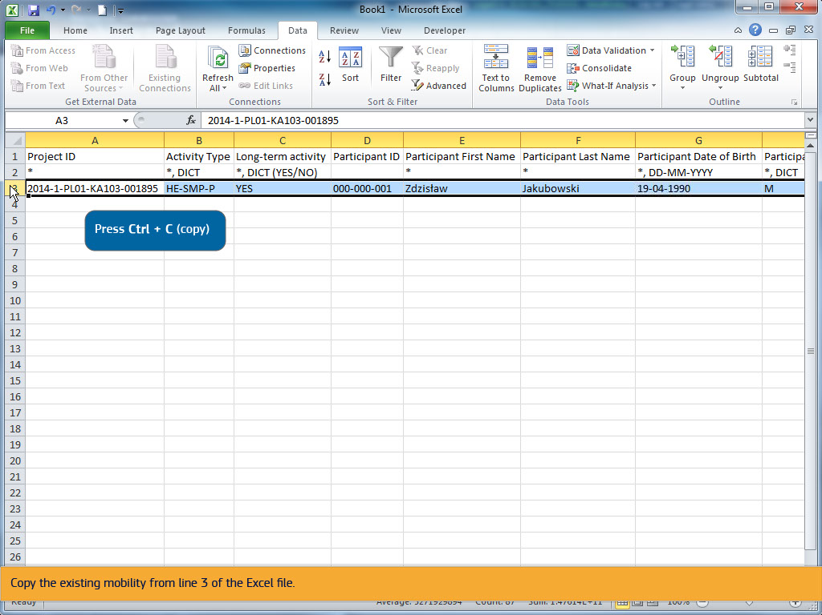
Text Captions

Press Ctrl + C (copy)

Copy the existing mobility from line 3 of the Excel file.

Slide 38 - Slide 38
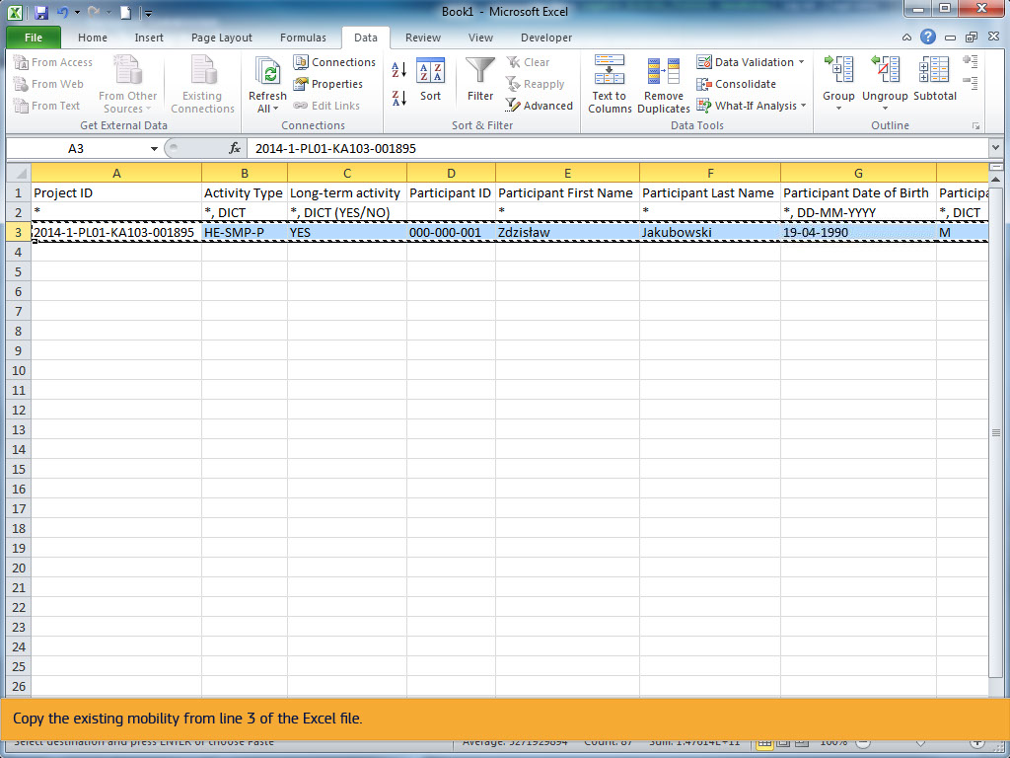
Text Captions

Copy the existing mobility from line 3 of the Excel file.

Slide 39 - Slide 39
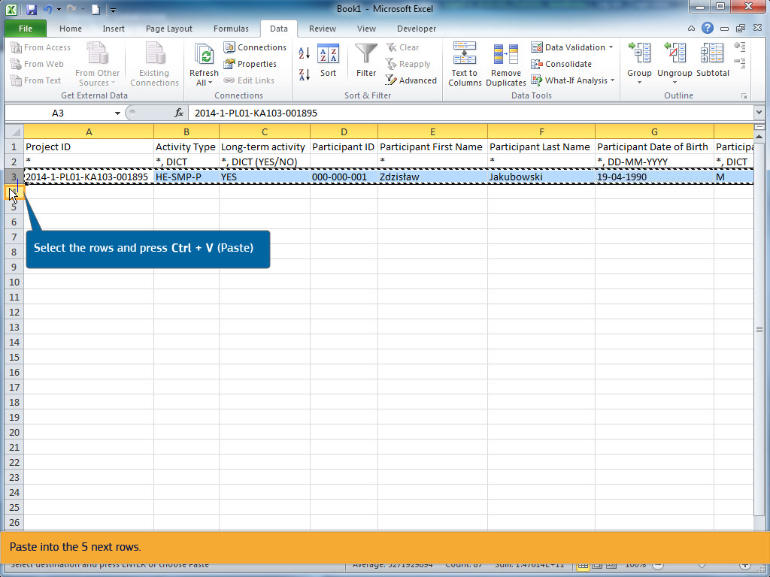
Text Captions

Select the rows and press Ctrl + V (Paste)

Paste into the 5 next rows.

Slide 42 - Slide 42
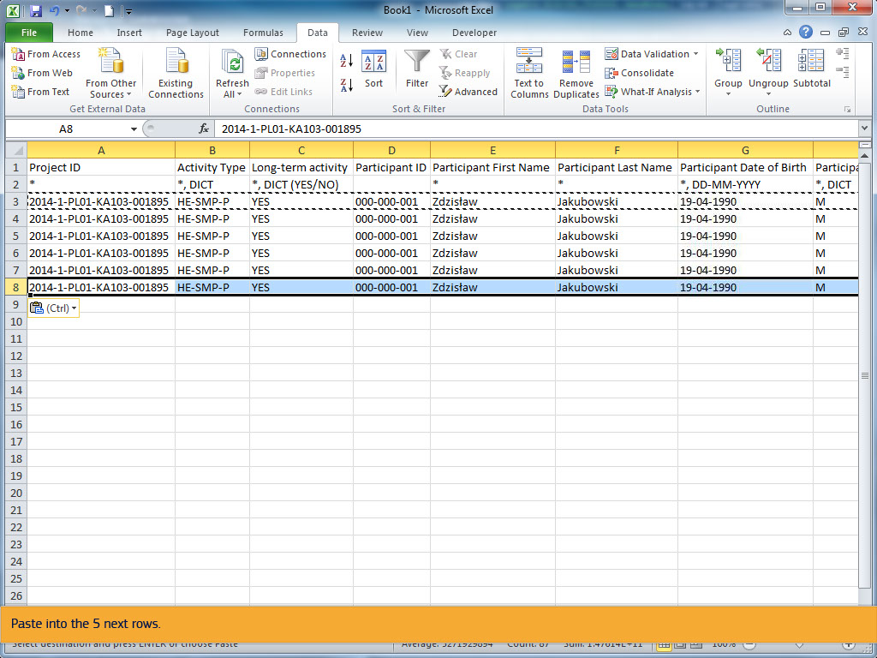
Text Captions

Paste into the 5 next rows.

Slide 43 - Slide 43
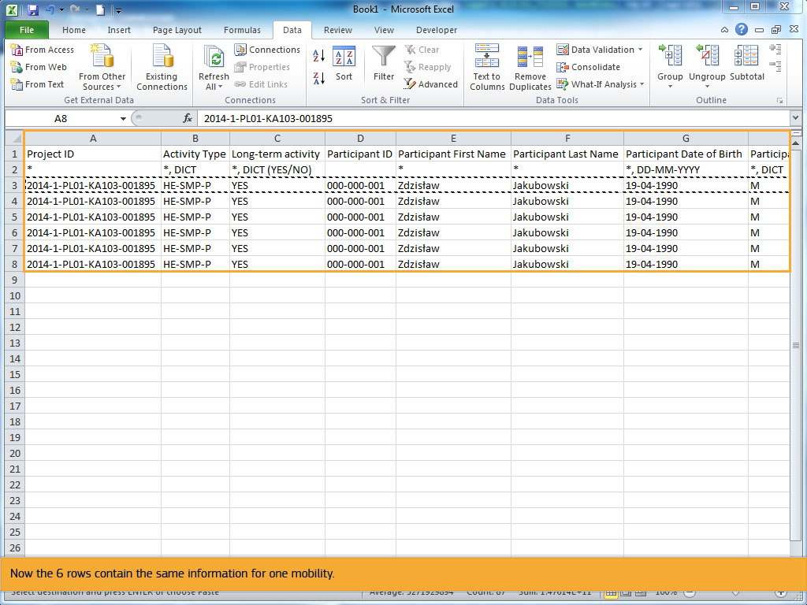
Text Captions

Now the 6 rows contain the same information for one mobility.

Slide 44 - Slide 44
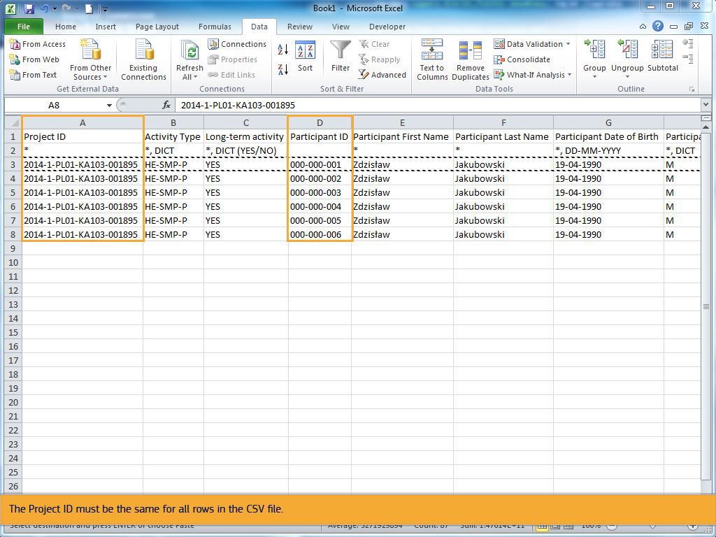
Text Captions

Before completing the details for each participant, update the participant ID with a unique ID or leave blank.

The Project ID must be the same for all rows in the CSV file.

Slide 45 - Slide 45
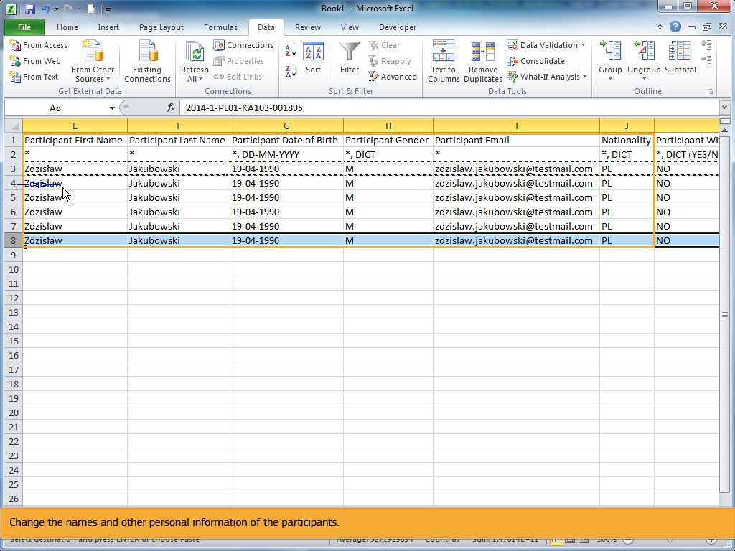
Text Captions

The following cells in each row, must be updated with 5 different participant details and a unique Mobility ID.

Change the names and other personal information of the participants.

Slide 49 - Slide 49
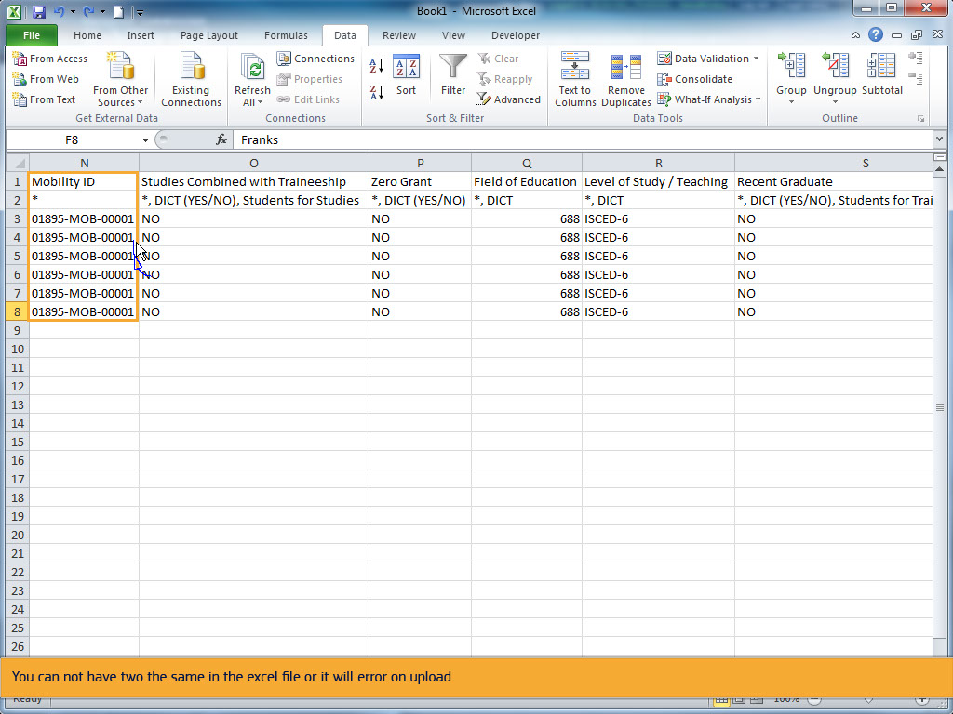
Text Captions

Don't forget to provide a unique Mobility ID for each row. This must be unique for the project.

You can not have two the same in the excel file or it will error on upload.

Slide 51 - Slide 51
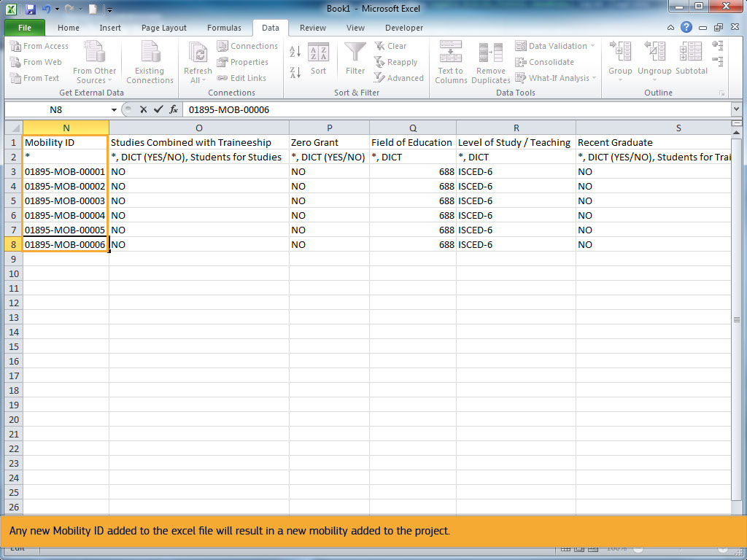
Text Captions

If the Mobility ID is the same as an existing Mobility ID, it will overwrite the existing mobility.

Any new Mobility ID added to the excel file will result in a new mobility added to the project.

Slide 52 - Slide 52
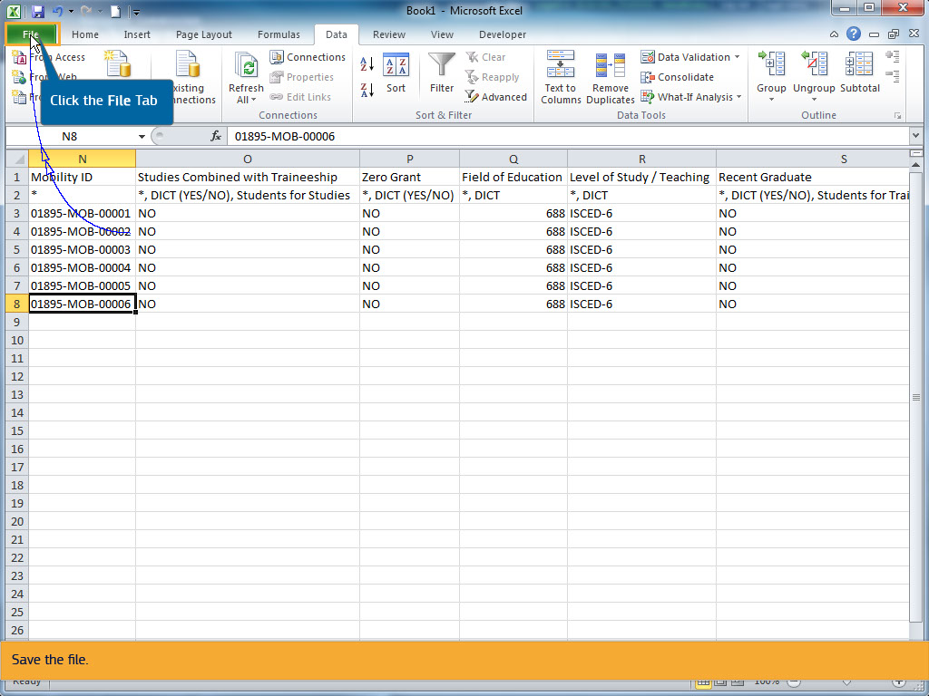
Text Captions

Click the File Tab

Save the file.

Slide 53 - Slide 53
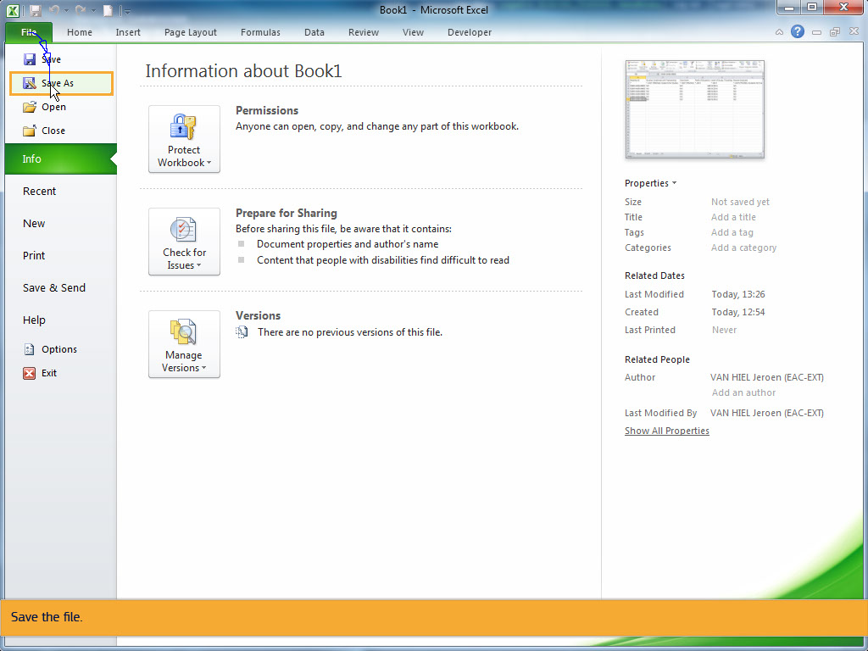
Text Captions

Save the file.

Slide 54 - Slide 54
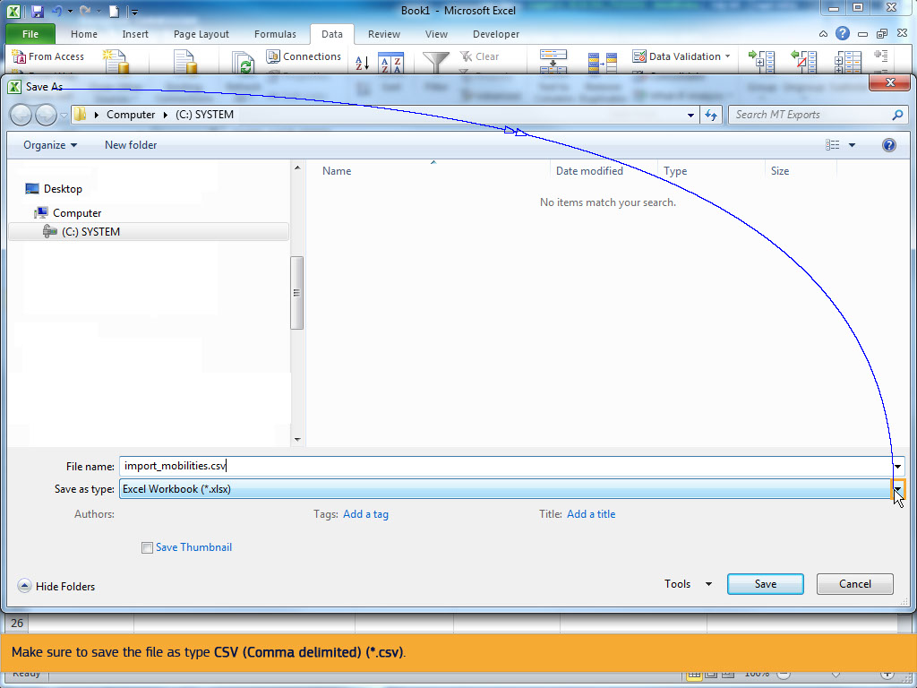
Text Captions

Make sure to save the file as type CSV (Comma delimited) (*.csv).

Slide 55 - Slide 55
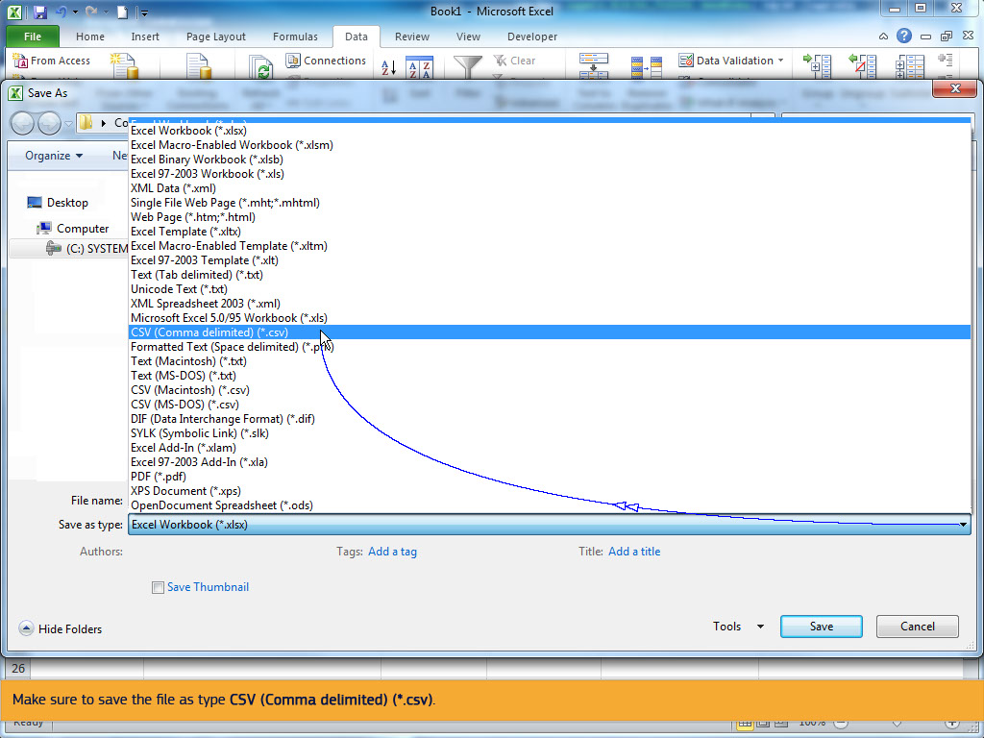
Text Captions

Make sure to save the file as type CSV (Comma delimited) (*.csv).

Slide 56 - Slide 56
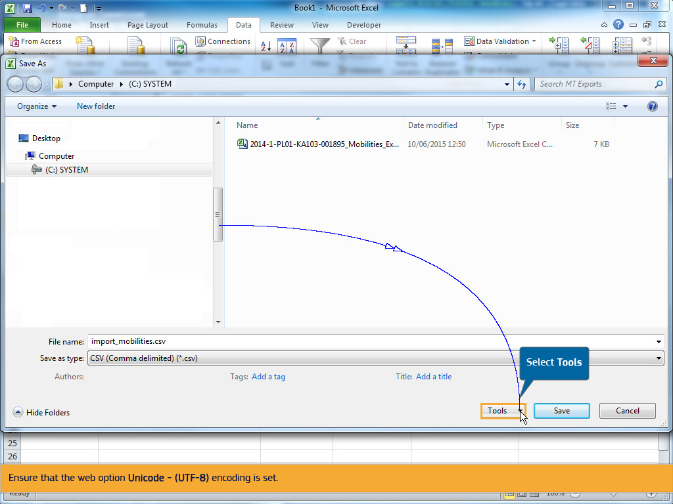
Text Captions

Select Tools

Ensure that the web option Unicode - (UTF-8) encoding is set.

Slide 57 - Slide 57
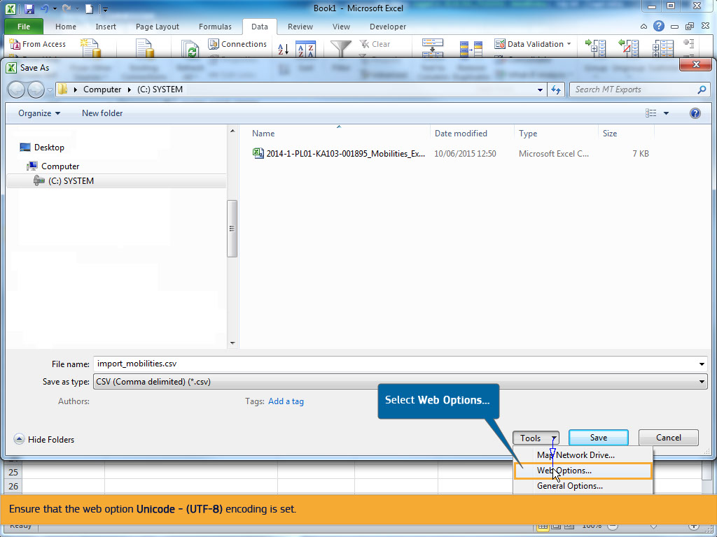
Text Captions

Select Web Options...

Ensure that the web option Unicode - (UTF-8) encoding is set.

Slide 58 - Slide 58
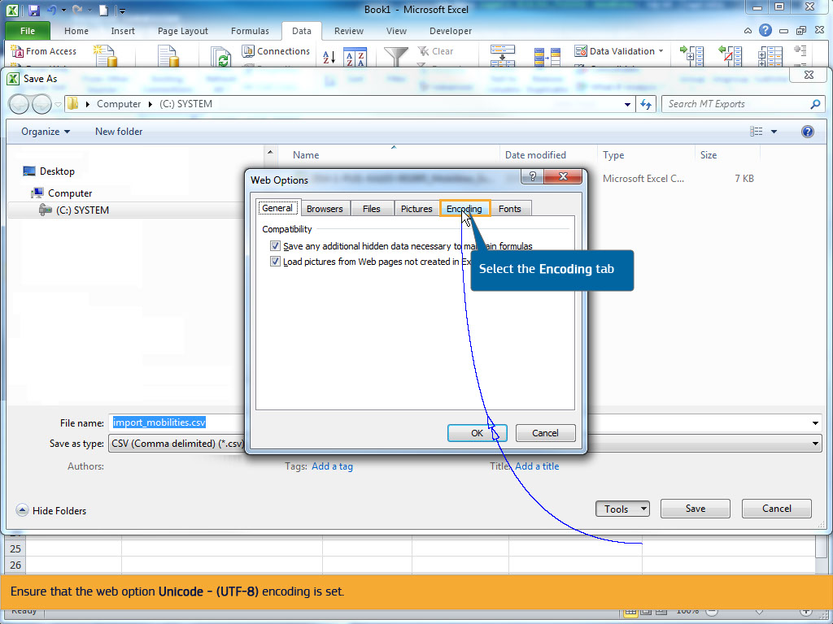
Text Captions

Select the Encoding tab

Ensure that the web option Unicode - (UTF-8) encoding is set.

Slide 59 - Slide 59
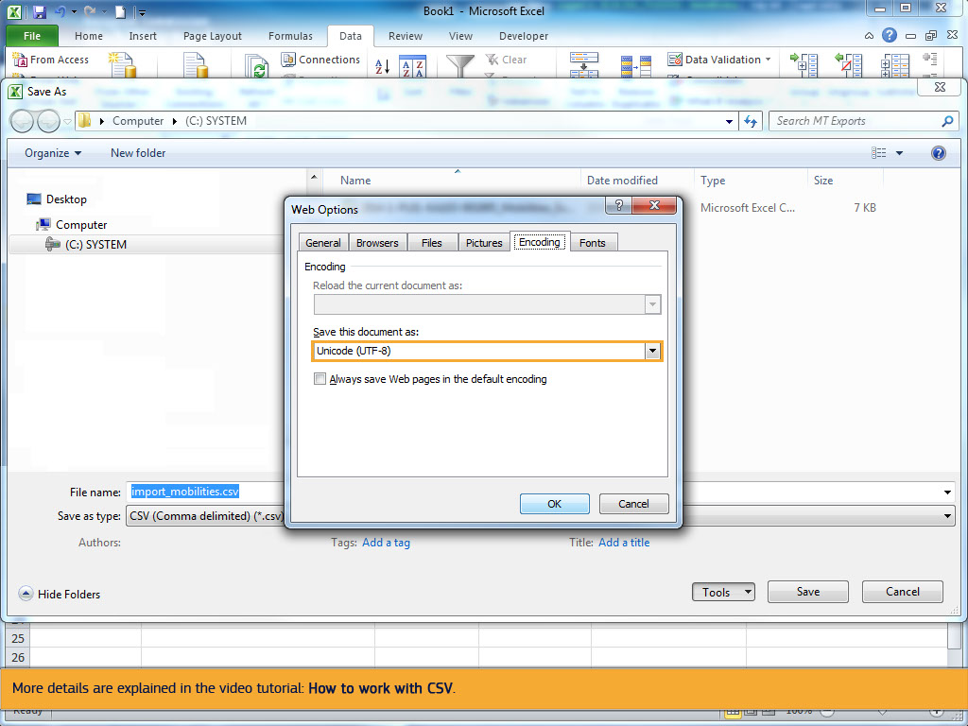
Text Captions

Please note, that even though UTF-8 is selected, MS Excel will not save the characters correctly for most of the 27 alphabets used by National Agencies and participant of the Erasmus+ programme.

In this case use an alternative tool such as LibreOffice Calc, Apache Open Office Calc or iworks Numbers.

More details are explained in the video tutorial: How to work with CSV.

Slide 60 - Slide 60
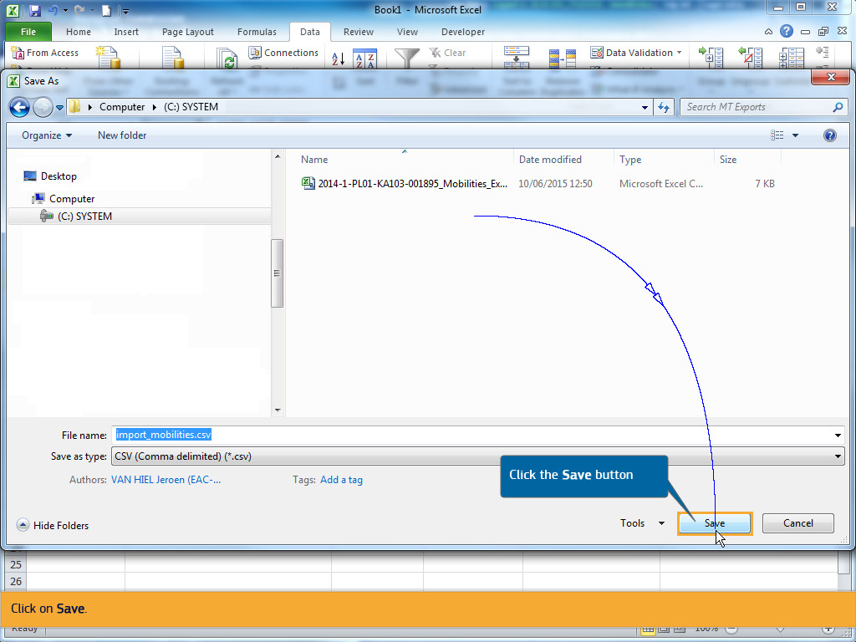
Text Captions

Click the Save button

Click on Save.

Slide 61 - Slide 61
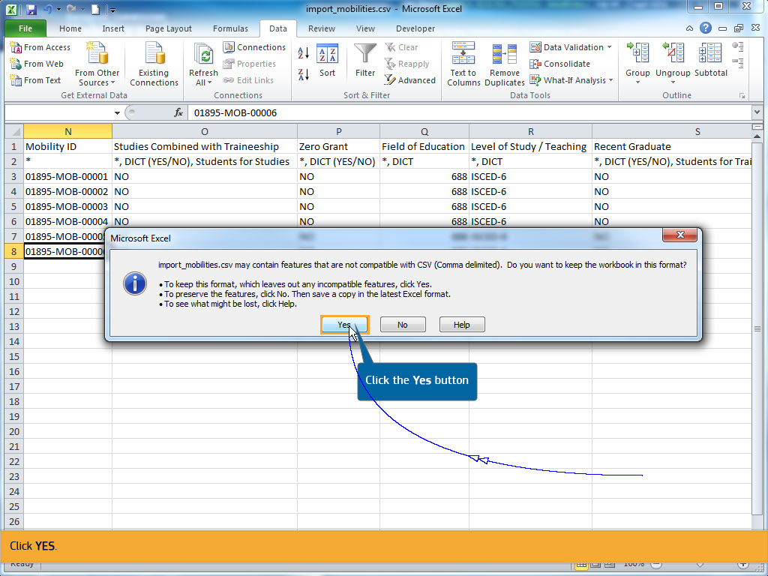
Text Captions

Click the Yes button

Click YES.

Slide 62 - Slide 62
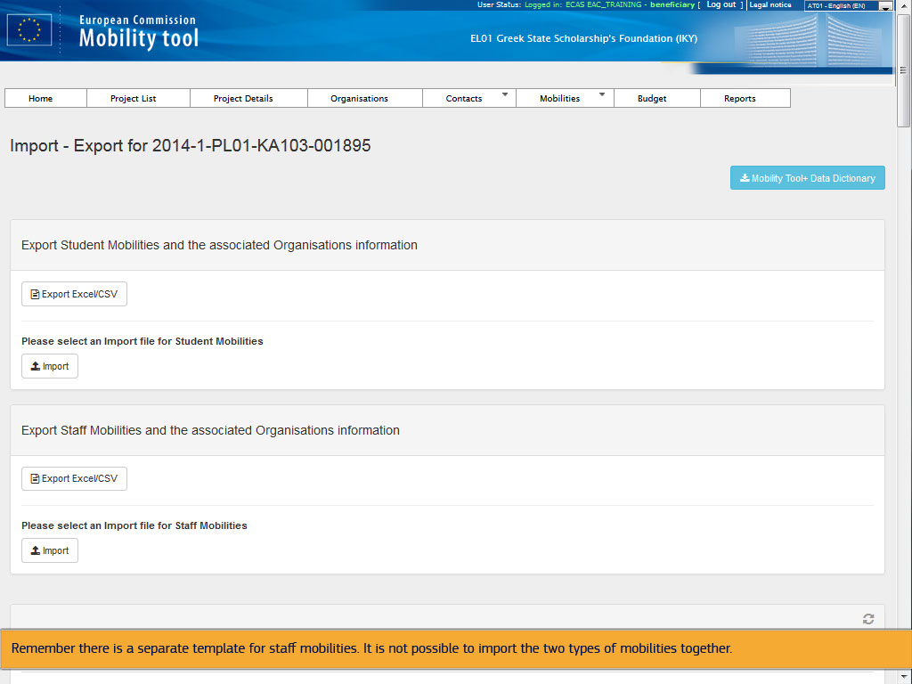
Text Captions

Return to the Import - Export mobilities screen of your project.

Now you are ready to import the list of Student Mobilities and the associated Organisation information.

Remember there is a separate template for staff mobilities. It is not possible to import the two types of mobilities together.

Slide 63 - Slide 63
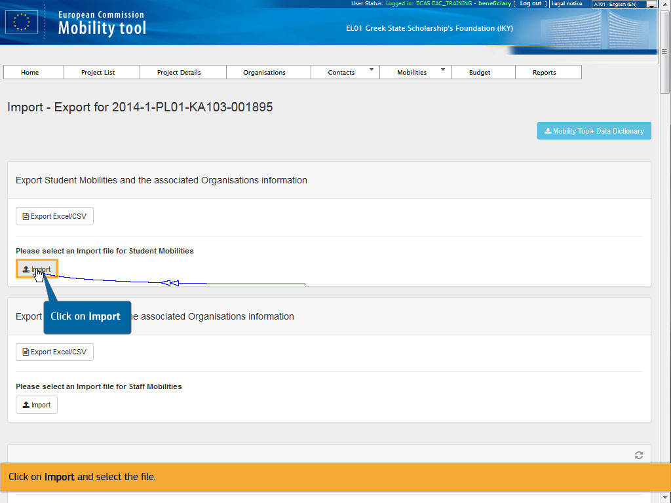
Text Captions

Click on Import

Click on Import and select the file.

Slide 64 - Slide 64
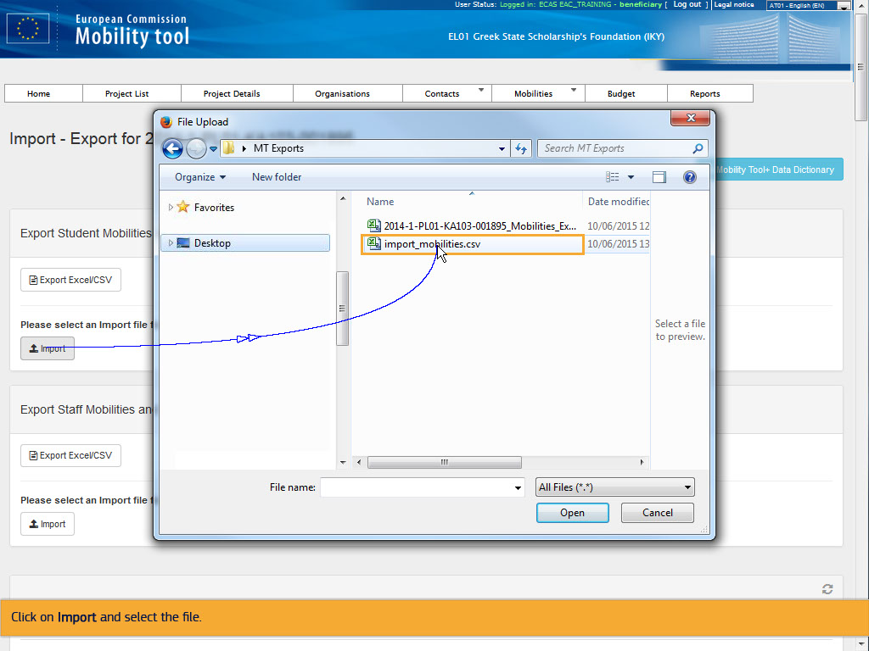
Text Captions

Click on Import and select the file.

Slide 65 - Slide 65
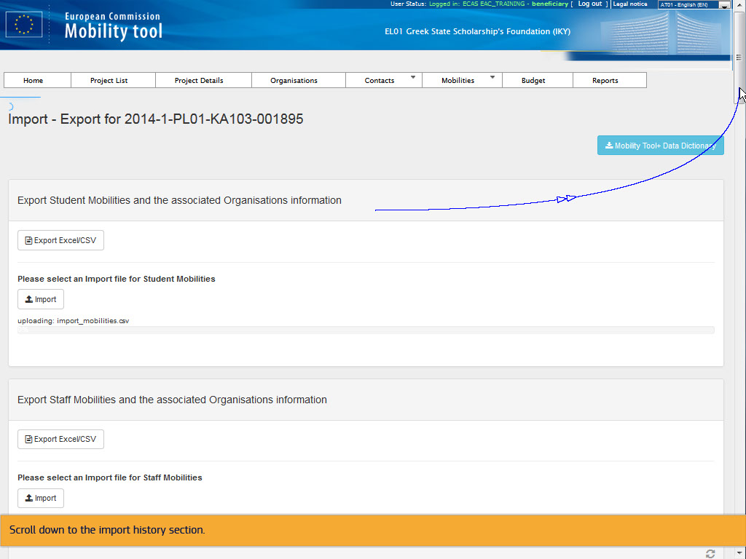
Text Captions

Scroll down to the import history section.

Slide 66 - Slide 66
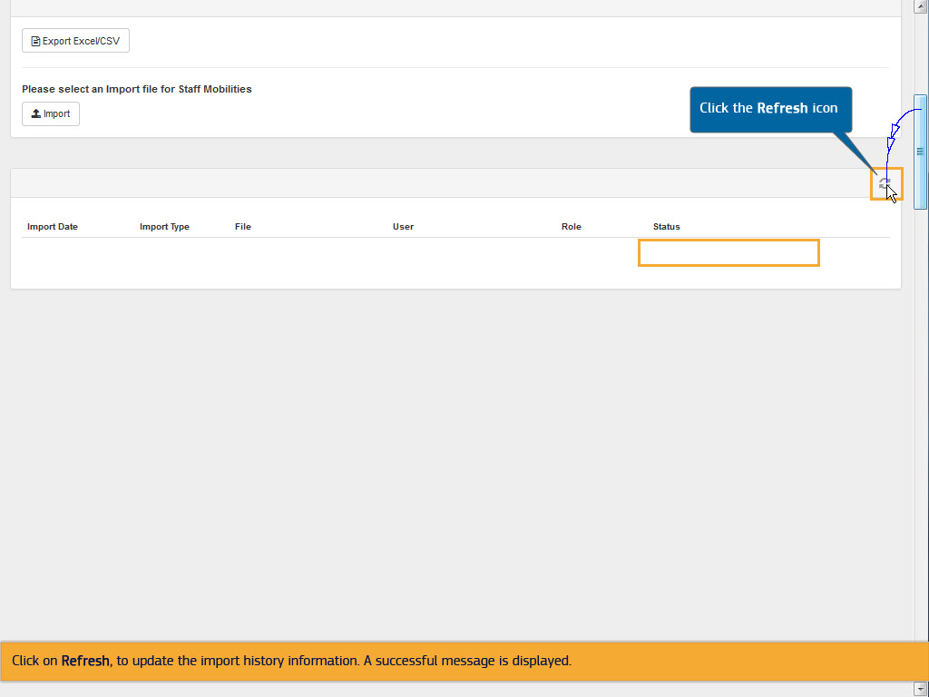
Text Captions

Click on Refresh, to update the import history information. A successful message is displayed.

Click the Refresh icon

Slide 67 - Slide 67
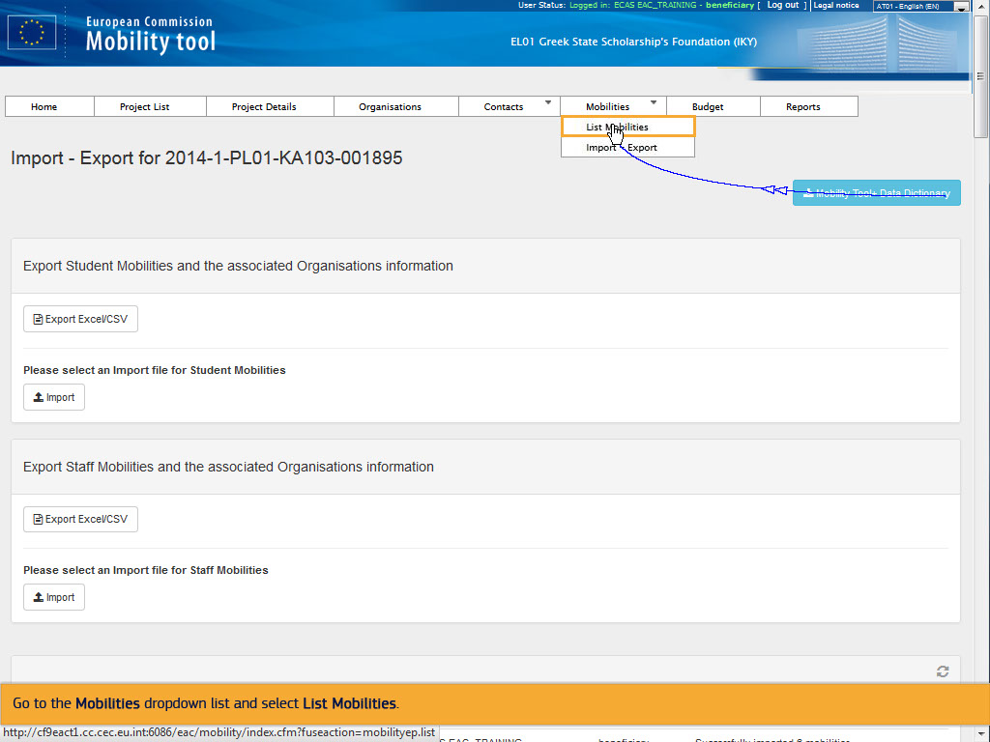
Text Captions

Go to the Mobilities dropdown list and select List Mobilities.

Slide 68 - Slide 68
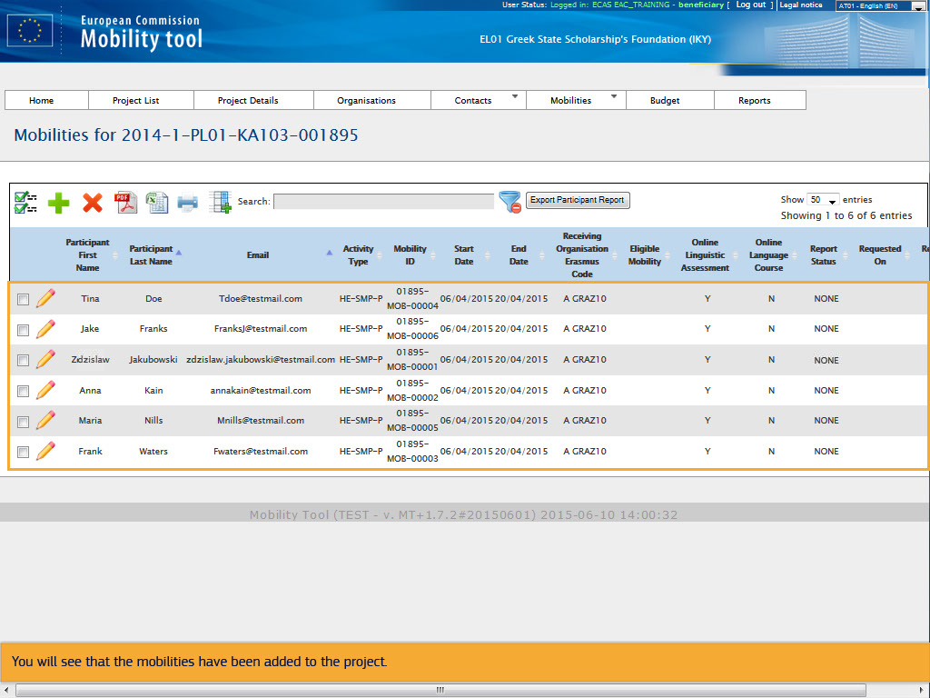
Text Captions

You will see that the mobilities have been added to the project.

Slide 69 - Slide 69
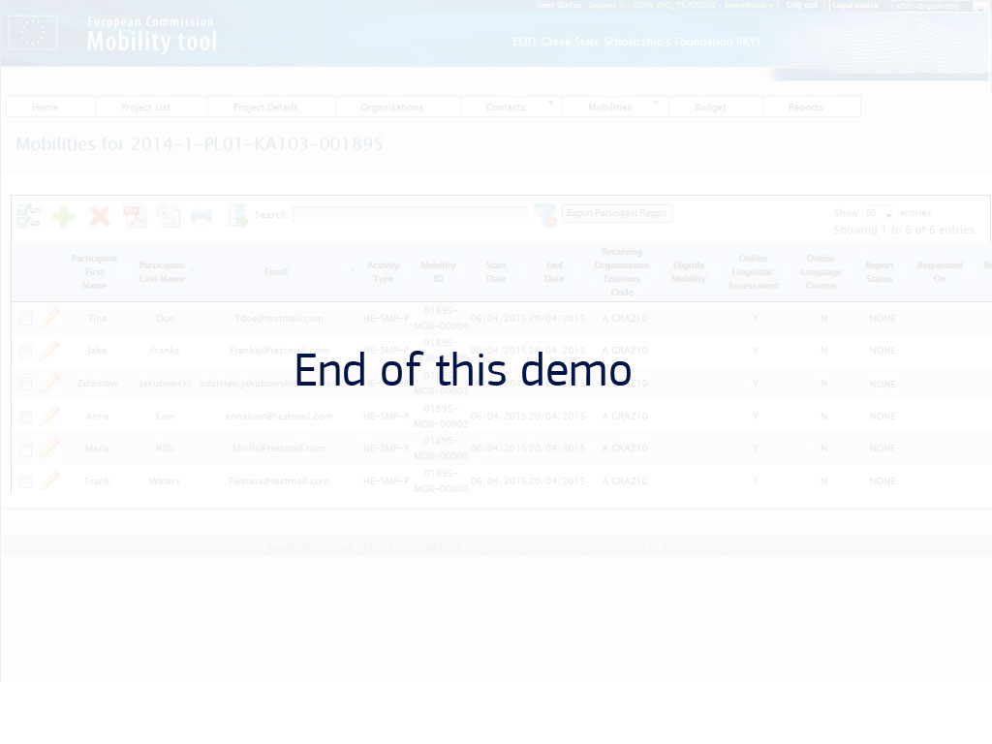
Text Captions

End of this demo

