Slide 1 - Slide 1
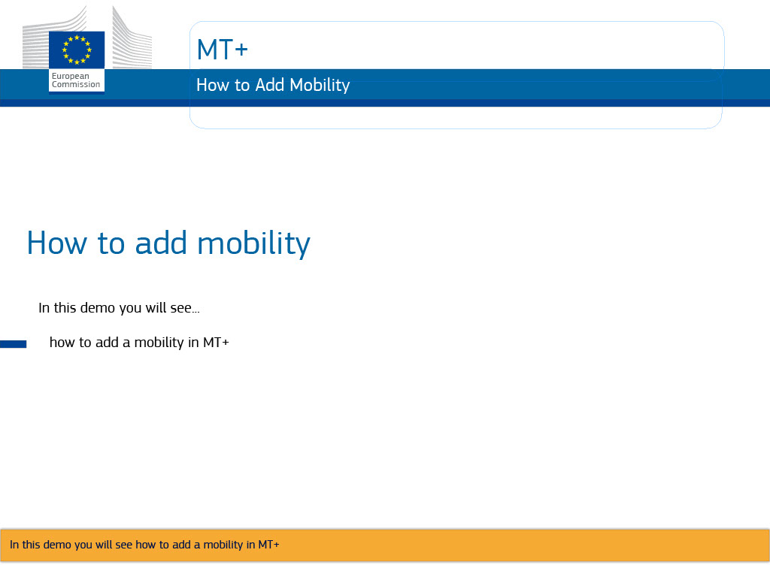
Text Captions

MT+

How to add mobility

In this demo you will see how to add a mobility in MT+

Slide 2 - Slide 2
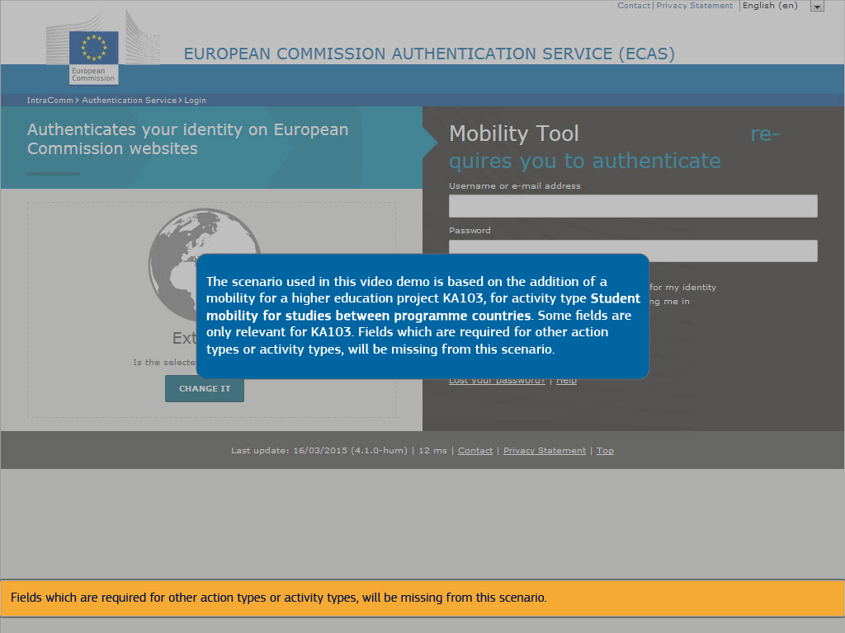
Text Captions

The scenario used in this video demo is based on the addition of mobility for a higher education project KA103, for activity type Student mobility for studies between programme countries.

Some fields are only relevant for KA103.

Fields which are required for other action types or activity types, will be missing from this scenario.

Slide 3 - Slide 3
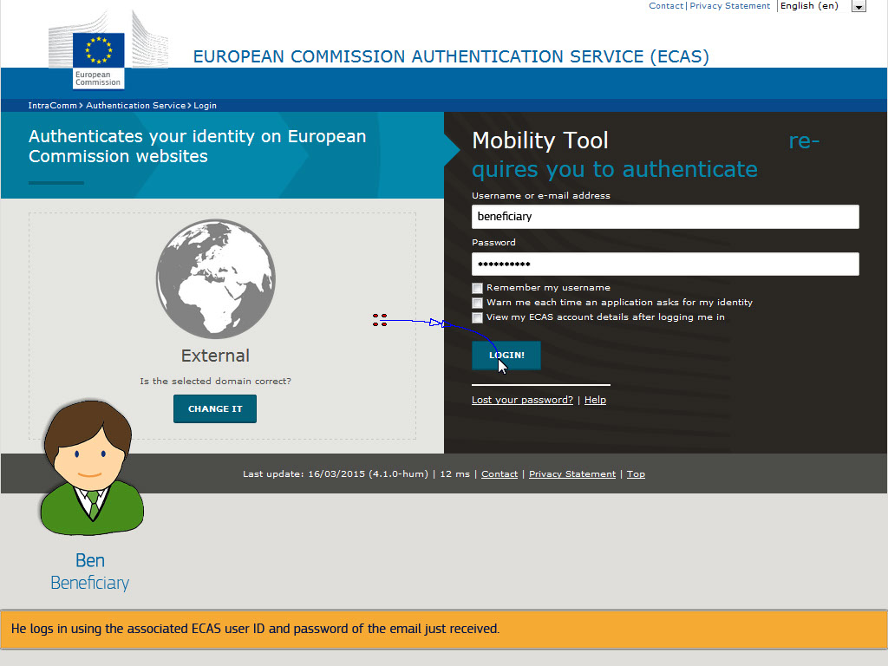
Text Captions

From the moment of processing the grant agreement signature in the National Agencies system, Ben will receive an automatic notification from the Mobility Tool.

He logs in using the associated ECAS user ID and password of the email just received.

Slide 4 - Slide 4
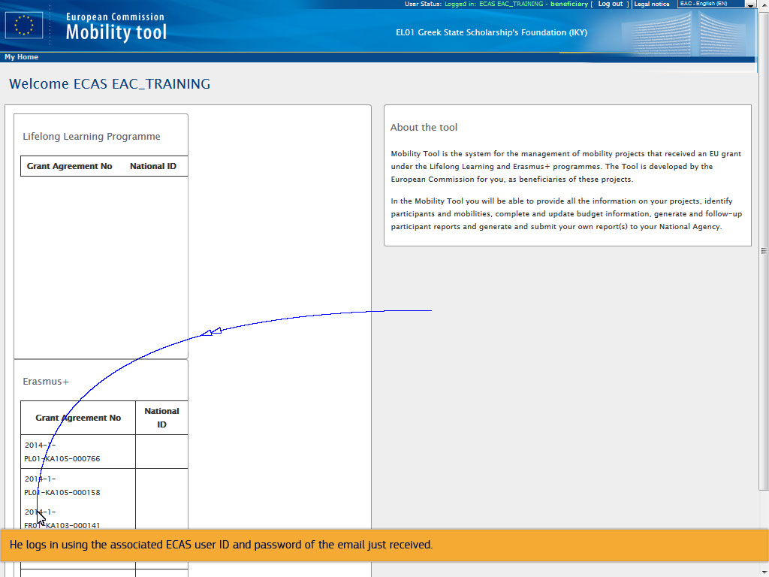
Text Captions

He logs in using the associated ECAS user ID and password of the email just received.

Slide 5 - Slide 5
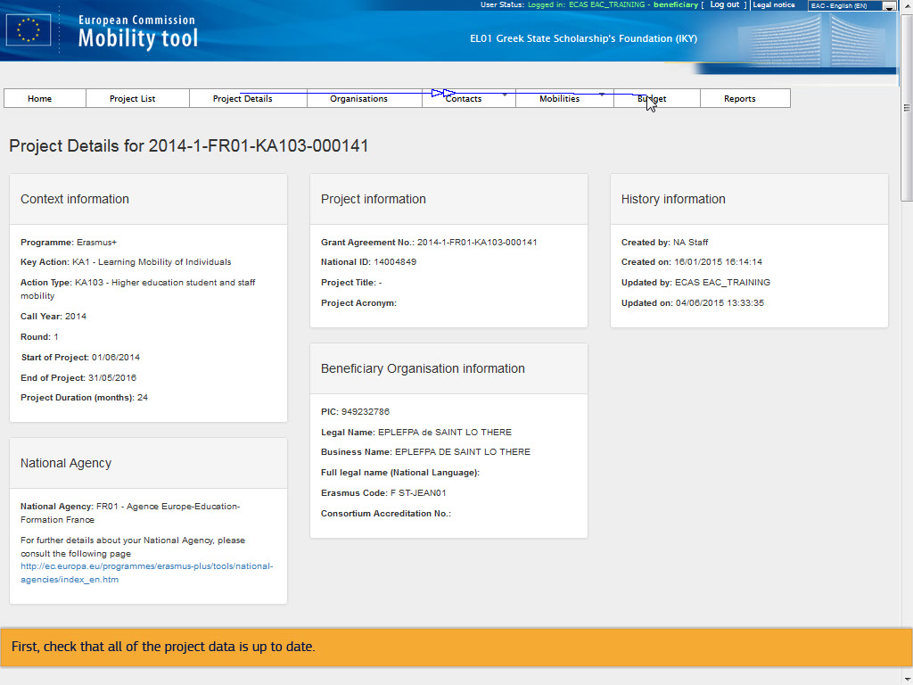
Text Captions

First, check that all of the project data is up to date.

Slide 6 - Slide 6
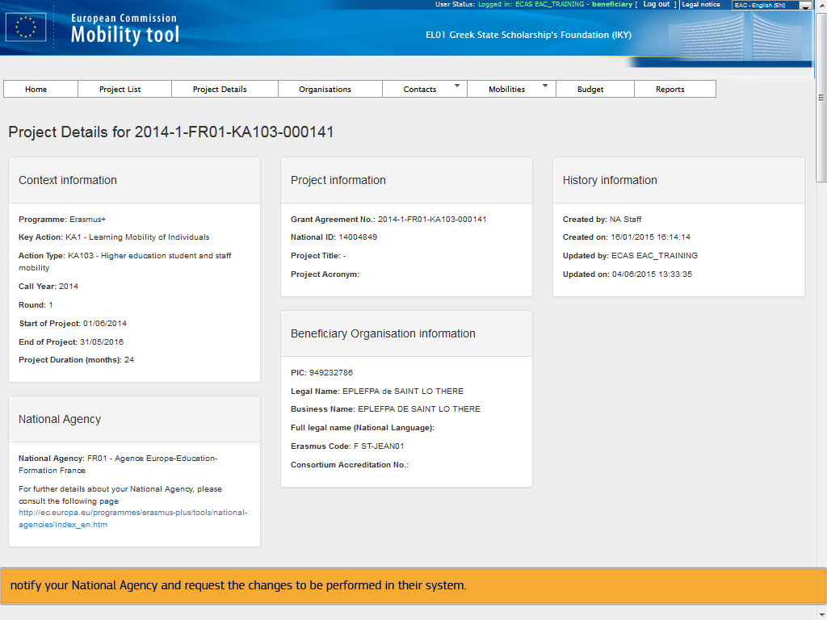
Text Captions

In case there are changes or amendments to be performed, notify your National Agency and request the changes to be performed in their system.

Slide 7 - Slide 7
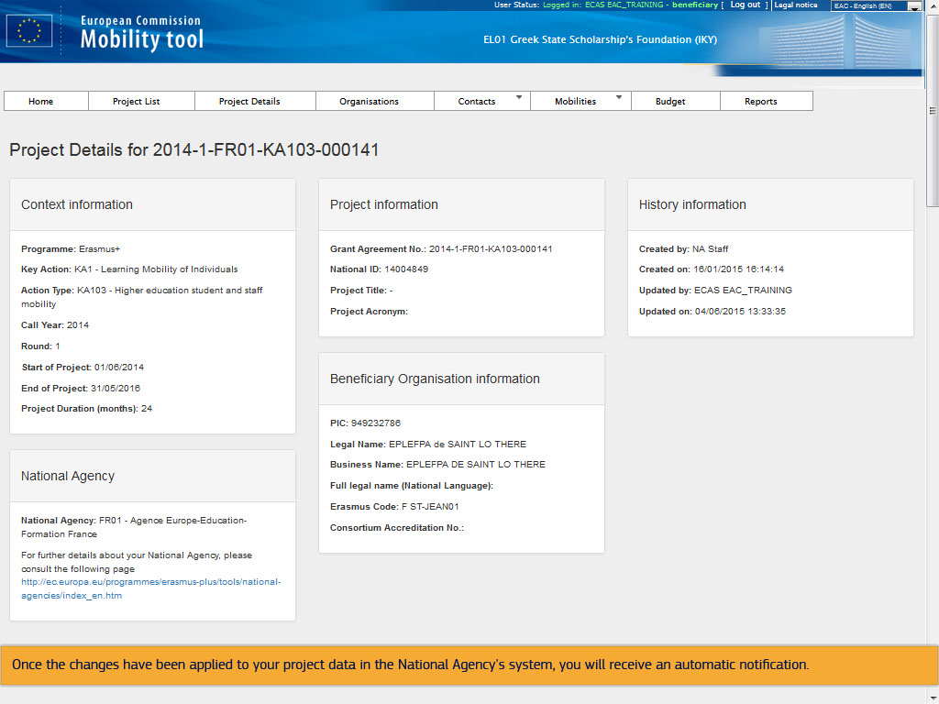
Text Captions

Once the changes have been applied to your project data in the National Agency's system, you will receive an automatic notification.

Slide 8 - Slide 8
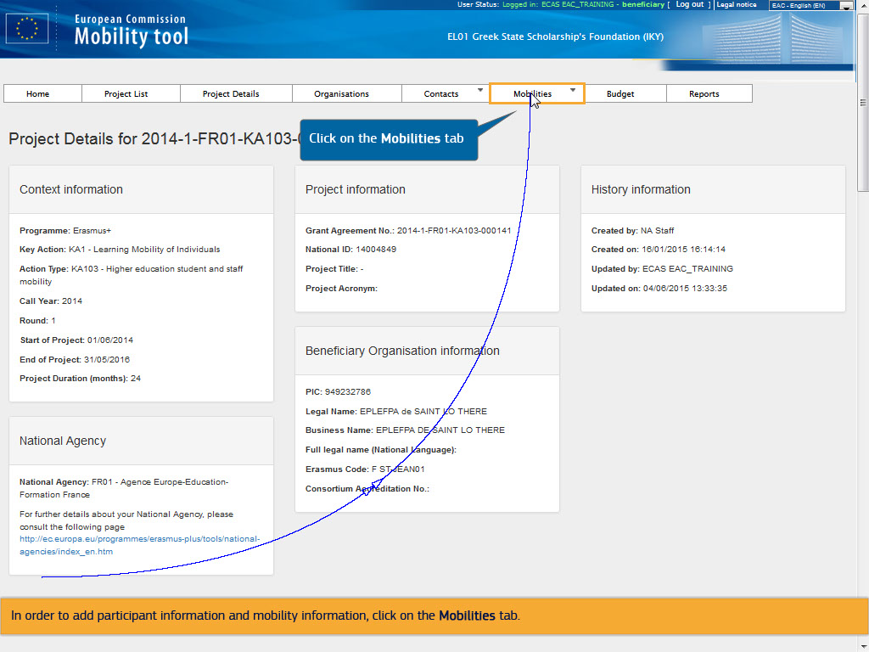
Text Captions

In order to add participant information and mobility information, click on the Mobilities tab.

Click on t

Slide 9 - Slide 9
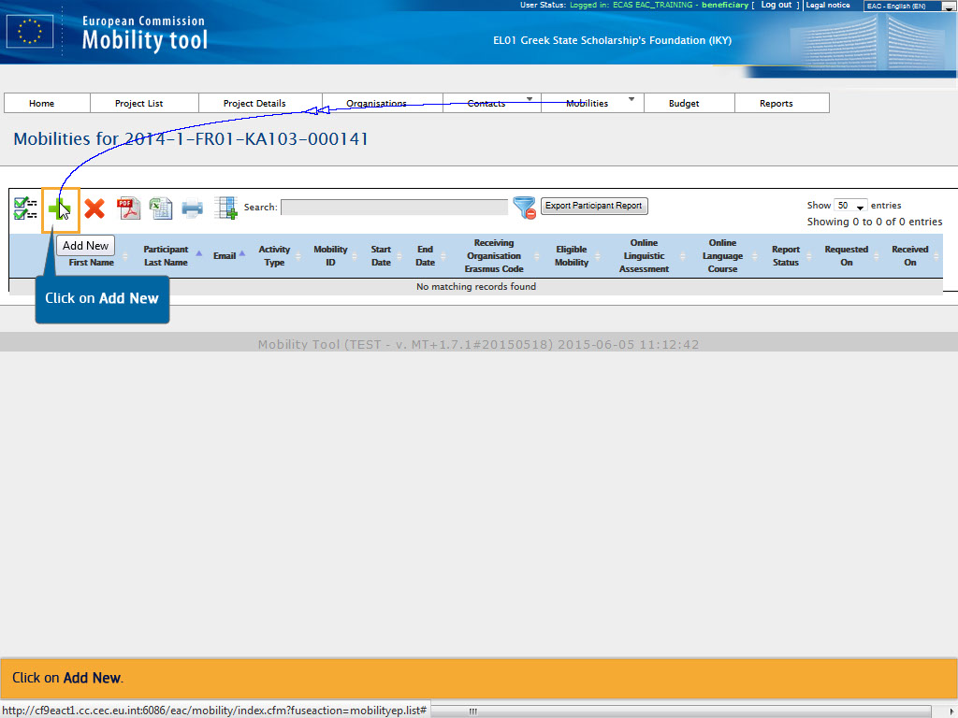
Text Captions

Click on Add New.

Click on Add New

Slide 10 - Slide 10
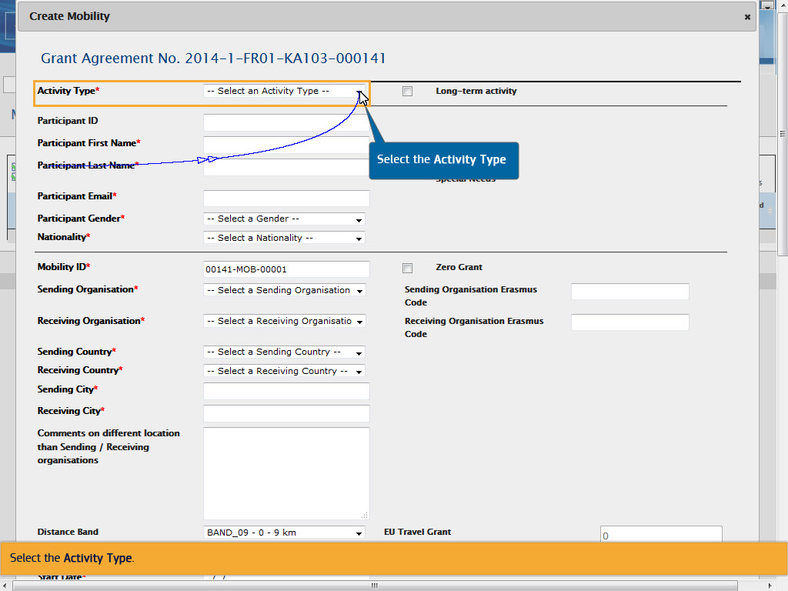
Text Captions

Select the Activity Type.

Select the Activity Type

Slide 11 - Slide 11
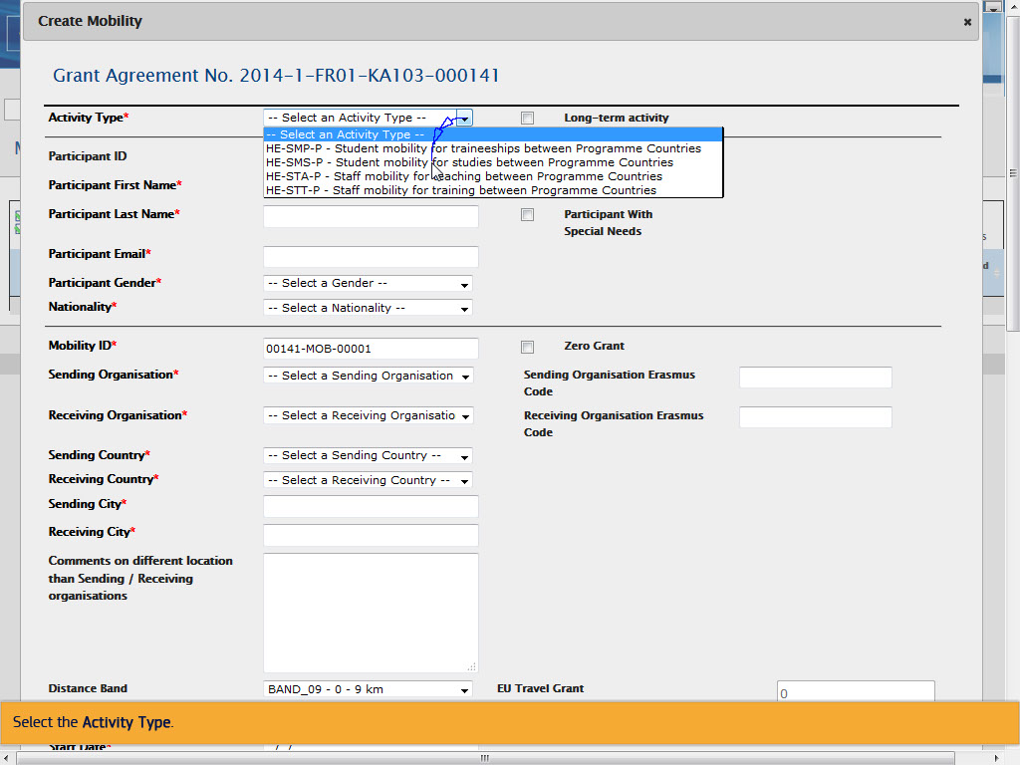
Text Captions

Select the Activity Type.

Slide 12 - Slide 12
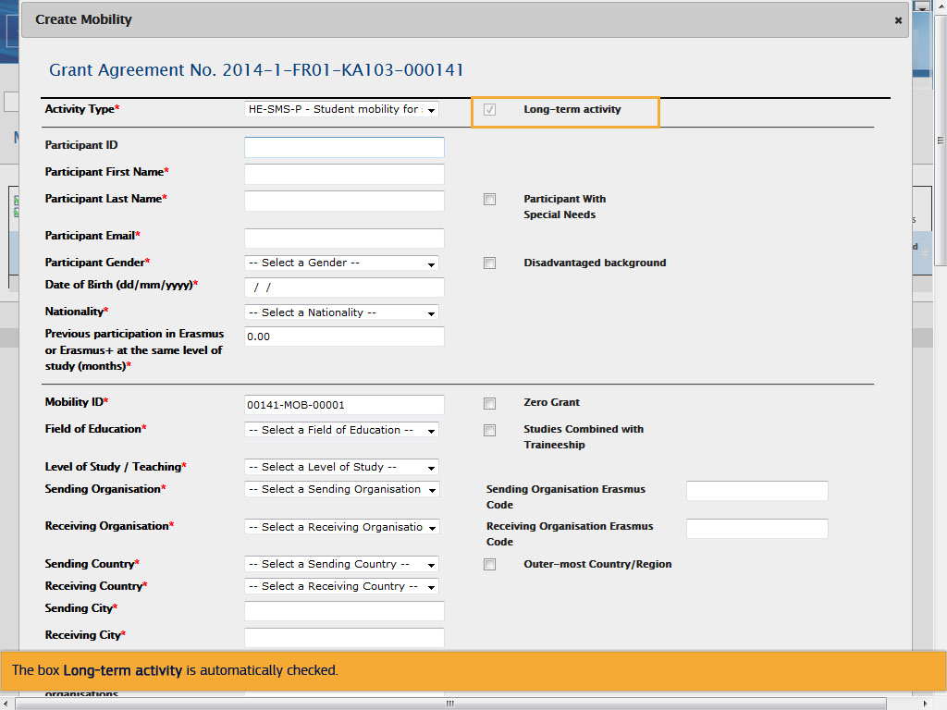
Text Captions

The box Long-term activity is automatically checked.

Slide 13 - Slide 13
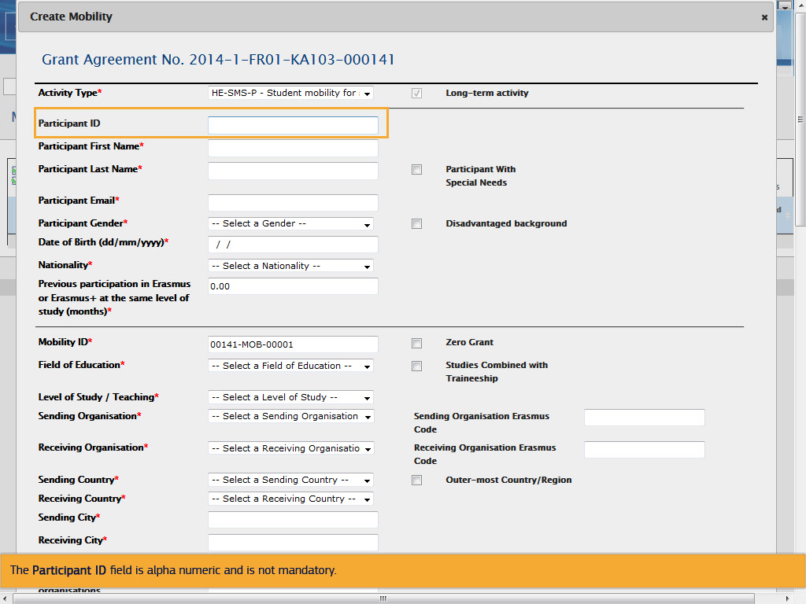
Text Captions

The Participant ID field is alpha numeric and is not mandatory.

Slide 14 - Slide 14
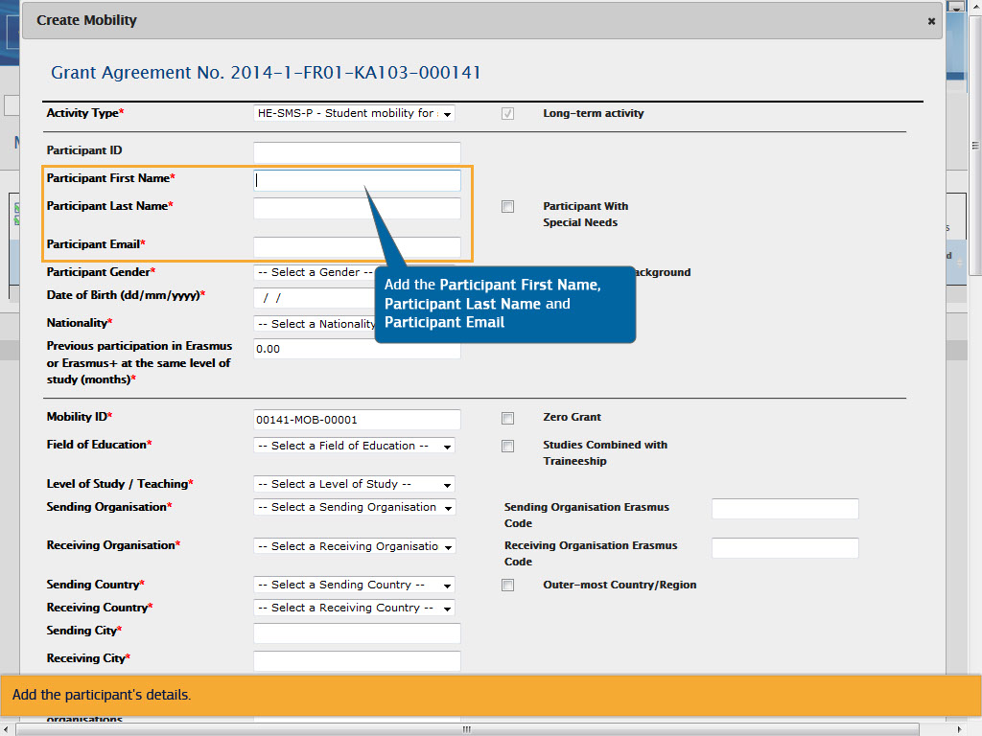
Text Captions

Add the participant's details.

Add the Participant First Name, Participant Last Name and Participant Email

Slide 15 - Slide 15
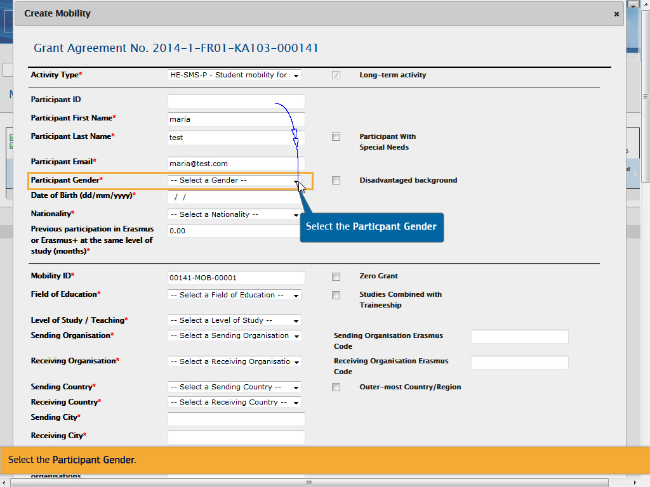
Text Captions

Select the Participant Gender.

Select the

Slide 16 - Slide 16
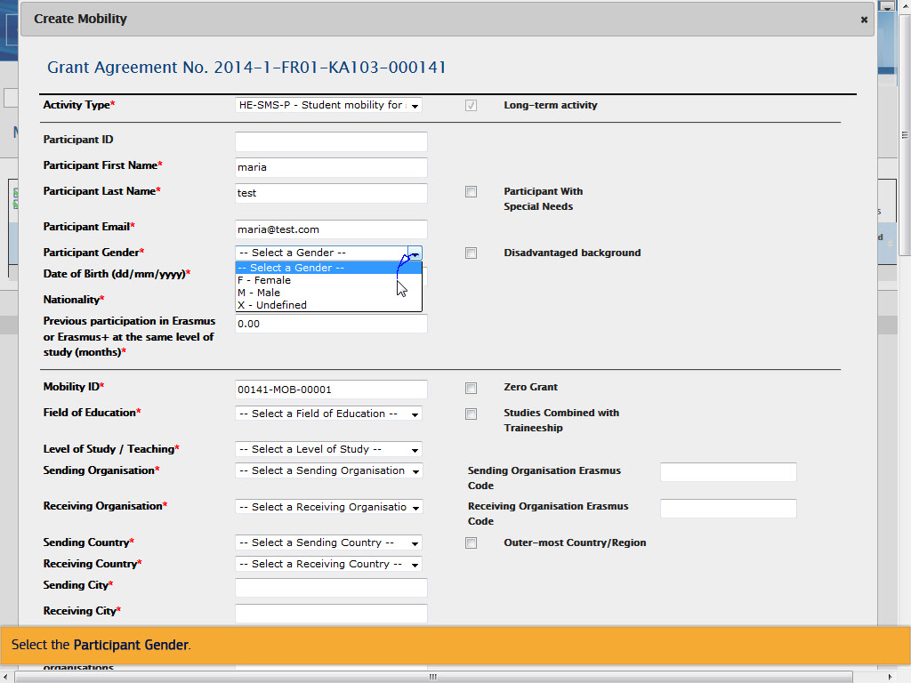
Text Captions

Select the Participant Gender.

Add the Date of Birth

Slide 18 - Slide 18
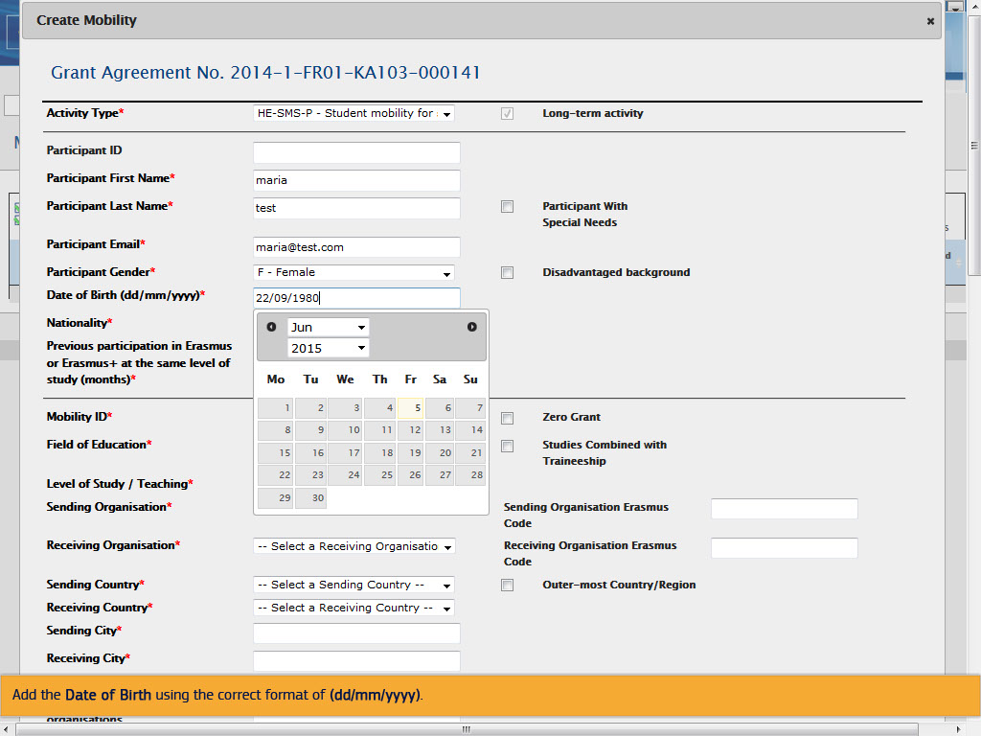
Text Captions

Add the Date of Birth using the correct format of (dd/mm/yyyy).

Slide 19 - Slide 19
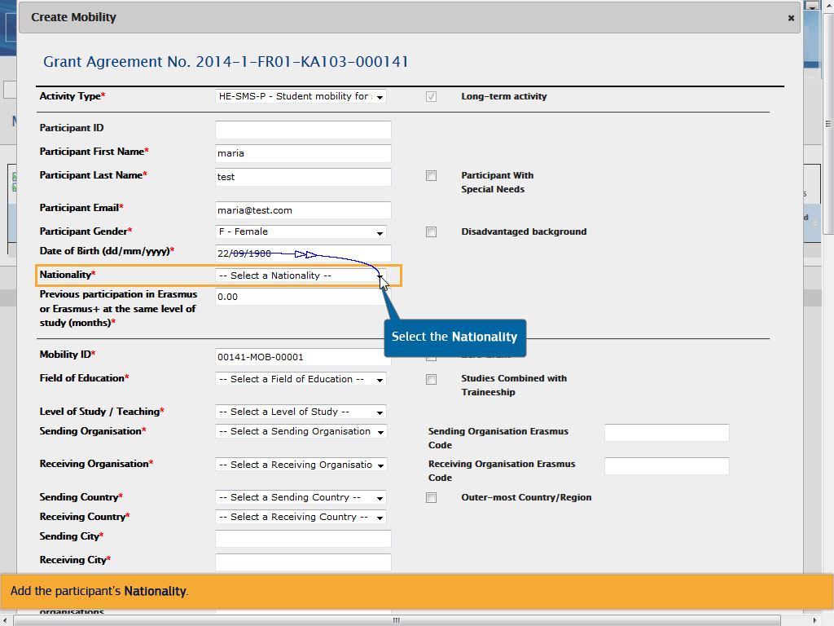
Text Captions

Add the participant's Nationality.

Select the Nationality

Slide 20 - Slide 20
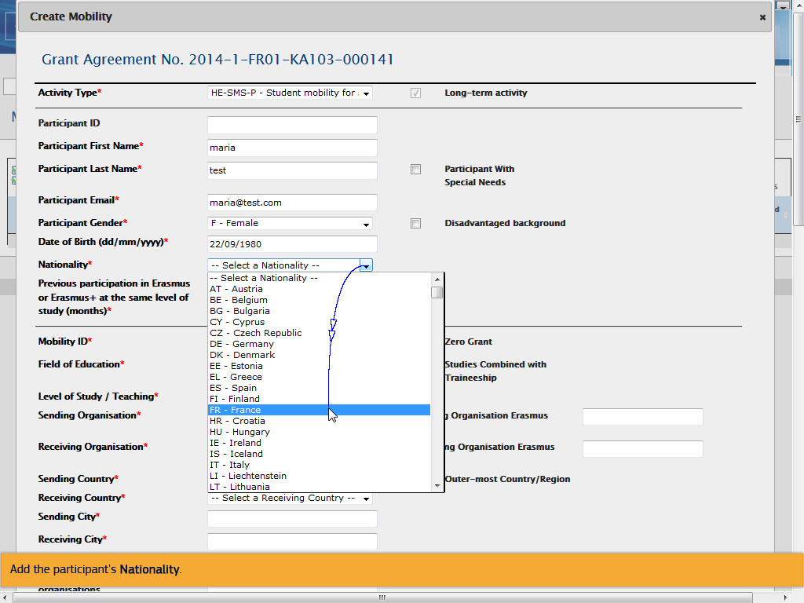
Text Captions

Add the participant's Nationality.

Slide 21 - Slide 21
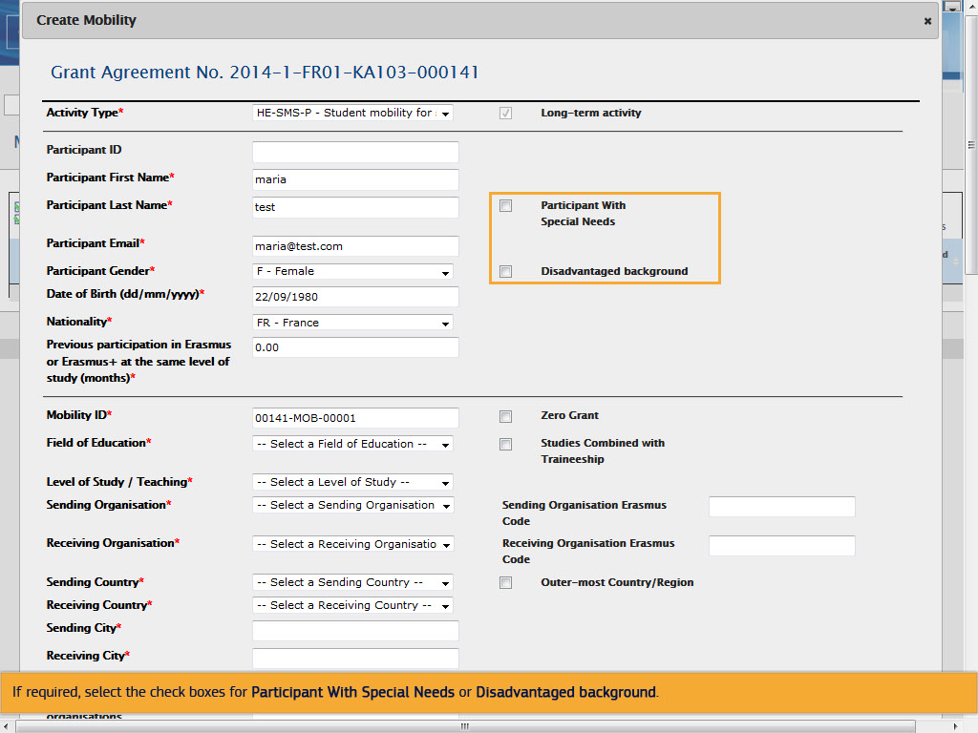
Text Captions

If required, select the check boxes for Participant With Special Needs or Disadvantaged background.

Slide 22 - Slide 22
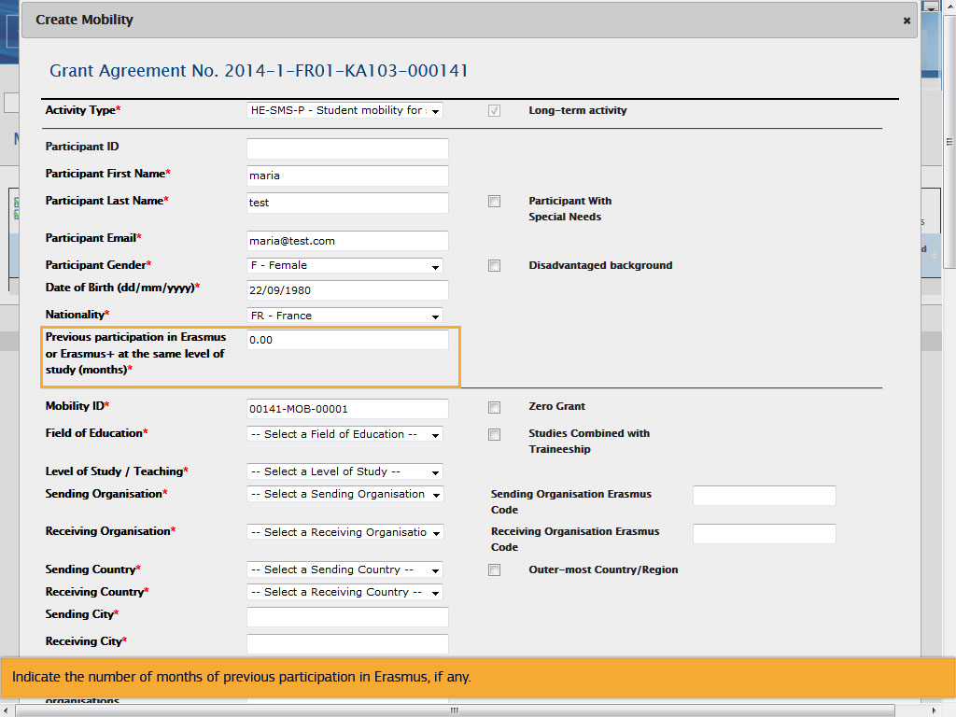
Text Captions

Indicate the number of months of previous participation in Erasmus, if any.

Slide 23 - Slide 23
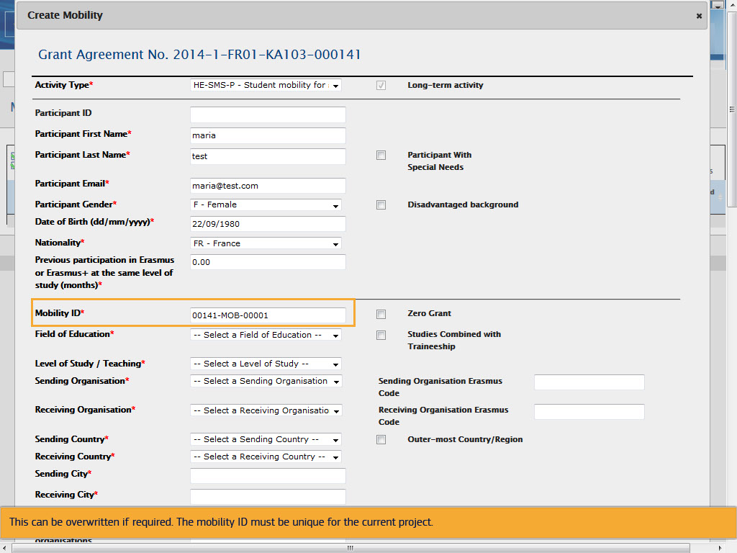
Text Captions

The Mobility ID is generated automatically and is composed of the project code, letters MOB and a sequential number.

This can be overwritten if required. The mobility ID must be unique for the current project.

Slide 24 - Slide 24
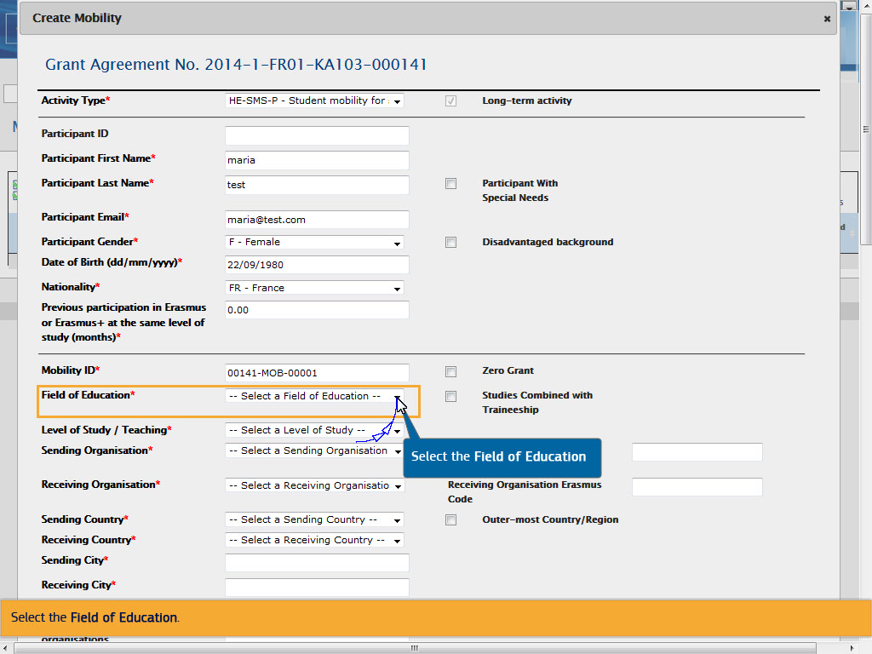
Text Captions

Select the Field of Education.

Select the Field of Education

Slide 25 - Slide 25
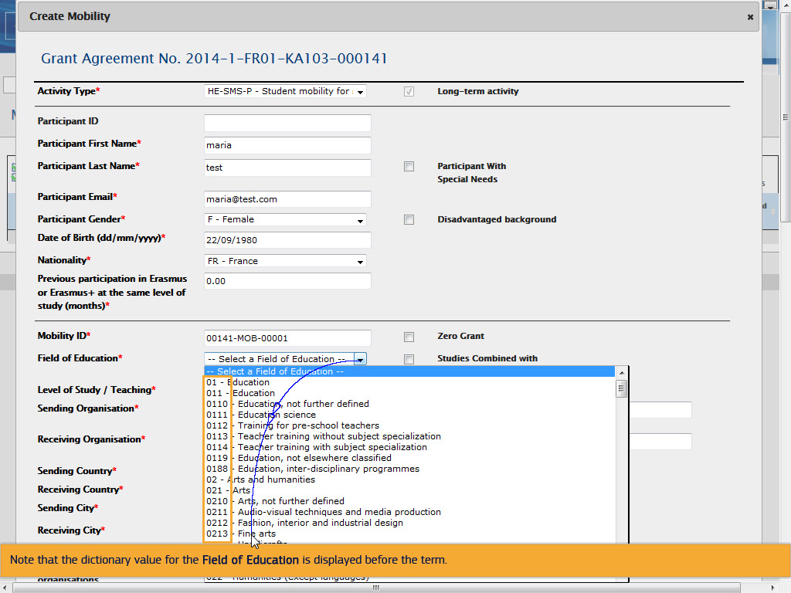
Text Captions

Note that the dictionary value for the Field of Education is displayed before the term.

Slide 26 - Slide 26
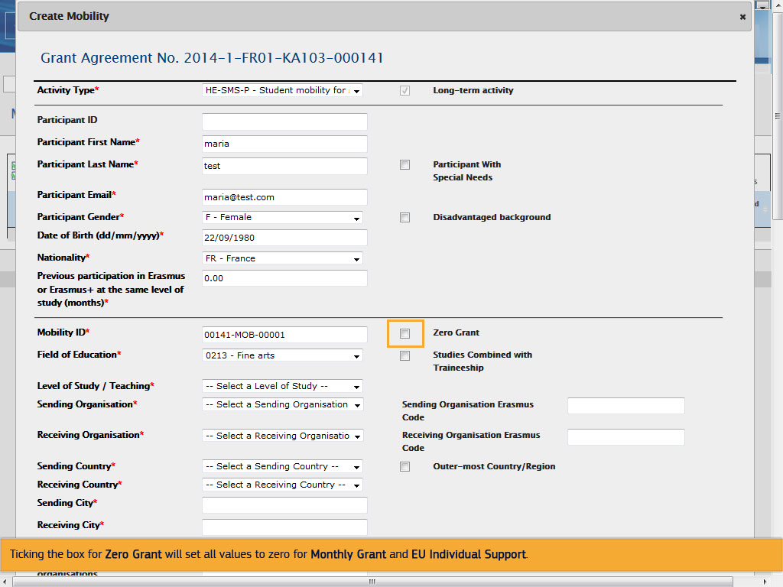
Text Captions

Ticking the box for Zero Grant will set all budget items to zero.

Slide 27 - Slide 27
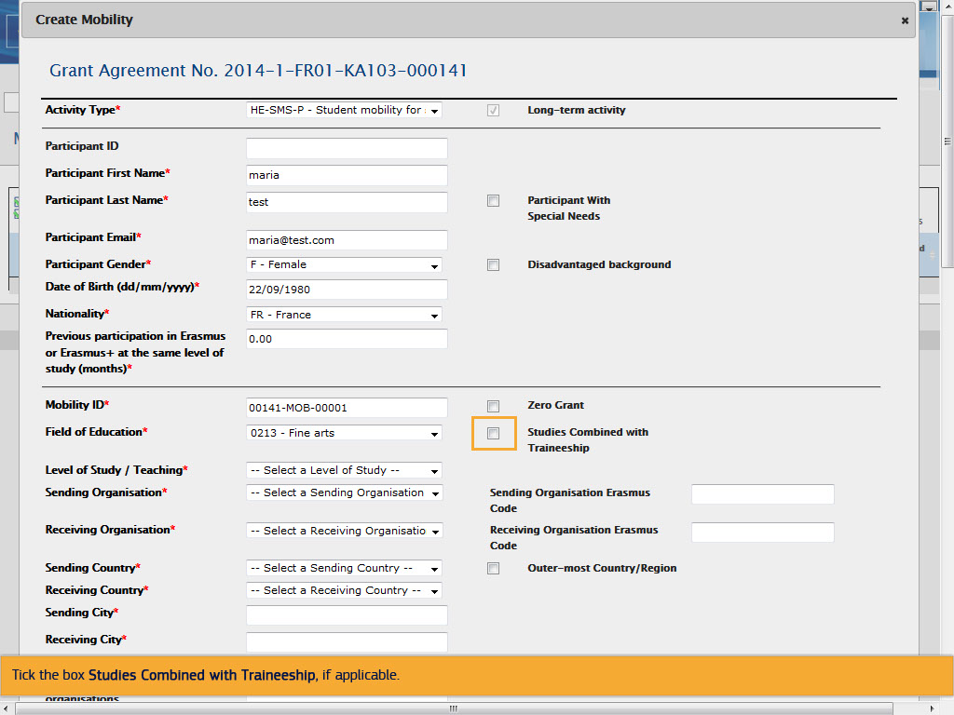
Text Captions

Tick the box Studies Combined with Traineeship, if applicable.

Slide 28 - Slide 28
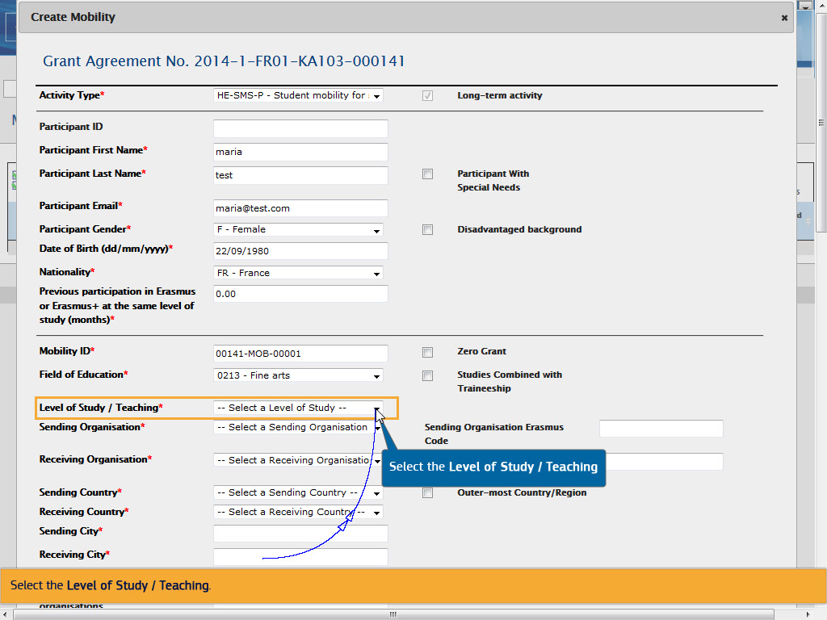
Text Captions

Select the Level of Study / Teaching.

Select the Level of Study / Teaching

Slide 29 - Slide 29
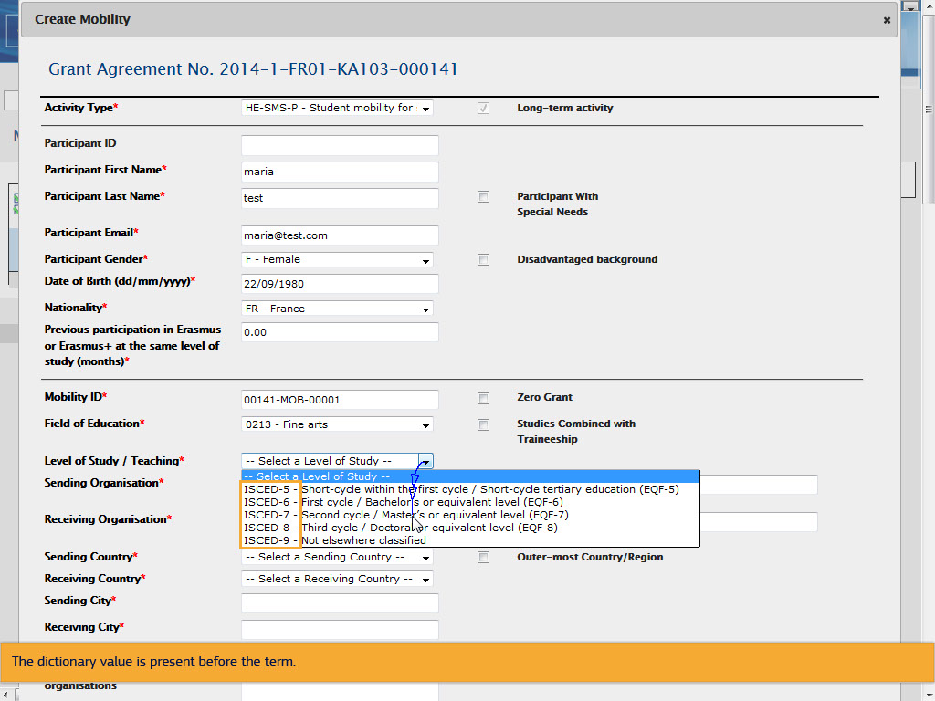
Text Captions

The dictionary value is present before the term.

Slide 30 - Slide 30
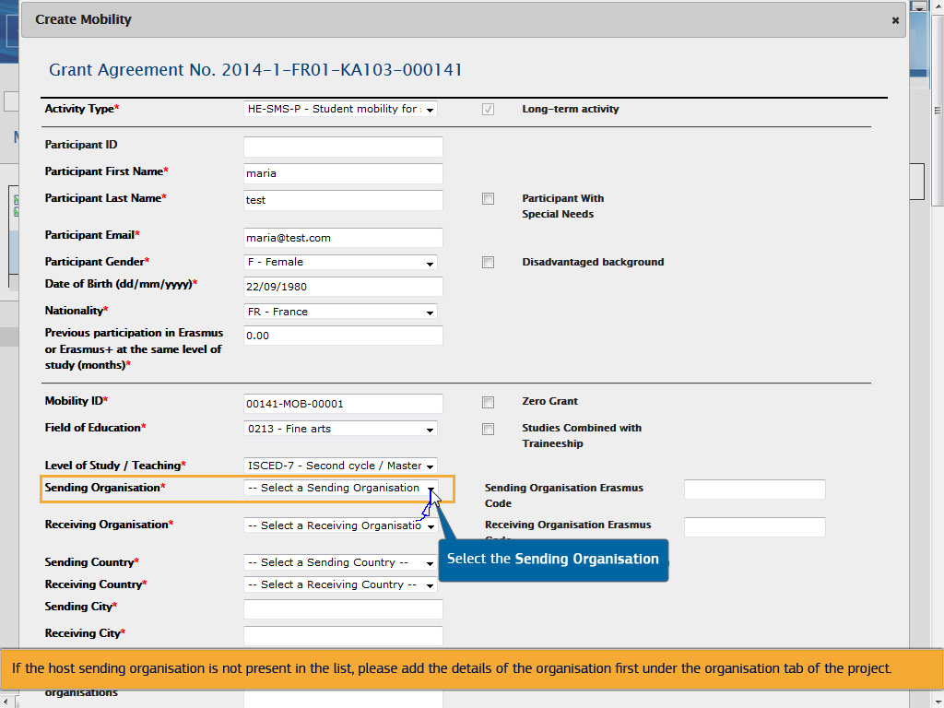
Text Captions

Select the Sending Organisation.

Only organisations added in the application form are added automatically to this list.

If the host sending organisation is not present in the list, please add the details of the organisation first under the organisation tab of the project.

Slide 31 - Slide 31
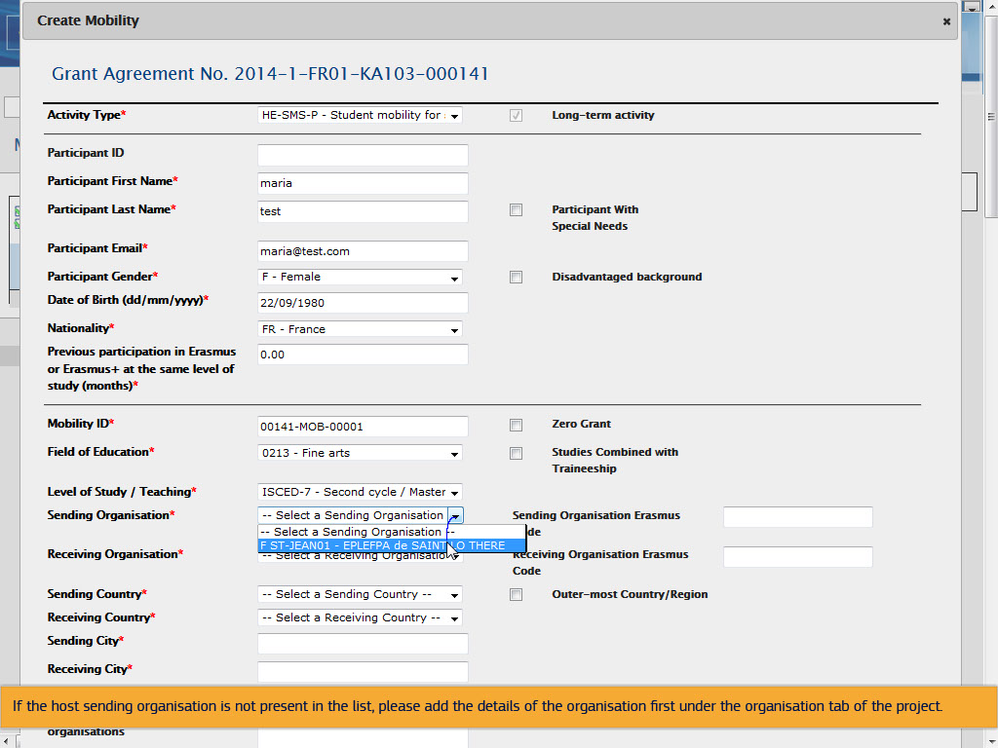
Text Captions

If the host sending organisation is not present in the list, please add the details of the organisation first under the organisation tab of the project.

Slide 32 - Slide 32
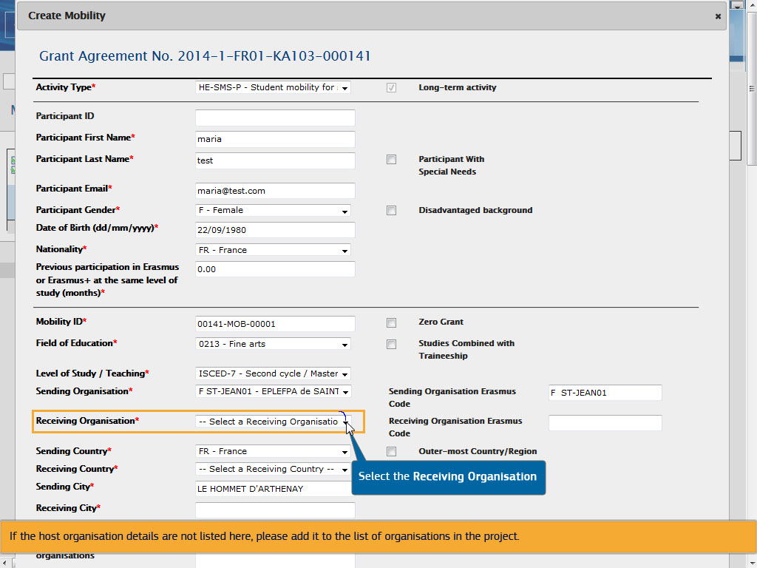
Text Captions

Select the Receiving Organisation.

If the host organisation details are not listed here, please add it to the list of organisations in the project.

Select the

Slide 33 - Slide 33
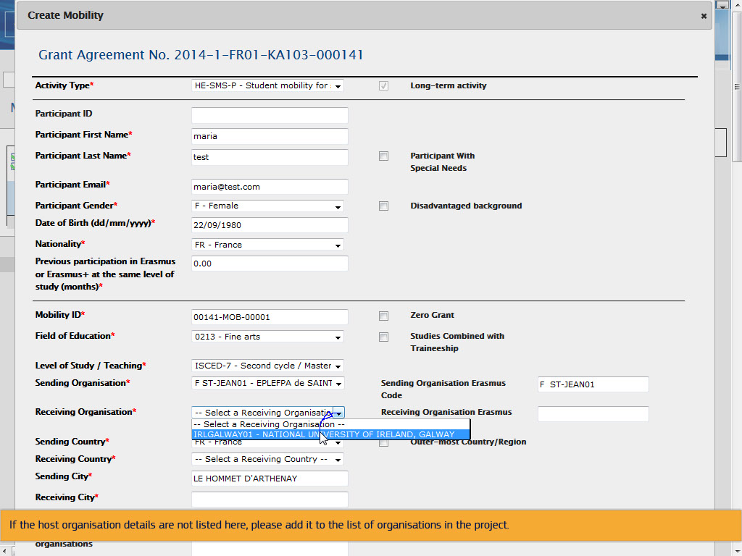
Text Captions

If the host organisation details are not listed here, please add it to the list of organisations in the project.

Slide 34 - Slide 34
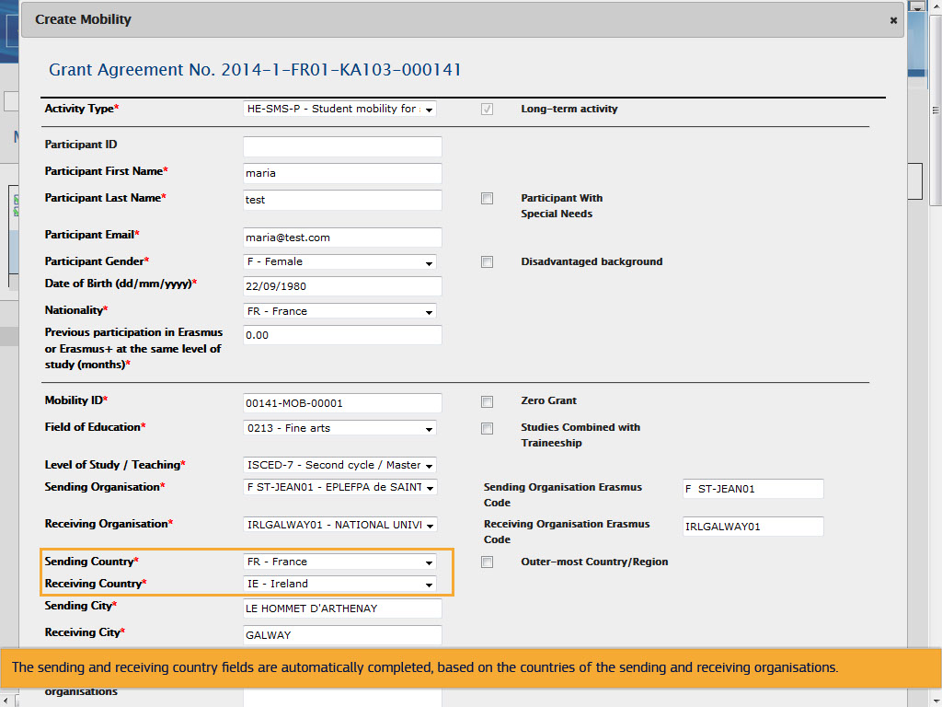
Text Captions

The sending and receiving country fields are automatically completed, based on the countries of the sending and receiving organisations.

Slide 35 - Slide 35
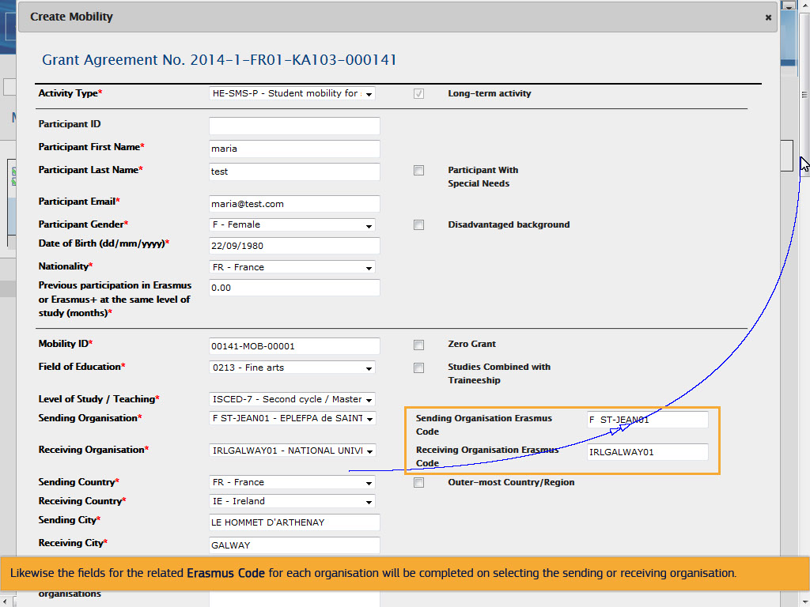
Text Captions

Likewise the fields for the related Erasmus Code for each organisation will be completed on selecting the sending or receiving organisation.

Slide 36 - Slide 36
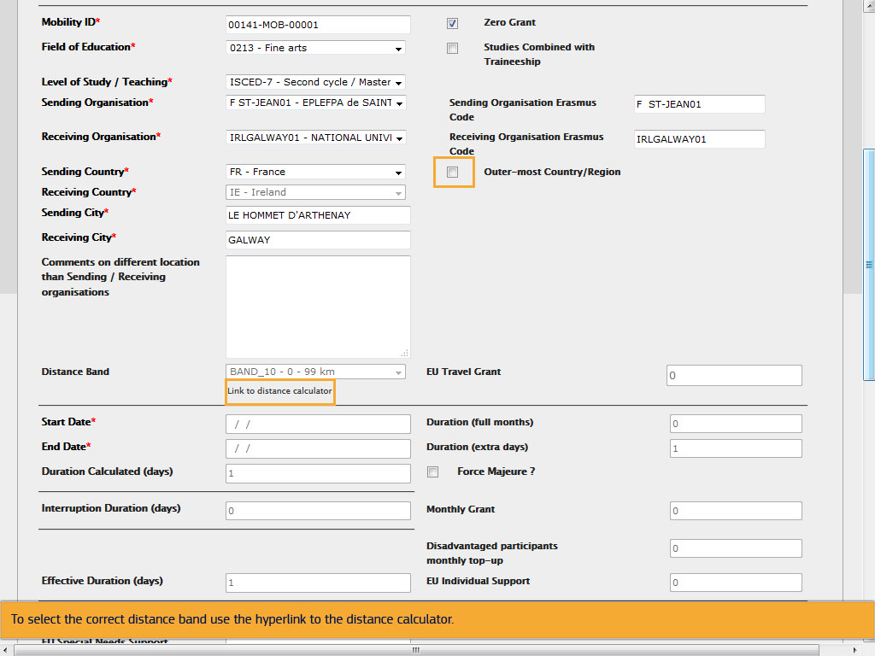
Text Captions

If applicable, check the Outer-most Country/Region box. This will activate the dropdown list of the Distance Band.

To select the correct distance band use the hyperlink to the distance calculator.

Slide 37 - Slide 37
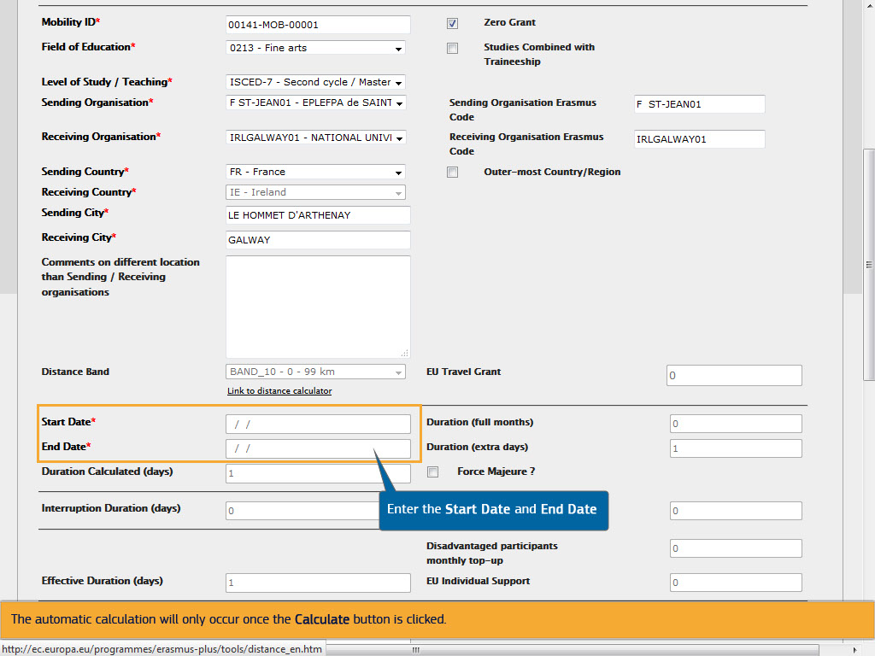
Text Captions

Enter the Start Date and End Date for the mobility. Some fields for the budget section will be calculated automatically and some need to be indicated.

The automatic calculation will only occur once the Calculate button is clicked.

Enter the Start Date and End Date

Slide 38 - Slide 38
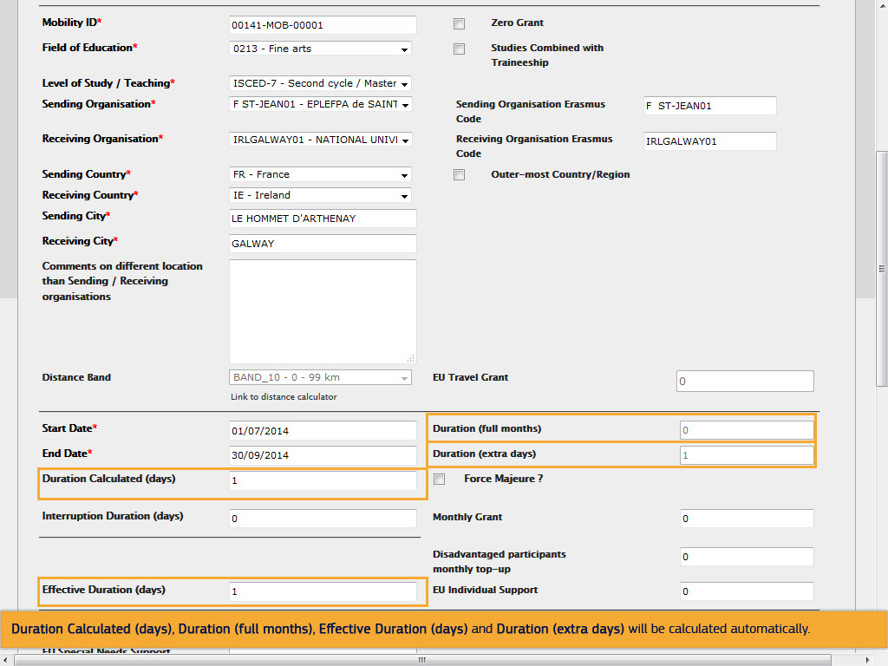
Text Captions

Duration Calculated (days), Duration (full months), Effective Duration (days) and Duration (extra days) will be calculated automatically.

Slide 39 - Slide 39
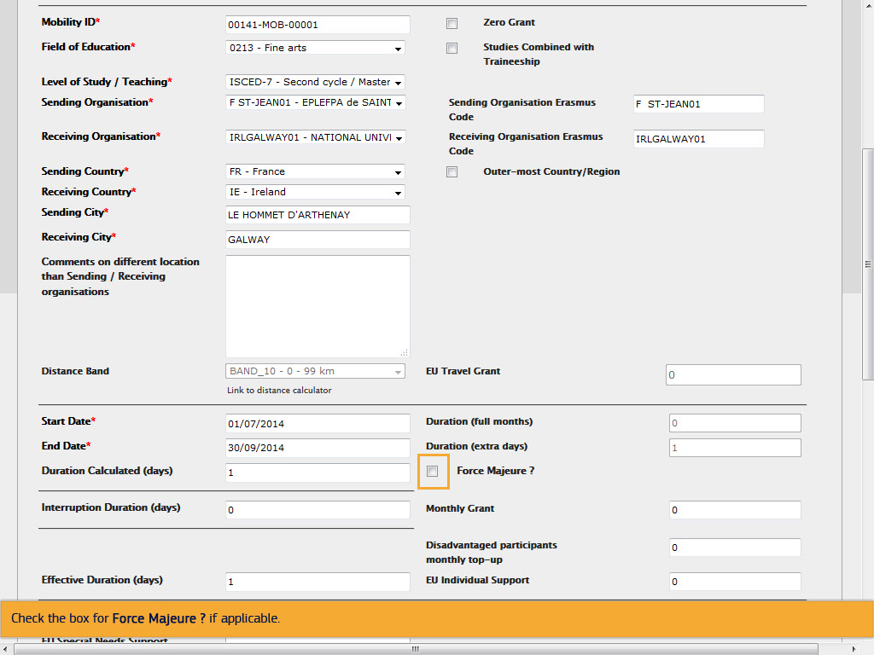
Text Captions

Check the box for Force Majeure ? if applicable.

Slide 40 - Slide 40
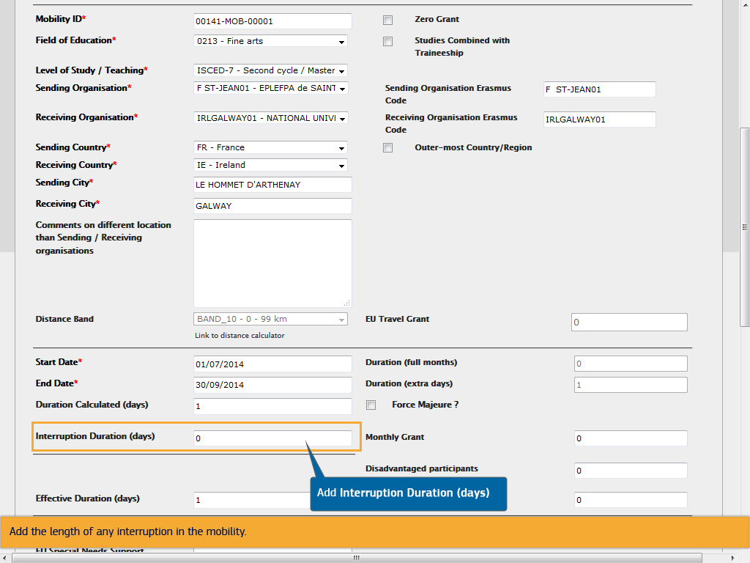
Text Captions

Add the length of any interruption in the mobility.

Add Interruption Duration (days)

Slide 43 - Slide 43
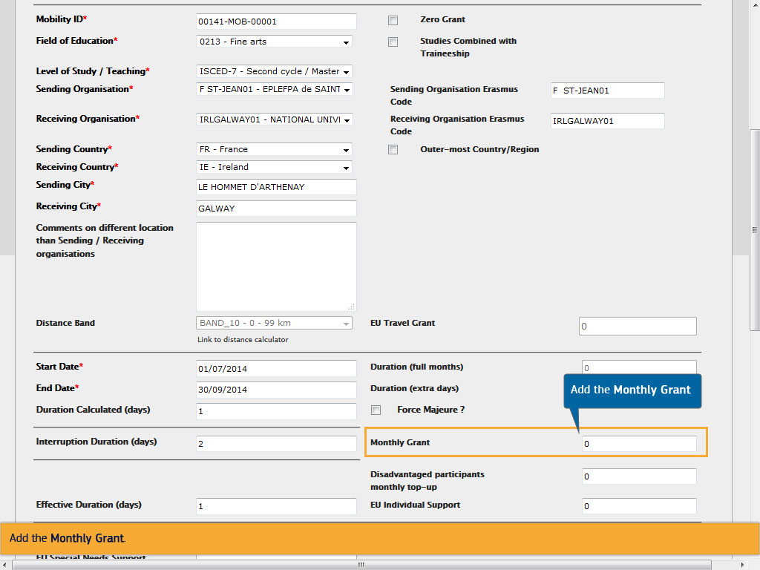
Text Captions

Add the Monthly Grant.

Add the Monthly Grant

Slide 46 - Slide 46
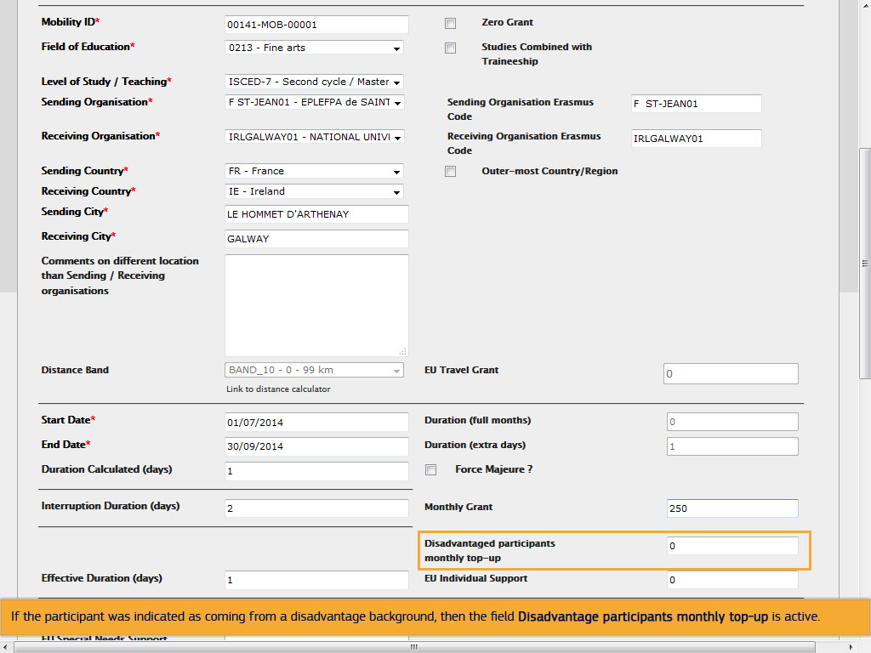
Text Captions

If the participant was indicated as coming from a disadvantage background, then the field Disadvantage participants monthly top-up is active.

Slide 47 - Slide 47
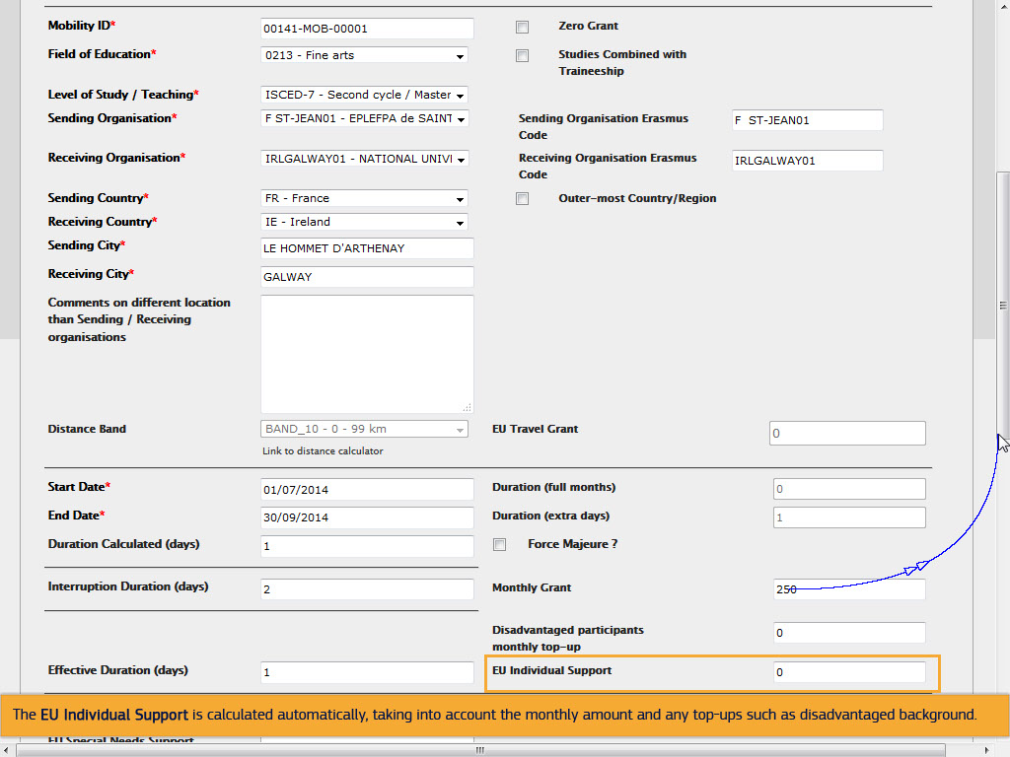
Text Captions

The EU Individual Support is calculated automatically, taking into account the monthly amount and any top-ups such as disadvantaged background.

Slide 48 - Slide 48
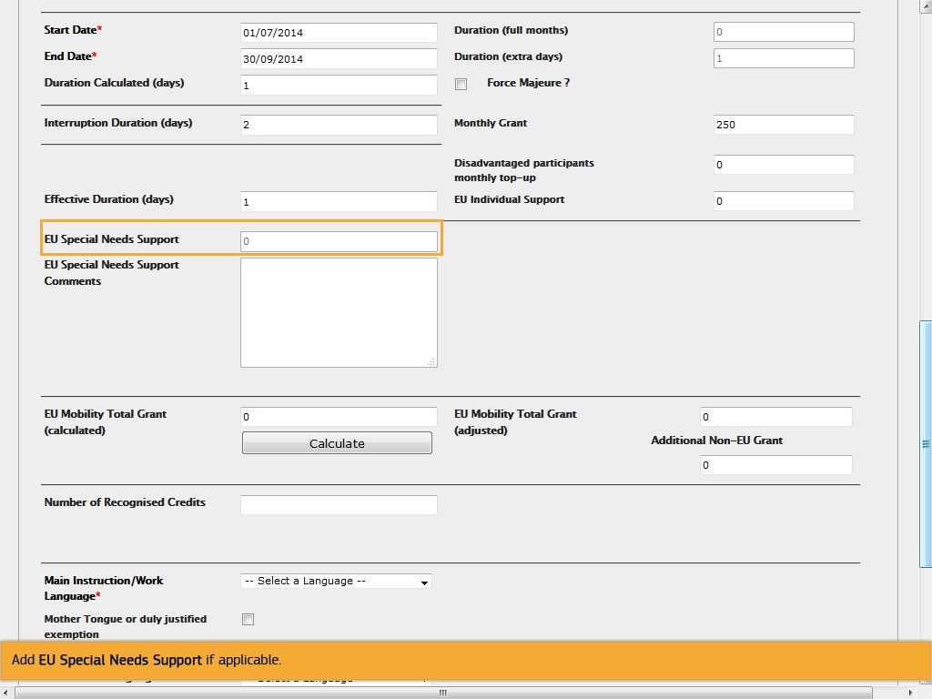
Text Captions

Add EU Special Needs Support if applicable.

Slide 49 - Slide 49
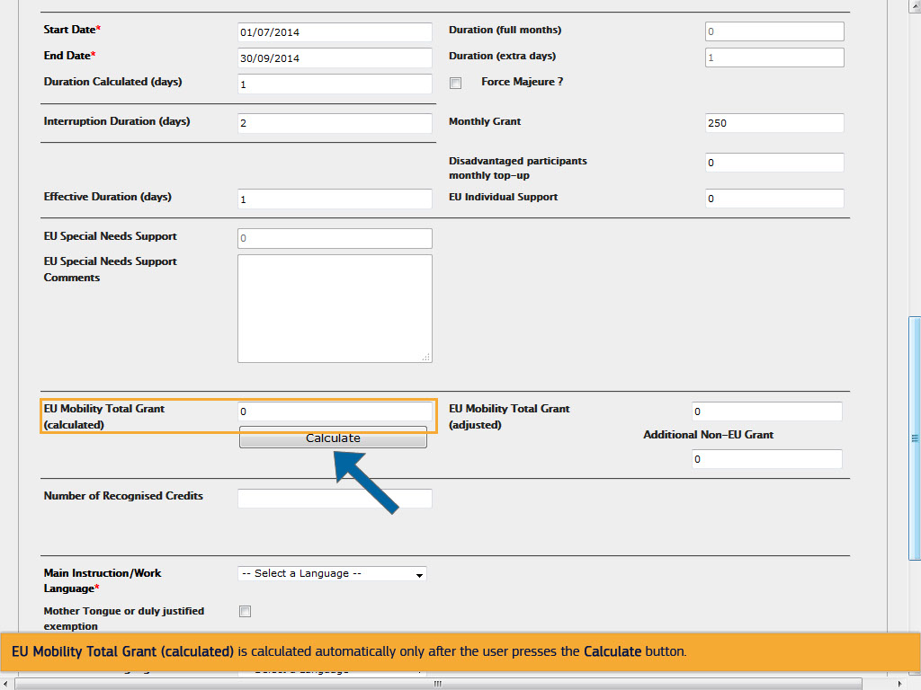
Text Captions

EU Mobility Total Grant (calculated) is calculated automatically only after the user presses the Calculate button.

Slide 50 - Slide 50
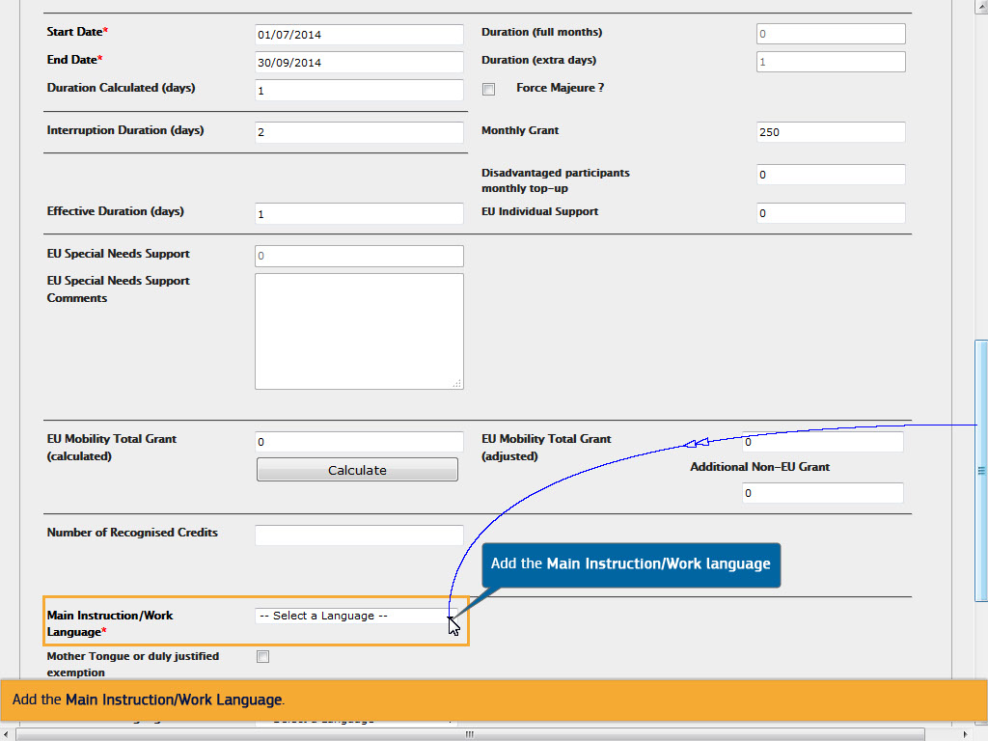
Text Captions

Add the Main Instruction/Work Language.

Add the Main Instruction/Work language

Slide 51 - Slide 51
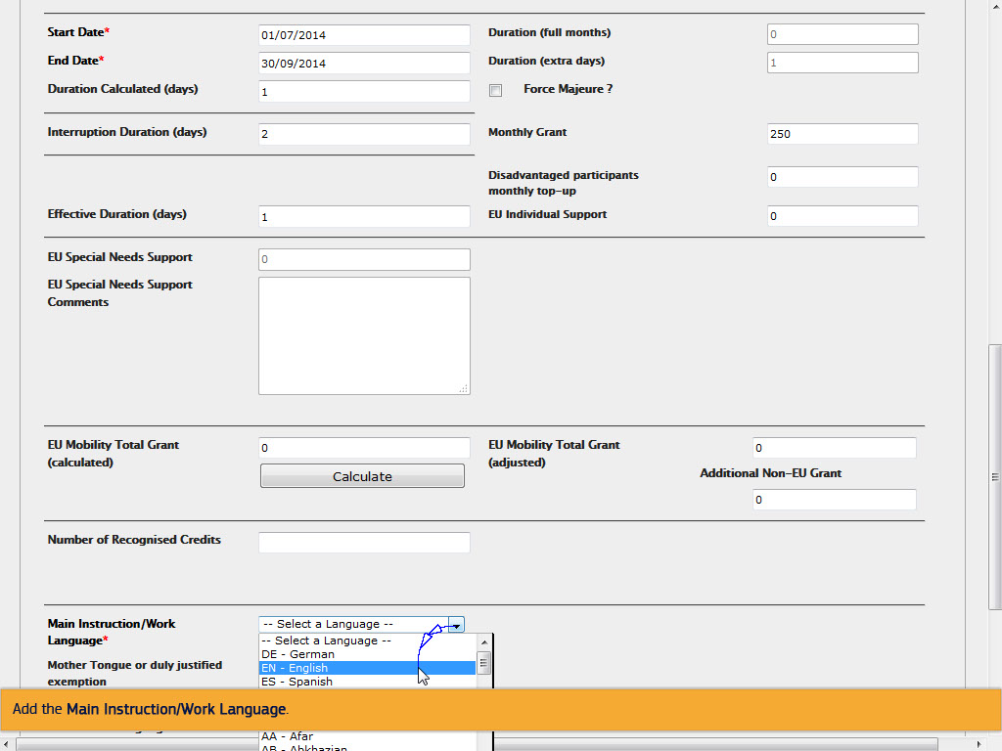
Text Captions

Add the Main Instruction/Work Language.

Slide 52 - Slide 52
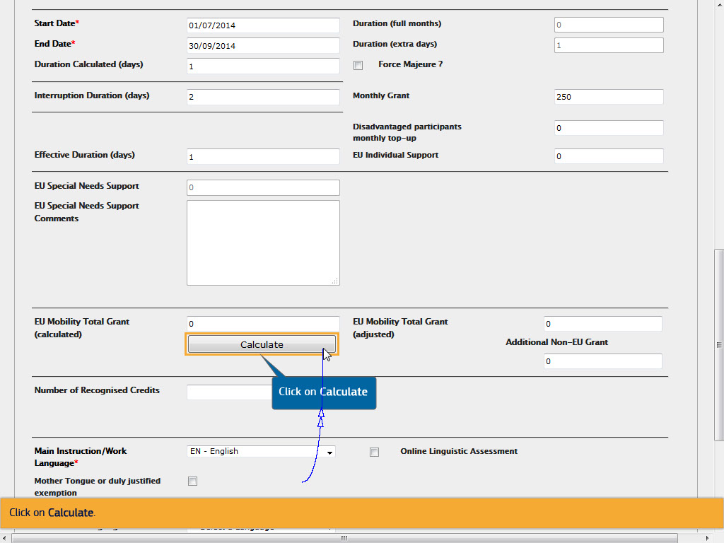
Text Captions

Click on Calculate.

Click on Calculate

Slide 53 - Slide 53
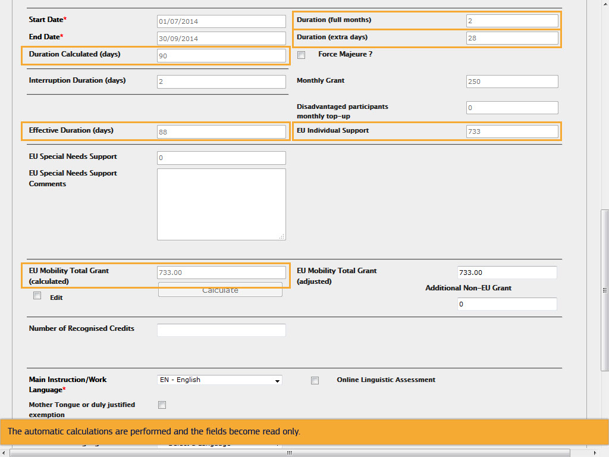
Text Captions

The automatic calculations are performed and the fields become read only.

Slide 54 - Slide 54
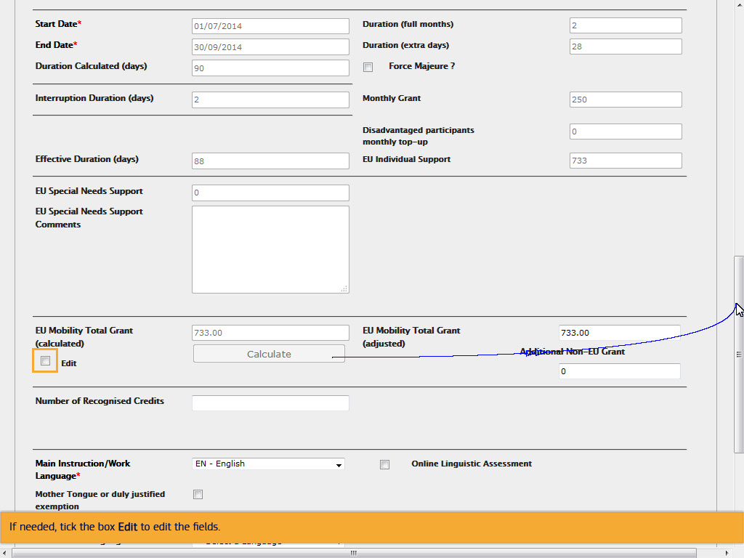
Text Captions

If needed, tick the box Edit to edit the fields.

Slide 55 - Slide 55
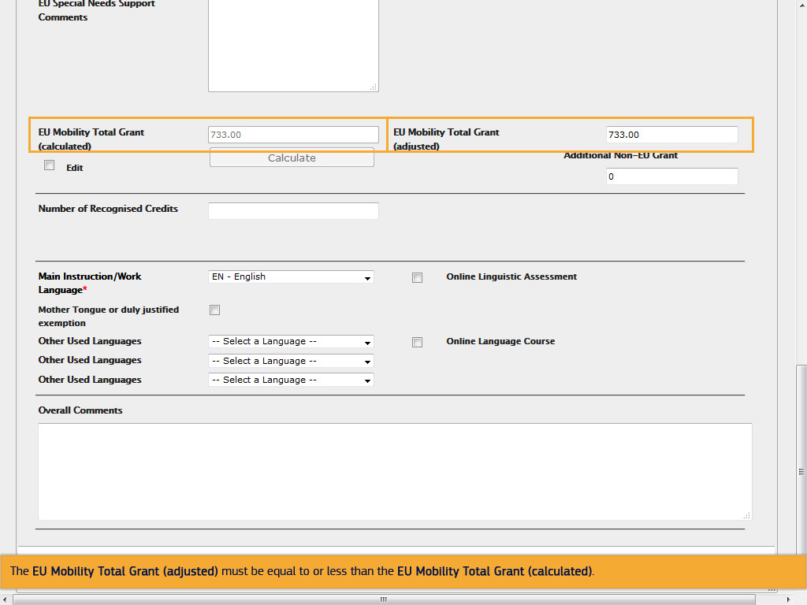
Text Captions

The EU Mobility Total Grant (adjusted) must be equal to or less than the EU Mobility Total Grant (calculated).

Slide 56 - Slide 56
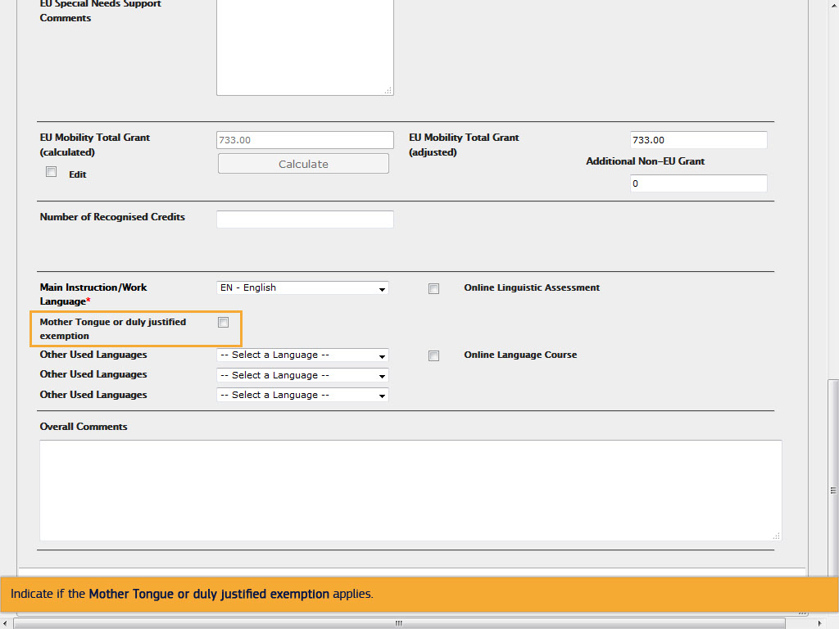
Text Captions

Indicate if the Mother Tongue or duly justified exemption applies.

Slide 57 - Slide 57
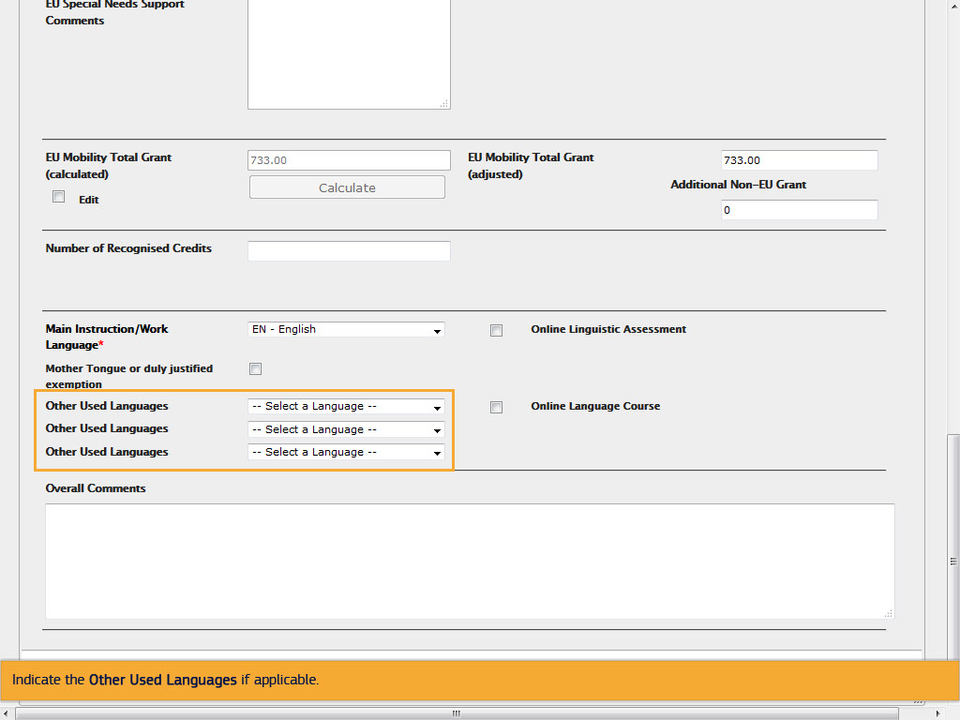
Text Captions

Indicate the Other Used Languages if applicable.

Slide 58 - Slide 58
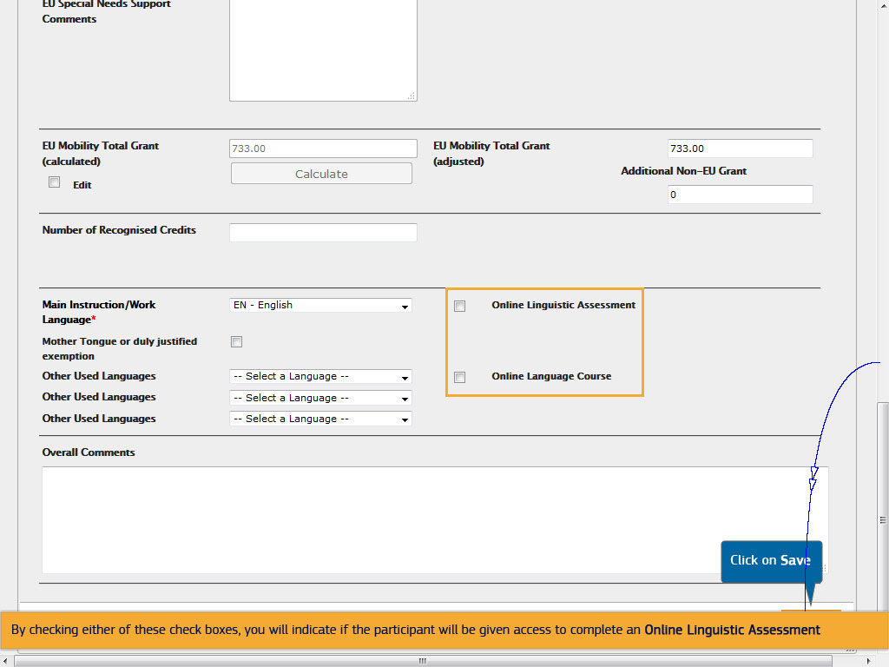
Text Captions

Click on Save

By checking either of these check boxes, you will indicate if the participant will be given access to complete an Online Linguistic Assessment or Online Language Course. Click on Save.

Slide 59 - Slide 59
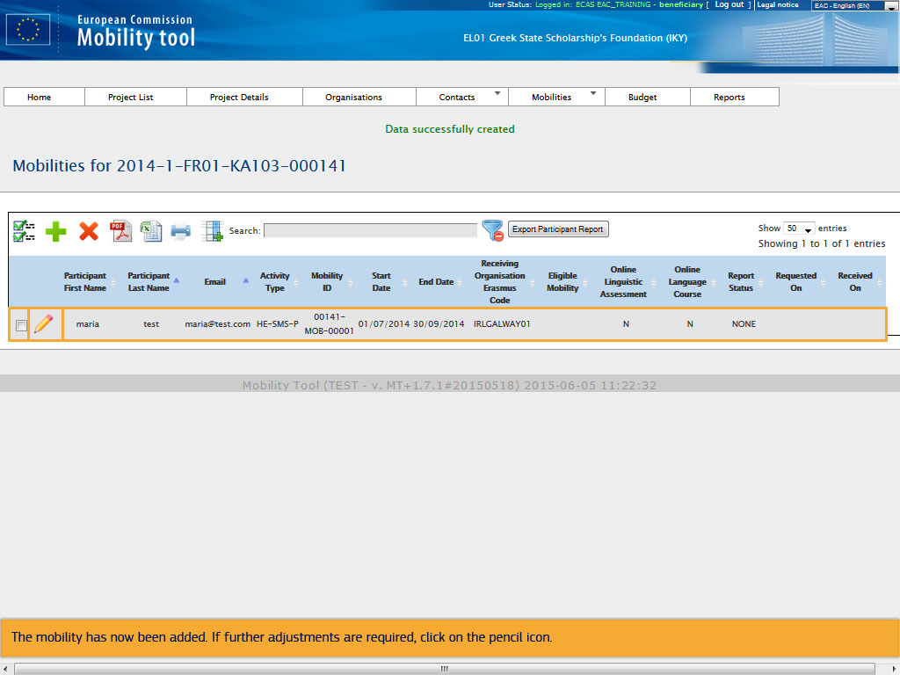
Text Captions

The mobility has now been added. If further adjustments are required, click on the pencil icon.

Slide 60 - Slide 60
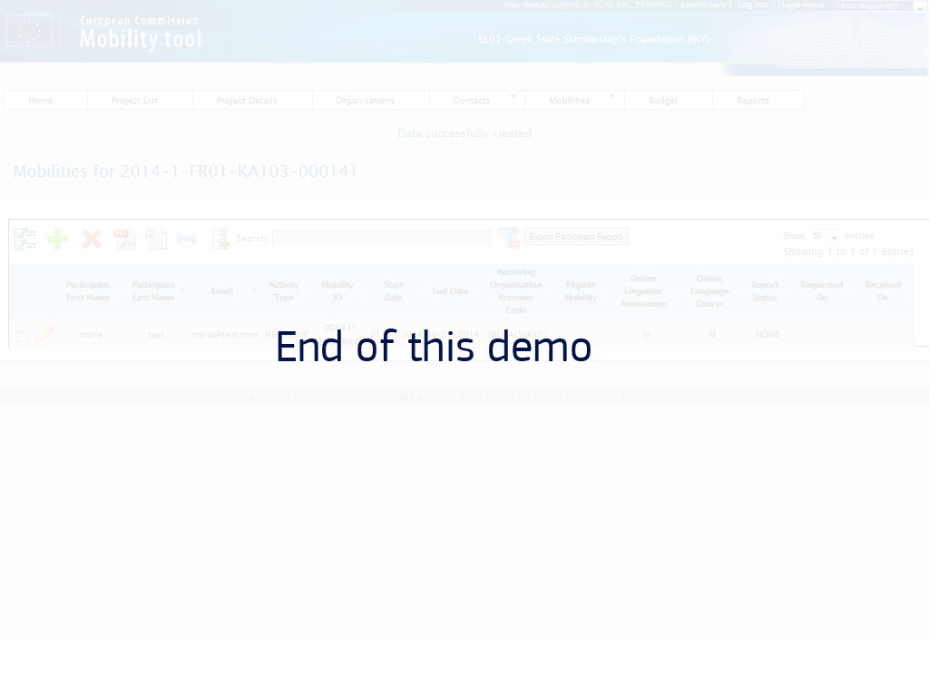
Text Captions

End of this demo

